TITLE: The place of speech recognition in patient clinical information transfer in nursing. 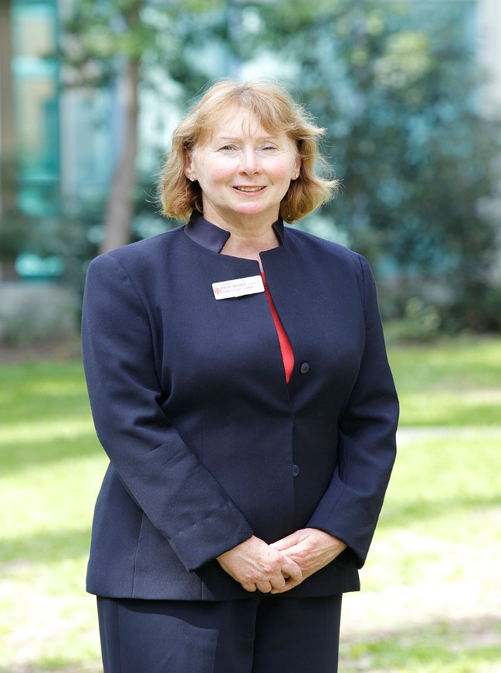
Professor Maree Johnson, RN., B.AppSci., MAppSci., PhD.
Associate Dean (Research), Faculty of Health Sciences, Australian Catholic University, Sydney. Australia.

ABSTRACT
Throughout a series of research projects, conducted over 10 years, the practicality of introducing speech recognition into the management of clinical nursing information has been examined. An initial study began whereby the principles of quality documentation for nursing were explored using a metasynthesis of the literature identifying 7 principles of quality nursing documentation (eg., patient centred, reflect the work of nurses, contain objective clinical judgement etc). An examination of 67 patient records using the as Nursing and Midwifery CAT, highlighted areas for improvement. A study of observed and recorded clinical handovers (n = 195) from speciality and general wards followed, developing a Nursing Handover MDS and electronic module within the clinical information system, which was implemented into 10 hospitals (11000 nurses).
Whether one set of clinical information could be defined from both the patient health care records and handover transcriptions (n = 162) was then examined. The verbal patient clinical handover was more comprehensive than the written (electronic) nursing notes with similarities in the content, supporting one set of clinical information. Three further studies were conducted: testing the acceptability of speech recognition technology to nurses, undertaking a systematic review of the use of speech recognition technology in health, classification of words and phrases (using Protégé Software) into a set of domains to form fields within a patient healthcare record, and machine learning of words and phrases for classification within the set domain,s resulting in 65% correct classification.
There is potential for nurses, using available speech recognition software to present clinical handover to oncoming nurses, while delivering simultaneously the nursing notes for the electronic patient health care record, for final approval. This presents a brave new world for nurses although the challenges to implementation are substantial.
BIOGRAPHY:
Professor Maree Johnson, is a registered nurse with a PhD in Epidemiology and Population Health. Dr. Johnson in internationally recognised for her work in patient safety and communication in health care. She is a recipient of $6 million dollars in research funding, has published some 400 refereed papers and technical reports. Professor Johnson is currently the Associate Dean of Research in the Faculty of Health Sciences at the Australian Catholic University, based at Sydney, Australia.

