The prevalence of depression among diabetic patients in Ethiopia: A Systematic review and Meta-Analysis, 2018.
Authors
Henok Mulugeta, BSc, MSc^{1*} *Corresponding author
Lecturer of Nursing, Department of Nursing, College of Health Science Debre Markos University
Address: P.O. Box 269, Debre Markos, Ethiopia
Email: mulugetahenok68@gmail.com
Phone number: +251913645701

Getenet Dessie, BSc, MSc¹
Lecturer of Nursing, Department of Nursing, College of Health Science Debre Markos University
Address: P.O. Box 269, Debre Markos, Ethiopia
Email: ayalew.d16@gmail.com
Phone number: +251923522712

Fasil Wagnew, BSc, MSc¹
Lecturer of Nursing, Department of Nursing, College of Health Science Debre Markos University
Address: P.O. Box 269, Debre Markos, Ethiopia

Email: fasilw.n@gmail.com

Phone number: +251918057206
Cheru Tesema, BSc, MPH²
Lecturer of public health, Department of Public Health, College of Health Science Debre Markos University
Address: P.O. Box, Debre Markos, Ethiopia
Email: chertesema@gmail.com
Phone number: +251913014126

Dube Jara, BSc, MPH²
Assistant Professor of Epidemiology, Department of Public Health, College of Health Science Debre Markos University
Address: P.O. Box 269, Debre Markos, Ethiopia
E-mail: jaradube@gmail.com
Phone number: +251913910575

The prevalence of depression among diabetic patients in Ethiopia: A Systematic review and Meta-Analysis, 2018.
Henok Mulugeta*¹, Getnet Dessie¹, Fasil Wagnew¹, Cheru Tesema², Dube Jara²
¹Department of Nursing, College of Health Sciences, Debre Markos University, Debre Markos, Ethiopia.
²Department of Public health, College of Health Sciences, Debre Markos University, Debre Markos, Ethiopia.
Abstract
Background: Diabetes Mellitus is a chronic metabolic disorder characterized by hyperglycemia.
Depression is one of the major important public health problem that often co-morbid with
diabetes. Despite of the huge effect of co-morbid depression and diabetes, the overall pooled prevalence of depression among diabetic patient in the country level remain unknown. Therefore, the objective of this systematic review and meta-analysis is to estimate the pooled prevalence of depression among patients with diabetes mellitus in Ethiopia.
Method: Data extraction was designed in accordance with the Preferred Reporting Items for
Systematic reviews and Meta-Analyses (PRISMA) guidelines. Studies were accessed through electronic web-based search from PubMed, Cochrane Library, Google Scholar, Embase and PsycINFO. All statistical analyses were done using STATA version 11 software using random effects model. The pooled prevalence was presented in forest plots.
Results: A total of 9 studies with 2944 participants included in this meta-analysis and the
overall pooled estimated prevalence of depression among diabetic patients in Ethiopia was 39.73 % (95% CI (28.02%, 51.45%)). According to subgroup analysis the estimated prevalence of depression in Addis Ababa was 52.9% (95% CI: 36.93%, 68.88%) and in Oromia region was 45.49% (95% CI: 41.94,49.03%).
Conclusion: The analysis revealed that the overall prevalence of co morbid depression among diabetic patients in Ethiopia was high. Therefore, ministry of health should design multi- sectorial approach and context specific interventions that address this co-morbid depression in this specific group as well as general population.
Keywords: Diabetes, Depression, Co-morbidity, Ethiopia
Background
Diabetes Mellitus is a chronic metabolic disorder characterized by hyperglycemia with disturbances of carbohydrate, protein and fat metabolism[1]. The global prevalence of diabetes has been increasing rapidly. In 2014, the overall global prevalence of diabetes among adult is 8.5%. In addition, according to world health organization report globally around 170 million persons are affected by diabetes and this figure more likely to be double by 2030. In 2015, an estimated 1.6 million deaths were directly caused by diabetes [2-4].
Today, the burden of Diabetes remains one of the major public health important problem in Africa which have been resulting in high mortality and morbidity. Diabetes is a common chronic medical condition in Sub-Saharan Africa countries including Ethiopian population. However, the overall incidence and prevalence of diabetes in Ethiopia is unknown due to very limited studies in the country[5, 6].
Depression, a common mental disorder characterized by persistent unhappiness and lack of interest in daily activities, is one of the major important public health problem that often comorbid with other chronic disease like diabetes and can worsen the effect of the disease outcomes. Depression alone and/or as comorbidity with diabetes is a common condition in the community [7-9].
The cause of depression in patients with diabetes is may be associated to the burden of complications, financial stress, poor overall health status, knowledge of diabetes, and poor glycemic control. The presence of depression in diabetic patients worsens the prognosis of diabetes, increases the non-compliance to the medical treatment, decreases the quality of life and increases mortality. Moreover, the burden of depression in patients with diabetes is linked with increased diabetes complications, high mortality rates and poor quality of life [10-12].
Different literature review and meta-analysis conducted worldwide showed that depression is a common comorbid condition among patients with diabetes [13-15]. A systematic literature review done to estimate the prevalence of co-morbid depression in adults with Type 1 diabetes showed that the prevalence of depression was 12.0% for people with diabetes[16]. Similarly, a systematic review and meta-analysis conducted in University Hospitals of Leicester revealed that the overall prevalence of depression was 17.6% in patients with diabetes[17].
The few studies conducted in Ethiopia has shown that the coexistence of diabetes and depression is highly prevalent in which depression was found to be remain as an important comorbid condition with diabetes. Additionally, depression is highly prevalent amongst diabetes patients and associated with a number of debilitating conditions such as presence of diabetic complications, co-morbidity and the disease duration. Even this few studies conducted on the prevalence of depression among diabetic patients in Ethiopia presented controversial and inconclusive findings [18-20].
Despite of the huge effect of co-morbid depression and diabetes and its importance as a public health problem in Ethiopia, the overall prevalence of depression among diabetes patient in the country level remain unknown. In addition, measuring of depression alone or as a comorbidity in patients with diabetes promote the overall health status, avoids negative effect of depression and even may prevent diabetes-related complications. Therefore, the objective of this systematic review and meta-analysis is to estimate the pooled prevalence of depression among patients with diabetes mellitus in Ethiopia.
Methods
Study design and Search strategy
A systemic review and meta-analysis was conducted using published and unpublished research on the prevalence of depression among patients with diabetes mellitus in Ethiopia. Our literature search strategy, selection of publications, data extraction and the reporting of results for the review were designed in accordance with the Preferred Reporting Items for Systematic reviews and Meta-Analyses (PRISMA) guidelines[21]. Both published and gray literatures on depression among diabetes patients were reviewed using the following major databases; PubMed, Cochrane Library, Google Scholar, CINAHL, Embase and PsycINFO. The search for published studies was restricted to articles published in English language, by the age of the study participants (adult with diabetes) whose age is greater than 18 and the study country (study conducted only in Ethiopia) but, it was not restricted by time. All published and unpublished articles up to November, 2017 were included in the systematic review. Systematic literature searches were conducted from June to November, 2017. During comprehensive literature search, the following search terms were used; “prevalence of depression among diabetes in Ethiopia” “depression OR diabetes in Ethiopia “, “depression AND diabetes in Ethiopia”. Additionally, we observed the reference lists of published studies to identify additional articles.

Study selection and Eligibility criteria
In this systematic review and meta-analysis, we included all studies that were conducted on the prevalence of depression among diabetic patients regardless of the types of diabetic mellitus. The participants were adult with diabetes whose age is greater than 18 years, regardless of their sex and other characteristics. We included all study types that were published in the form of journal articles, master’s thesis and dissertations in English. Furthermore, literatures which failed to report prevalence of depression and those studies conducted on children were excluded. Since the number of articles in Ethiopia is relatively limited, no restriction was made for date of publication. But, studies that were not conducted in Ethiopia were also excluded.
Quality assessment and Critical appraisal
In this systematic review and meta-analysis the qualities of each article were assessed by using a critical appraisal tool for use in systematic reviews for prevalence study[22]. The methodological quality and eligibility of the identified articles were also assessed by three reviewers (HM, GD and FW) and disagreements among reviewers were fixed accordingly with discussion. A modified version of the Newcastle-Ottawa Scale for cross-sectional study adapted from PA Modesti et al[23] was also used to evaluate the quality of studies.
Data Extraction
After the search was conducted, data were extracted using pre-piloted data extraction form which were developed by the authors. It included name of author, year of publication, region in the country, study design, response rate sample size, number of people with outcome and overall prevalence. H.M. and F.W conducted the primary data extraction then G.D, D.J and C.T examined the extracted data independently. Any disagreement and inconsistencies were resolved by discussion and consensus.
Data Analysis and synthesis
The extracted data were entered into computer through command window of STATA v.11 and the analysis was performed using STATA v.11. A random effects model was used to estimate the overall pooled prevalence. An important statistical issue in meta-analysis is handling of heterogeneity among studies. DerSimonian and Laird method, which assumes heterogeneity across studies, is the most common method for using random effects model in Meta-analysis[24, 25]. A random effects meta-analysis is also recommended for use when heterogeneity between studies exists[26]. Data manipulation and all statistical analyses were done using STATA software, version 11.
The heterogeneity of studies was checked using I² test statistics. I² statistics used to quantify the percentage of total variation in study estimate due to heterogeneity[27]. I² statistics ranges from 0 to 100 percent. A value of 0% indicates no observed heterogeneity while 100% indicates significant heterogeneity. A p-value less than 0.05 was used to declare heterogeneity[28, 29]. In this meta-analysis, I² values was found to be high (> 75%). Since this value is definite indicative of significant high heterogeneity, we conducted the analysis with a random effects model with 95% CIs as opposed to the fixed effect model to adjust for the observed variability. Moreover, presence of heterogeneity was also assessed by subgroup analysis and meta regression.
Visual assessment of publication bias was conducted using funnel plot. Asymmetry of the funnel plot is an indicator of publication bias[15]. Egger’s and Begg’s tests were also conducted to check potential publication bias. A p-value less than 0.05 were used to declare statistical significance of publication bias[30]. Additionally, sensitivity analysis was also done to assess whether the pooled prevalence estimates were influenced by individual studies.
Results
Selection and identification of studies
A total of 121 studies were identified from the literature search. We added two gray literatures that were not found in the search. Of these studies, 5 articles duplicate records were identified and removed. Reviewing of titles and abstracts resulted in exclusion of 100 irrelevant articles. After assessing the full texts of the remaining articles, additional 3 articles were excluded due to poor quality. Moreover, based on the inclusion and exclusion criteria for entry into the study a total of 6 studies were excluded as they did not meet the inclusion criteria. Then, a total of nine unique studies were eligible and enrolled for final analysis (Figure 1).
Characteristics of included studies
A total of 9 studies with 2944 participants included in this meta-analysis are summarized in Table 1. The studies were conducted from 2013 to 2017 in different regions of the country. Among 9 studies two of them[20, 31] were conducted in Addis Ababa, three study[18, 32, 33] were in Amhara region, two studies[12, 19] were in Oromia region, and the other two studies[34, 35] conducted in other region of the country. All studies were cross-sectional study conducted among adult diabetic patients in Ethiopia. The study with minimum and maximum sample size was conducted in Amhara and Oromia region respectively[12, 32]. In addition, out of all studies enrolled in this meta-analysis six studies[12, 18, 31, 33-35] conducted among both type 1 and type 2 diabetic patients while the remaining four studies[1, 32] conducted only among type 2 diabetic patients (Table 1).
121 published articles and 2 gray articles were identified through database search (PubMed, Cochrane Library, Google Scholar, CINAHL, Embase and PsycINFO).
(n=123)

5 articles duplicates excluded

118 articles enrolled for Titles and abstracts screen

Exclusion of 100 irrelevant articles

18 full text articles checked for eligibility

Exclusion 3 articles due to poor quality
6 studies failed to meet the inclusion criteria

9 studies eligible for final quantitative analysis (meta-analysis)

Figure 1: Flowchart of study selection for meta-analysis of prevalence of depression among diabetic patients in Ethiopia, 2018.

S. No | Author/s(reference) | Publication year | Study design | Study area, Region | Sample size | Response rate | Prevalence %  (95% CI)
1 | Erkie M et al[31] | 2013 | Cross-sectional | Addis Ababa | 313 | 100% | 61(55.6,66.4)
2 | Teshager W and Birhanu W[33] | 2016 | Cross-sectional | Bahir Dar, Amhara region | 416 | 100% | 40.4(35.7,45)
3 | Tilahun B et al[34] | 2016 | Cross-sectional | Mekele, Tigray region | 264 | 100% | 17(12.5,21.5)
4 | Takele T[12] | 2017 | Cross-sectional | Ambo, Oromia Region | 423 | 100% | 47(42,51.8)
5 | Tesfa D et al[20] | 2016 | Cross-sectional | Addis Ababa | 264 | 95.6% | 44.7(38.7,50.7)
6 | Anteneh M et al[18] | 2016 | Cross-sectional | Gonder, Amhara Region | 415 | 98% | 15.4(11.9,18.9)
7 | Asres B et al[35] | 2016 | Cross-sectional | Hawassa, SNNPR  Region | 326 | 100% | 24.5(19.8,29)
8 | Sisay D et al[19] | 2014 | Cross-sectional | Jimma, Oromia Region | 335 | 96% | 43.6(38.3,48.9)
9 | Getnet D et al[32] | 2017 | Cross-sectional | Debre Markos, Amhara Region | 188 | 98% | 64.9(58,71.7)
Table 1: Characteristics of studies included in meta-analysis of the prevalence of depression among diabetic patients in Ethiopia, 2018.

Prevalence of depression among diabetes mellitus patients (Meta-analysis)
The pooled prevalence using the fixed effect model showed significant heterogeneity between the studies. Hence, we performed the analyses using random effects model. Using random effects model, the estimated pooled prevalence of depression among diabetic patients reported by the 9 studies was 39.73 % (95% CI (28.02%, 51.45%)) with significant heterogeneity between studies (I²=98.1%, p=0.001). The pooled prevalence of depression presented using forest plot (Figure 2).
Subgroup analysis by study area was conducted to assess the potential heterogeneity between studies. Of the 9 studies, the highest estimated depression prevalence found in studies conducted in Addis Ababa (52.9% (95% CI: 36.93% to 68.88%), I²=93.6 %), followed by studies conducted in Oromia region was (45.49% (95% CI: 41.94,49.03%), I²=0.0 %) (Figure 3).

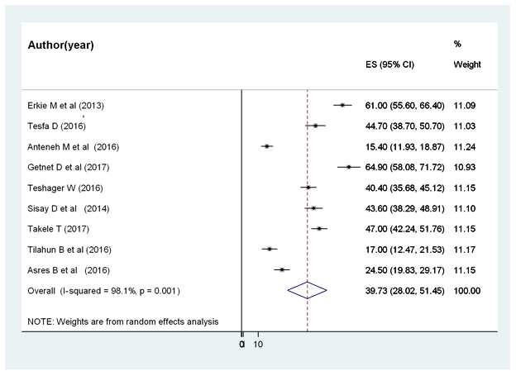

Figure 2. Forest plot showing the pooled prevalence of depression among diabetic patients in Ethiopia, 2018.
Investigation of heterogeneity
Heterogeneity in systematic reviews and meta-analysis results of studies is inevitable due to different in study quality, methodology, sample size, and inclusion criteria for participants[36, 37]. In this meta-analysis the value of I² is definite indicative of significant high heterogeneity, so we conducted the analysis with a random effects model to adjust for the observed variability. Further, presence of heterogeneity was also assessed by subgroup analysis. However, the level of heterogeneity was high after subgroup analysis (Figure 3). Then we further try to investigate the sources heterogeneity using Meta regression model using publication year and sample size as covariates. Meta‐regression is a more complex and preferable method than subgroup analysis for investigating heterogeneity and has the potential advantage of allowing the assessment of one or more covariates simultaneously[38]. The result of meta regression analysis showed that both covariates were not statistically significant for the presence of heterogeneity (Table 2).
NOTE: Weights are from random effects analysis
.
.
.
.
Overall (I-squared = 98.1%, p = 0.001)
Other
Anteneh M et al (2016)
Takele T (2017)
Getnet D et al (2017)
Asres B et al (2016)
Subtotal (I-squared = 80.4%, p = 0.024)
Sisay D et al (2014)
Tesfa D (2016)
Subtotal (I-squared = 0.0%, p = 0.350)
Subtotal (I-squared = 93.6%, p = 0.001)
Author(Year)
Amhara
Erkie M et al (2013)
Oromia
Subtotal (I-squared = 98.9%, p = 0.001)
Teshager W (2016)
Addis ababa
Tilahun B et al (2016)
39.73 (28.02, 51.45)
15.40 (11.93, 18.87)
47.00 (42.24, 51.76)
ES (95% CI)
64.90 (58.08, 71.72)
24.50 (19.83, 29.17)
20.73 (13.38, 28.08)
43.60 (38.29, 48.91)
44.70 (38.70, 50.70)
45.49 (41.94, 49.03)
52.90 (36.93, 68.88)
61.00 (55.60, 66.40)
40.10 (13.26, 66.94)
40.40 (35.68, 45.12)
17.00 (12.47, 21.53)
100.00
11.24
11.15
Weight
10.93
11.15
22.32
11.10
11.03
22.24
22.11
%
11.09
33.33
11.15
11.17
39.73 (28.02, 51.45)
15.40 (11.93, 18.87)
47.00 (42.24, 51.76)
ES (95% CI)
64.90 (58.08, 71.72)
24.50 (19.83, 29.17)
20.73 (13.38, 28.08)
43.60 (38.29, 48.91)
44.70 (38.70, 50.70)
45.49 (41.94, 49.03)
52.90 (36.93, 68.88)
61.00 (55.60, 66.40)
40.10 (13.26, 66.94)
40.40 (35.68, 45.12)
17.00 (12.47, 21.53)
100.00
11.24
11.15
Weight
10.93
11.15
22.32
11.10
11.03
22.24
22.11
%
11.09
33.33
11.15
11.17

0
0
1
10

Figure 3. Subgroup analysis by regions on the prevalence of depression among diabetic patients in Ethiopia, 2018.
Table 2: Meta-regression analysis of factors with heterogeneity of the prevalence of depression among diabetic patients in Ethiopia, 2018.
Heterogeneity source | Coefficients | Std. Err. | P-value
Publication Year | -2.886568 | 5.008484 | 0.585
Sample size | -.076825 | .0818828 | 0.384

Publication bias
Presence of publication bias was examined using funnel plots and tests (Egger’s and begs). In this meta-analysis funnel plots and tests indicated evidence of publication bias. Each point in funnel plots represents a separate study and asymmetrical distribution is evidence of the existence of publication bias[39]. First, each study's effect size was plotted against the standard error and visual inspection of the funnel plot suggest some asymmetry, as three studies lay on the left side and six studies on the right side of the line representing the pooled prevalence (Figure. 4). In addition, trim and fill analysis was also performed (Figure. 5). Trim and fill analysis is a non-parametric methods for estimating the number of missing studies that might exist and it helps for reducing and adjusting publication bias in meta-analysis[40]. We also performed Egger’s and Begg’s tests to investigate publication bias. The result of these tests showed significant evidence of publication bias (p-value < 0.05).

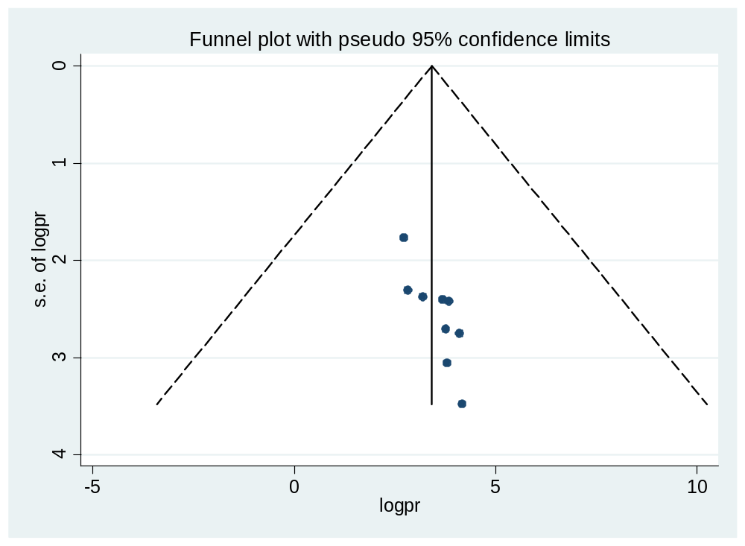

Figure. 4: Funnel plots to test the publication bias of the 9 studies, 2018.

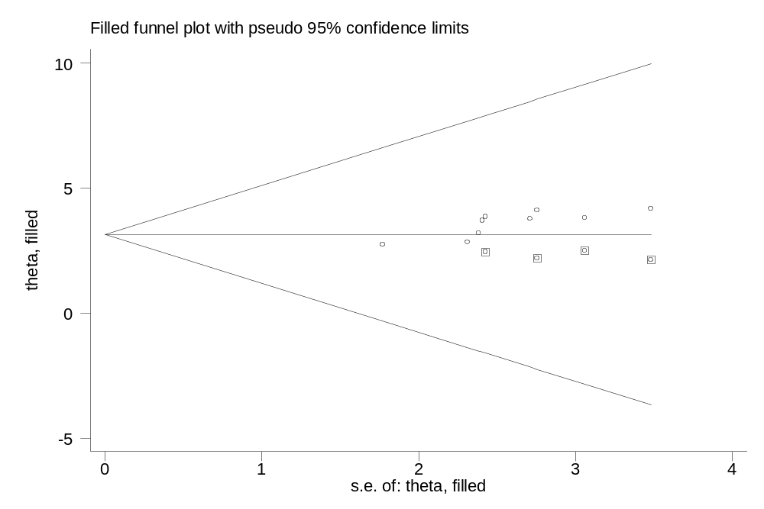

Fig. 5: Result of trim and fill analysis for adjusting publication bias of the 9 studies, 2018.
Sensitivity analysis
The result of sensitivity analyses using random effects model suggested that no single study unduly influenced the overall prevalence estimate of depression among patients with diabetes (Fig.6).
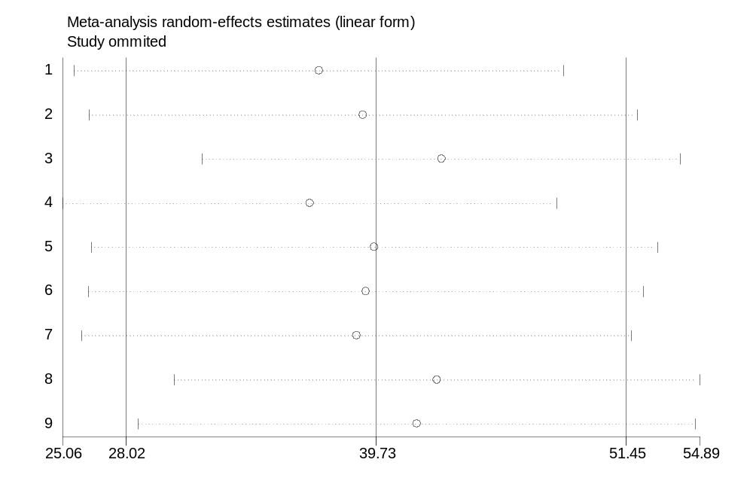
Fig 6: Result of Sensitivity analysis of the 9 studies, 2018.
Discussion
Depression is a very common highly prevalent comorbid condition in diabetic patients[41]. Comorbid depression with diabetes linked with 1.5-fold increase in risk of mortality and 50-75% increase the cost of health care service[28, 42]. There was limited data on depression as a comorbid with other chronic diseases. This meta-analysis aimed to estimate the overall pooled prevalence of depression among diabetic patients in Ethiopia.
The finding of this 9 studies involving 2944 participants showed that the overall pooled prevalence of depression among diabetic patients was 39.73 % (95% CI (28.02%, 51.45%))). This finding is consistent with the studies conducted in Netherlands (31%)[43], in Bahrain(33.3%)[44], in Malaysia (30.5%)[45], in Palestine(40%)[46] and in Nigerian teaching hospital(30%)[47].
The finding of this meta-analysis showed that depression is common comorbid condition among diabetic patients. This is in line with the recent meta-analysis done in Washington[13] which identified the link between depression and diabetes mellitus and showed that the presence of diabetes doubles the odds of comorbid depression.
The pooled estimate of this meta-analysis is higher than other similar systematic review and meta-analysis[16, 17]. The higher prevalence of depression in Ethiopia could be due to poor quality of diabetic care service, lower level of education, measurement tool used to quantify the level of depression and other forms of stressors. On the contrary, several studies among diabetic patients had found higher prevalence of depression than our study [48-50]. The possible reason for the lower proportion of depression might be due to strong family and social support implemented in our society. The difference might also be due to methodological issue, sample size, socio-demographic characteristics of the study participants and others.
Although the power to detect much differences was low due to the analysis involves small number of studies, the pooled estimate indicated that the risk of depression is very common in diabetic patients as compared with the general population. Even though there are a number of factors in each studies such as age, sex, socio-economic status, presence complications, additional comorbid condition, duration of the diseases and the like, it was not possible to conduct factor analysis and examine the pooled odds ratios because of luck of similar and related factors across the studies.
Nevertheless, this review has provided valuable information regarding the prevalence of depression among diabetic patients, there were some limitations that could be addressed in future systematic review and meta-analysis. One of the limitations of this study is that factor analysis was not conducted due to luck of similar factors to be analyzed across the studies as only small number of studies reviewed.

Conclusion

The systematic review and meta-analysis showed that the prevalence of comorbid depression was highly prevalent among patients with diabetes. The difference was observed in the prevalence of depression in different region of the country. The highest prevalence of depression was found in studies conducted in Addis Ababa, followed by studies conducted in Oromia region. Health education and patient education given by health care providers at all level should incorporate mental health issues among patients with diabetes mellitus. In order to improve the patient’s mental status early screening with appropriate psychiatric assessments and treatment with pharmacotherapy or psychotherapy should be incorporated as a routine practice in diabetic clinic. Future research should focus on identification of the associated factors for depression among diabetic patients.

Conflict of Interests
The authors declare that they have no competing interests.
Acknowledgement
We would like to thank all authors of studies included in this systematic review and meta-analysis.
Authors’ contributions
HM developed the protocol and involved in the design, selection of study, data extraction, and statistical analysis and developing the initial drafts of the manuscript. GD, FW, CT and DJ involved in data extraction, quality assessment, statistical analysis and revising subsequent drafts. HM and DJ prepared the final draft of the manuscript. All authors read and approved the final draft of the manuscript.
References
1. Abebe SM, Berhane Y, Worku A, Assefa A: Diabetes mellitus in North West Ethiopia: a community based study. BMC Public Health 2014, 14(1):97.
2. Dejenie Habtewold T, Radie YT, Sharew NT: Prevalence of depression among type 2 diabetic outpatients in black lion general specialized hospital, Addis Ababa, Ethiopia. Depression research and treatment 2015, 2015.
3. Mathers CD, Loncar D: Projections of global mortality and burden of disease from 2002 to 2030. PLoS medicine 2006, 3(11):e442.
4. Organization WH: World Health Organization Diabetes Fact Sheet. In.; 2011.
5. Gudina EK, Amade ST, Tesfamichael FA, Ram R: Assessment of quality of care given to diabetic patients at Jimma University Specialized Hospital diabetes follow-up clinic, Jimma, Ethiopia. BMC endocrine disorders 2011, 11(1):19.
6. Motala AA: Diabetes trends in Africa. Diabetes/metabolism research and reviews 2002, 18(S3).
7. Bitew T: Prevalence and risk factors of depression in Ethiopia: a review. Ethiopian journal of health sciences 2014, 24(2):161-169.
8. Moussavi S, Chatterji S, Verdes E, Tandon A, Patel V, Ustun B: Depression, chronic diseases, and decrements in health: results from the World Health Surveys. The Lancet 2007, 370(9590):851-858.
9. Solomon S: Depression: Let's talk. Journal of Current Research in Scientific Medicine 2017, 3(1):1.
10. Bădescu S, Tătaru C, Kobylinska L, Georgescu E, Zahiu D, Zăgrean A, Zăgrean L: The association between Diabetes mellitus and Depression. Journal of medicine and life 2016, 9(2):120.
11. Mier N, Bocanegra-Alonso A, Zhan D, Wang S, Stoltz SM, Acosta-Gonzalez RI, Zuniga MA: Clinical depressive symptoms and diabetes in a binational border population. The Journal of the American Board of Family Medicine 2008, 21(3):223-233.
12. Tiki T: Prevalence and Associated Factors of Depression among Type 2 Diabetes Mellitus Patients on Follow up at Ambo General Hospital, Oromia Regional State, Ethiopia, Institutional Based Cross Sectional Study. J Depress Anxiety 2016, 6:259.
13. Anderson RJ, Freedland KE, Clouse RE, Lustman PJ: The prevalence of comorbid depression in adults with diabetes. Diabetes care 2001, 24(6):1069-1078.
14. Mezuk B, Eaton WW, Albrecht S, Golden SH: Depression and type 2 diabetes over the lifespan: a meta-analysis. Diabetes care 2008, 31(12):2383-2390.
15. Nouwen A, Winkley K, Twisk J, Lloyd C, Peyrot M, Ismail K, Pouwer F, Consortium EDiDR: Type 2 diabetes mellitus as a risk factor for the onset of depression: a systematic review and meta-analysis. In.: Springer; 2010.
16. Barnard K, Skinner T, Peveler R: The prevalence of co‐morbid depression in adults with Type 1 diabetes: systematic literature review. Diabetic Medicine 2006, 23(4):445-448.
17. Ali S, Stone M, Peters J, Davies M, Khunti K: The prevalence of co‐morbid depression in adults with Type 2 diabetes: a systematic review and meta‐analysis. Diabetic Medicine 2006, 23(11):1165-1173.
18. Birhanu AM, Alemu FM, Ashenafie TD, Balcha SA, Dachew BA: Depression in diabetic patients attending University of gondar hospital Diabetic clinic, northwest ethiopia. Diabetes, metabolic syndrome and obesity: targets and therapy 2016, 9:155.
19. Dejene S, Negash A, Tesfay K, Jobset A, Abera M: Depression and diabetes in Jimma university specialized hospital, Southwest Ethiopia. J Psychiatry 2014, 17(126):2.
20. Habtewold TD, Alemu SM, Haile YG: Sociodemographic, clinical, and psychosocial factors associated with depression among type 2 diabetic outpatients in Black Lion General Specialized Hospital, Addis Ababa, Ethiopia: a cross-sectional study. BMC psychiatry 2016, 16(1):103.
21. Moher D, Liberati A, Tetzlaff J, Altman DG, Group P: Preferred reporting items for systematic reviews and meta-analyses: the PRISMA statement. PLoS medicine 2009, 6(7):e1000097.
22. Munn Z, Moola S, Riitano D, Lisy K: The development of a critical appraisal tool for use in systematic reviews addressing questions of prevalence. International journal of health policy and management 2014, 3(3):123.
23. Modesti PA, Reboldi G, Cappuccio FP, Agyemang C, Remuzzi G, Rapi S, Perruolo E, Parati G: Panethnic differences in blood pressure in Europe: a systematic review and meta-analysis. PloS one 2016, 11(1):e0147601.
24. George BJ, Aban IB: An application of meta-analysis based on DerSimonian and Laird method. Journal of Nuclear Cardiology 2016, 23(4):690-692.
25. IntHout J, Ioannidis JP, Borm GF: The Hartung-Knapp-Sidik-Jonkman method for random effects meta-analysis is straightforward and considerably outperforms the standard DerSimonian-Laird method. BMC medical research methodology 2014, 14(1):25.
26. Knol M, Twisk JW, Beekman AT, Heine R, Snoek FJ, Pouwer F: Depression as a risk factor for the onset of type 2 diabetes mellitus. A meta-analysis. Diabetologia 2006, 49(5):837.
27. Higgins J, Thompson SG: Quantifying heterogeneity in a meta‐analysis. Statistics in medicine 2002, 21(11):1539-1558.
28. Park M, Katon WJ, Wolf FM: Depression and risk of mortality in individuals with diabetes: a meta-analysis and systematic review. General hospital psychiatry 2013, 35(3):217-225.
29. Wang J, Wu X, Lai W, Long E, Zhang X, Li W, Zhu Y, Chen C, Zhong X, Liu Z: Prevalence of depression and depressive symptoms among outpatients: a systematic review and meta-analysis. BMJ open 2017, 7(8):e017173.
30. Sarokhani D, Delpisheh A, Veisani Y, Sarokhani MT, Manesh RE, Sayehmiri K: Prevalence of depression among university students: a systematic review and meta-analysis study. Depression research and treatment 2013, 2013.
31. Erkie M, Feleke Y, Desalegne F, Anbessie J, Shibre T: Magnitude, clinical and sociodemographic correlate of depression in diabetic patients, Addis Ababa, Ethiopia. Ethiopian medical journal 2013, 51(4):249-259.
32. Getenet Dessie, Girma Alem, Henok Mulugeta, kalkidan Muluken, Fikirte Marelign, Dereje Ayana, Sefanite Sleshi, Selam Teka, Worku S: Prevalence of Depression and Associated Factors among Type 2 Diabetic Outpatients in Debre Markos Referral Hospital, Debre Markos, Ethiopia. 2017.
33. Teshager W/giorgis, Giru BW: Prevalence of Depression and Associated Factors among Adult Diabetic Patients Attending Outpatient Department, at Felege Hiwot Referral Hospital, Bahir Dar, Northwest Ethiopia. International Journal of Health Sciences and Research 2016, 6(9):264-276.
34. Mossie TB, Berhe GH, Kahsay GH, Tareke M: Prevalence of depression and associated factors among diabetic patients at Mekelle City, North Ethiopia. Indian journal of psychological medicine 2017, 39(1):52.
35. Tilahune AB, Bekele G, Mekonnen N, Tamiru E: Prevalence of unrecognized depression and associated factors among patients attending medical outpatient department in Adare Hospital, Hawassa, Ethiopia. Neuropsychiatric disease and treatment 2016, 12:2723.
36. Baker W, Michael White C, Cappelleri J, Kluger J, Coleman C: Understanding heterogeneity in meta‐analysis: the role of meta‐regression. International journal of clinical practice 2009, 63(10):1426-1434.
37. Melsen W, Bootsma M, Rovers M, Bonten M: The effects of clinical and statistical heterogeneity on the predictive values of results from meta-analyses. Clinical Microbiology and Infection 2014, 20(2):123-129.
38. Hardy RJ, Thompson SG: Detecting and describing heterogeneity in meta‐analysis. Statistics in medicine 1998, 17(8):841-856.
39. Egger M, Smith GD, Schneider M, Minder C: Bias in meta-analysis detected by a simple, graphical test. Bmj 1997, 315(7109):629-634.
40. Duval S, Tweedie R: Trim and fill: a simple funnel‐plot–based method of testing and adjusting for publication bias in meta‐analysis. Biometrics 2000, 56(2):455-463.
41. Vankar G, Parikh V, Banwari G, Parikh M: Depression in diabetes mellitus. Archives of Indian Psychiatry 2007, 9:38-42.
42. Simon GE, Katon WJ, Lin EH, Ludman E, VonKorff M, Ciechanowski P, Young BA: Diabetes complications and depression as predictors of health service costs. General hospital psychiatry 2005, 27(5):344-351.
43. Pouwer F, Geelhoed‐Duijvestijn P, Tack C, Bazelmans E, Beekman AJ, Heine R, Snoek FJ: Prevalence of comorbid depression is high in out‐patients with Type 1 or Type 2 diabetes mellitus. Results from three out‐patient clinics in the Netherlands. Diabetic Medicine 2010, 27(2):217-224.
44. Nasser J, Habib F, Hasan M, Khalil N: Prevalence of depression among people with diabetes attending diabetes clinics at primary health settings. Bahrain Med Bull 2009, 31:1-7.
45. Kaur G, Tee GH, Ariaratnam S, Krishnapillai AS, China K: Depression, anxiety and stress symptoms among diabetics in Malaysia: a cross sectional study in an urban primary care setting. BMC family practice 2013, 14(1):69.
46. Sweileh WM, Abu-Hadeed HM, Al-Jabi SW, Sa’ed HZ: Prevalence of depression among people with type 2 diabetes mellitus: a cross sectional study in Palestine. BMC public health 2014, 14(1):163.
47. James BO, Omoaregba JO, Eze G, Morakinyo O: Depression among patients with diabetes mellitus in a Nigerian teaching hospital. South African journal of psychiatry 2010, 16(2).
48. Asghar S, Hussain A, Ali S, Khan A, Magnusson A: Prevalence of depression and diabetes: A population‐based study from rural Bangladesh. Diabetic medicine 2007, 24(8):872-877.
49. Khullar S, Dhillon H, Kaur G, Sharma R, Mehta K, Aggarwal R, Singh M, Singh P: The prevalence and predictors of depression in type 2 diabetic population of Punjab. Community mental health journal 2016, 52(4):479-483.
50. Raval A, Dhanaraj E, Bhansali A, Grover S, Tiwari P: Prevalence & determinants of depression in type 2 diabetes patients in a tertiary care centre. 2010.

