The duty to care: Examining nurses’ ethical responsibility to report for work in the face of disasters and extreme events
Dónal O’Mathúna, PhD, Dublin City University, Ireland and The Ohio State University, USA)

Abstract (300 word limit)
Epidemics, pandemics and disasters occur with increased frequency. Concerns are increasing about chemical, biological, radiological, nuclear, and explosive (CBRNE) events. The potentially large numbers of injured, traumatized and dying patients require many nurses and other healthcare professionals. Sometimes, caring for patients puts nurses at serious risk of harm, such as when patients are infectious or contaminated. This creates ethical conflicts between one’s professional duty to care and the need to care for oneself, one’s family, and future patients. History records many examples of nurses accepting significant risks during wars and infectious outbreaks, like with Ebola virus disease. Such decisions have been lauded as heroic whether undertaken for personal moral or religious reasons, or in response to a professional duty to care. However, some question whether such a duty to care is ethically obligatory in the face of pandemics and CBRNE events. The University of Toronto’s report into pandemic influenza, completed after the SARS outbreak there, called for much further ethical analysis of the duty to care. A systematic review found that nurses are under-prepared for the ethical challenges faced in disasters. This presentation will review the ethical arguments used to justify and also limit the duty to care. It will discuss the World Health Organization’s guidance on ethics in pandemics which notes that the duty to care is not unlimited during pandemics, and that employers and governments have reciprocal duties to provide training and protective equipment. This presentation will argue that rather than looking to legal and regulatory responses, the ethical virtues of courage and volunteerism should be fostered as part of promoting trust in nurses and other healthcare professionals. Virtue ethics includes a narrative approach that values the role of stories to inspire people to strive towards ethical ideals and praiseworthy leadership, even when caring involves serious risks.

Image
Ebola outbreak, Sierra Leone 2014. Photo used with permission WHO/Winnie Rommeril
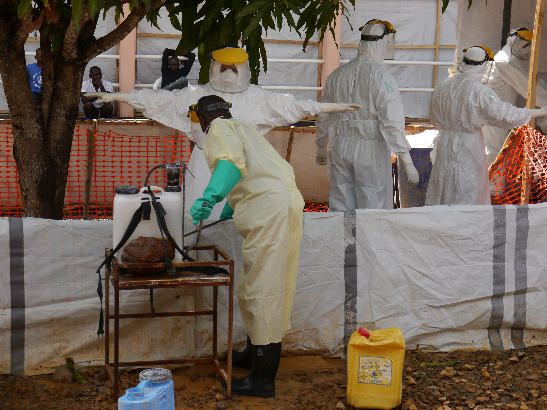

[Graph/figure/photo]

Recent Publications (minimum 5)
- American Nurses Association (2017) Who will be there? Ethics, the law, and a nurse’s duty to respond in a disaster. https://www.nursingworld.org/~4af058/globalassets/docs/ana/ethics/who-will-be-there_disaster-preparedness_2017.pdf.
- Aoyagi Y, Beck CR, Dingwall R, Nguyen-Van-Tam JS (2015) Healthcare workers’ willingness to work during an influenza pandemic: a systematic review and meta-analysis. Influenza and Other Respiratory Viruses 9(3): 120-130.
- Johnstone M-J, Turale S (2014) Nurses’ experiences of ethical preparedness for public health emergencies and healthcare disasters: A systematic review of qualitative evidence. Nursing and Health Sciences 16: 67-77.
- Malm H, May T, Francis LP, Omer SB, Salmon DA, Hood R (2008) Ethics, pandemics, and the duty to treat. American Journal of Bioethics 8(8): 4-19.
- University of Toronto Joint Centre for Bioethics Pandemic Influenza Working Group (2005) Stand on guard for thee. Ethical considerations in preparedness planning for pandemic influenza. http://jcb.utoronto.ca/publications/documents/stand_on_guard.pdf.
- World Health Organization (2007) Ethical considerations in developing a public health response to pandemic influenza. http://www.who.int/csr/resources/publications/WHO_CDS_EPR_GIP_2007_2/en.

Biography (150 word limit)
Dónal O’Mathúna is Associate Professor in the College of Nursing at The Ohio State University, USA and in the School of Nursing & Human Sciences, Dublin City University, Ireland. His research interests focus on both healthcare ethics and evidence-based practice. His ethics research has focused on disasters and humanitarian crises. He has led funded research projects on healthcare and research ethics in the context of disasters and humanitarian crises. He has contributed to ethics initiatives and guidelines with the World Health Organization, UNICEF and the UN agency for disaster risk reduction (UNISDR). As the director of a new virtual Center for Disaster & Humanitarian Ethics (http://www.ge2p2.org/cdhe), he is helping develop practical tools and support strategies to facilitate reflection on ethical issues in humanitarian research. He has spoken and published widely, including peer-reviewed articles in The Lancet, Bioethics, BMC Medical Ethics, Journal of Evidence-Based Medicine, and Worldviews on Evidence-based Nursing.
Email: omathuna.6@osu.edu

Notes/Comments:

