Title: ER-DRIP Education Workshop learning to implement family presence during resuscitation into practice.
Name and Affiliation Dr Joanne Porter, Nareeda Miller, Anita Giannis and Nicole Coombs: Federation University, Victoria, Australia.

Abstract (300 word limit)

Background: The practice of allowing family to be present during resuscitation has been debated in emergency departments since the early 1980’s, with evidence that the practice and implementation of FPDR is inconsistent despite formal endorsement. This study aimed to develop an education package for emergency nurses, paramedics and medical personnel in order to develop competence in the implementation of FPDR.

The aim of this interactive workshop will be to teach participants on how to implement the ER-DRIP Education package into clinical practice. The acronym ER-DRIP1 (emergency personnel, reassurance, diagnosis, regular up-dates, interventions and prognosis). Working through the education package participants will identify resuscitation team roles and responsibilities, identify the barriers, benefits and enablers of family presence during resuscitation using videos to assist learning. The three scenarios have been developed to assist with participant discussion and understanding of the implementation of FPDR.

Image

https://youtu.be/F13hM3NS-WA

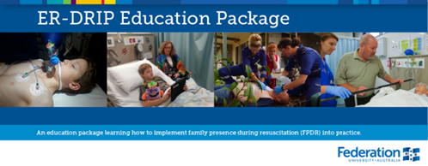

Recent Publications (minimum 5)
- Porter, J. Cooper, S. & Taylor, B. (2014). Emergency Resuscitation team roles: What constitutes a team and who’s looking after the family? Journal of Nursing Education and Practice
- Porter, J. Cooper, S. & Taylor, B. (2013). Family presence during resuscitation (FPDR): A survey of emergency personnel in Victoria, Australia. Australasian Emergency Nursing Journal – AENJ



Biography (150 word limit)

Dr Joanne Porter currently works at the School of Nursing, Midwifery and Healthcare at Federation University Australia, Gippsland campus. Teaching into the undergraduate program, and postgraduate higher Degree supervision. She has worked both in Metropolitan and regional health facilities predominantly in Emergency departments and Intensive care units. Her research interests include, deteriorating patient outcomes, simulation, and emergency care research. Her PhD through Monash University used a mixed methods approach to investigate the affect family presence during resuscitation (FPDR) had on personnel in the emergency department. Joanne currently holds the position of Senior lecturer and has an extensive research history with a number of publications and competitive grants.

Email: joanne.porter@federation.edu.au

Notes/Comments:

