Title: Undergraduate nursing student’s preparation for clinical placement: A simulated live ward experience.
Name and Affiliation Dr Joanne Porter, Dr Ainsley James, Dr Linda Jones, and Megan Jackson: Federation University, Victoria, Australia.

Abstract (300 word limit)

Aim: The aim of this paper is to report and showcase the development and evaluation of a simulated live lab ward experience for undergraduate nursing students.

Background: The proposed research will use live human actor simulation compared to manikin simulation to develop clinical thinking skills and the transition to practice for nursing students. In a study by Shinnick and Woo (2012), they found that nursing students liked the practicality of human actors in a 12 minute simulated environment believing it enhanced their safety of practice and critical thinking skills. The use of simulation engages students through multiple learning styles allowing students to practice skills in a safe learning environment with the added important feedback and reflection loop.

Method: The live lab experience included 15 patient actors and relatives, together with undergraduate final year students in the role of registered nurse and second year students. The day included a pre-briefing, 2 hour shift in the live lab caring for the patients, a focus group interview and final full cast debriefing session.

Results: A total of 13 students participated in the event, each started the day with heightened anxiety however stated that the experience increased their clinical skills, teamwork, and communication skills.

Conclusion: A live lab simulation experience is greatly valued by participants and leads to increased clinical confidence. Although a time and resource intensive exercise the staff, patient actors, research crew and nursing student participants all enjoyed the experience which helped develop and enhance clinical performance and preparation.
Image

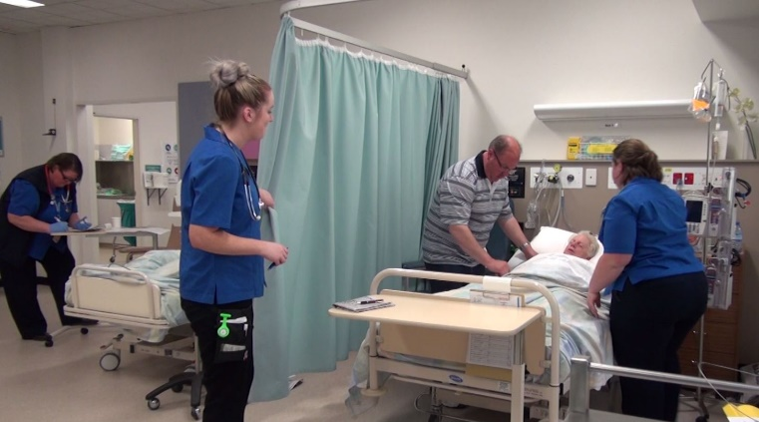

Recent Publications (minimum 5)
- Shinnick, M.A. & Woo, M.A. (2012). The effect of human patient simulation on critical thinking and its predictors in pre-licensure nursing students. Nurse Education Today 33, 1062-1067. DOI: 10.1016/j.nedt.2012.04.004



Biography (150 word limit)

Dr Joanne Porter currently works at the School of Nursing, Midwifery and Healthcare at Federation University Australia, Gippsland campus. Teaching into the undergraduate program, and postgraduate higher Degree supervision. She has worked both in Metropolitan and regional health facilities predominantly in Emergency departments and Intensive care units. Her research interests include, deteriorating patient outcomes, simulation, and emergency care research. Her PhD through Monash University used a mixed methods approach to investigate the affect family presence during resuscitation (FPDR) had on personnel in the emergency department. Joanne currently holds the position of Senior lecturer and has an extensive research history with a number of publications and competitive grants.

Email: joanne.porter@federation.edu.au

Notes/Comments:

