Title: Family Presence During Resuscitation (FPDR): Development of an education training package.
Name and Affiliation Dr Joanne Porter, Nareeda Miller, Anita Giannis and Nicole Coombs: Federation University, Victoria, Australia.

Abstract (300 word limit)

Aim: The aim of this paper is to report and showcase the development of an education training package using video scenarios utilising the acronym ER-DRIP to teach clinicians on how to implement Family presence during resuscitation (FPDR).

Background: The practice of allowing family to be present during resuscitation has been debated in emergency departments since the early 1980’s, with evidence that the practice and implementation of FPDR is inconsistent despite formal endorsement. This study aimed to develop an education package for emergency nurses, paramedics and medical personnel in order to develop competence in the implementation of FPDR.

Method: The acronym ER-DRIP1 (emergency personnel, reassurance, diagnosis, regular up-dates, interventions and prognosis) was developed following a state wide survey2, a period of resuscitation observation and interviews with emergency personnel in Victoria. An education training package was developed, which provides students with a series of videos together with discussion notes which aims to develop the skills necessary to successfully implement FPDR for both paediatric and adult patients. The three scenarios include a paediatric respiratory arrest, a myocardial infarction and a stroke victim.

Results: A total of three scenarios were written and filmed with the use of simulation trained live actors, emergency personnel and paramedics aiming to mimic resuscitation events.

Conclusion: FPDR, although widely endorsed is practiced inconsistently. Additional training and education around the implementation and practice of FPDR was identified as essential, the training package aims to build clinical confidence and competence.

Image

https://youtu.be/F13hM3NS-WA

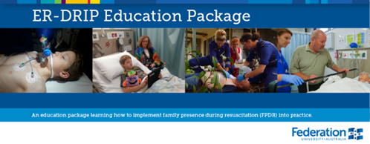

Recent Publications (minimum 5)
- Porter, J. Cooper, S. & Taylor, B. (2014). Emergency Resuscitation team roles: What constitutes a team and who’s looking after the family? Journal of Nursing Education and Practice
- Porter, J. Cooper, S. & Taylor, B. (2013). Family presence during resuscitation (FPDR): A survey of emergency personnel in Victoria, Australia. Australasian Emergency Nursing Journal – AENJ



Biography (150 word limit)

Dr Joanne Porter currently works at the School of Nursing, Midwifery and Healthcare at Federation University Australia, Gippsland campus. Teaching into the undergraduate program, and postgraduate higher Degree supervision. She has worked both in Metropolitan and regional health facilities predominantly in Emergency departments and Intensive care units. Her research interests include, deteriorating patient outcomes, simulation, and emergency care research. Her PhD through Monash University used a mixed methods approach to investigate the affect family presence during resuscitation (FPDR) had on personnel in the emergency department. Joanne currently holds the position of Senior lecturer and has an extensive research history with a number of publications and competitive grants.

Email: joanne.porter@federation.edu.au

Notes/Comments:

