Title: Application of urban clinical practice guidelines to rural settings for Heart Attack Care
Julie Benz RN DNP CNS-BC CCRN APRN Regis University, Denver CO USA and St. Anthony Hospital, Lakewood, CO USA
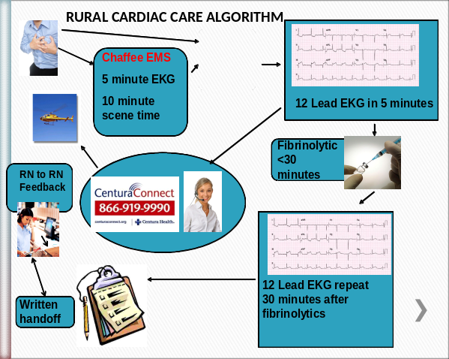

Abstract (300 word limit)
Statement of the problem: Heart attack mortality has dropped in the United States with the employment of interventional cardiology, angioplasty and stent placement. Tertiary Hospitals are set up to accept ST Elevation Myocardial Infarctions (STEMI) patients. Rural Hospitals must transport the STEMI patient for care delivery. Purpose of the study: Rural settings can enhance clinical outcomes for ST Elevation Myocardial Infarctions (STEMI) patients by employing adaptations to the urban setting practice guidelines. The use of pre-planned algorithms and transport access to tertiary care facilities will shorten ischemic times and improve patient outcomes and survival. Methodology: A multi-disciplinary team was developed in a Rural Access Hospital servicing a mountain county in Colorado, USA. Medical record review revealed variance in case interventions and room for growth. An algorithm was developed to reduce process time and keep care on a predetermined track. The medical records for one year prior to the algorithm development were compared to the medical records for one year following the algorithm development. Findings: Three STEMI patients in the control group were compared to seven STEMI patients in the intervention group. The differences between the two means were analyzed with the two-sample t test. The care delivery time was reduced from 288 minutes in 2010, without the algorithm to 150 minutes with the algorithm in 2011. The use of the STEMI transfer checklist went from 0% to 71%, improving care sequencing and handoffs. Conclusions & Significance: The care delivery time was reduced from 288 minutes in 2010, without the algorithm to 150 minutes with the algorithm in 2011, a reduction in 78 minutes of ischemic time for the STEMI patient. The use of the STEMI transfer checklist went from 0% to 71%, improving care sequencing and handoffs.

Image

Recent Publications (minimum 5)
Benz, J. (2016). “High Reliability is Built with Resilience”, A Healthcare Handbook for Patient Safety and Quality, Oster, C and Braaten J. Indianapolis, IN: Sigma Theta Tau International. American Journal of Nursing Book of the Year.
Benz, J. (2016) Perianesthesia “Cardiovascular” Nursing Core Curriculum, Schick L, Windle, PE (3rd Ed) St Louis: Elsevier
Hudak C, Gallo R, & Benz J (1994). “Heart Failure”, “Acute Myocardial Infarction”, “Anatomy and Physiology of the Respiratory System”, “Assessment: Respiratory System”, “Pharmacologic agents”, “Common Pulmonary Disorders”, and “Adult Respiratory Distress Syndrome”, Critical Care Nursing: A Holistic Approach, (6th Ed). Philadelphia JB Lippincott
Hudak C, Gallo R, & Benz J (1986). “Heart Failure”, “Acute Myocardial Infarction”, “Disseminated Intravascular Coagulation Syndrome”, and “Assessment: Respiratory System”. Critical Care Nursing: A Holistic Approach, (5th Ed). Philadelphia: JB Lippincott
Benz J, “Acute Myocardial Infarction” in Critical Care Nursing: A Holistic Approach, ed., Hudak C, Gallo R, & Lohr, R (4th Ed.). (Philadelphia: JB Lippincott, 1982).

Biography (150 word limit)
Julie Benz RN DNP CNS-BC CCRN APRN
I am life long career critical care nurse. I have been a Clinical Nurse Specialist for most of my career: bedside practice, teaching, completing research, coaching, publishing, and in leadership positions. My specialist is Cardiovascular Nursing and Resuscitation such as Code Blue and Rapid Response. I became an RN in 1974, obtained a BSN in 1976, MS in 1978 and DNP in 2012. I have been very active with American Heart Association and served on a Heart Attack Study group for the State of Colorado. I am Joint Appointed Assistant Professor at Regis University and teach undergraduate nursing, I belong to the professional groups of AACN, National Association of Clinical Nurse Specialists, Doctorate of Nursing Practice and Sigma Theta Tau International.
Email: jbenz@regis.edu

