Title: Nursing Students’ Sleep Patterns and Perceptions of Safe Practice
Lois James, PhD, Assistant Professor, Washington State University College of Nursing, USA.

Abstract (300 word limit)

Statement of the Problem: Nursing students make an abrupt transition from traditional classes into clinical rotations and shift work. Understanding student nurses’ initial sleep patterns in response to clinical rotations can yield insights into opportunities for occupational interventions at the university and hospital level. The purpose of this project was to describe students’ sleep patterns and perceptions of safe practice during their first semester of clinical rotations.

Methodology: We measured the sleep of 19 full-time J2 nursing students before, during, and after their first clinical rotations. Sleep was measured objectively using wrist activity monitors (actigraphy) and sleepiness was measured using sleep diaries for seven consecutive days at each time period. During these same time periods we used Bandura’s self-efficacy scales to measure students’ perceptions of safe practice (see figure 1 for a conceptual model of self-efficacy). We then used multi-level-modeling (MLM) to explore associations between students’ sleep, sleepiness, and their perceptions of safe practice.

Findings: Nursing students’ sleep quantity did not differ across time periods, they consistently received approximately 7 hours and 20 minutes per night. The number of students reporting sleepiness however increased from 29% before rotations, to 32% during rotations, to 39% after rotations. Furthermore, students assigned to night shift rotations had lower self-efficacy scores than students assigned to day shift rotations (82% vs. 87%). Finally, within individual students, feeling sleepy significantly predicted lower safe-practice self-efficacy scores (f=42.55; df=1,60; p<.001).

Conclusion & Significance: Our results reveal that sleepiness significantly degrades student confidence in their ability to perform safe nursing practice. Our work addresses a gap in the total worker health (TWH) research by examining a critical period in the professional development of nurses, and helps to guide occupational interventions—particularly those targeted towards reducing nursing student sleepiness.

Image
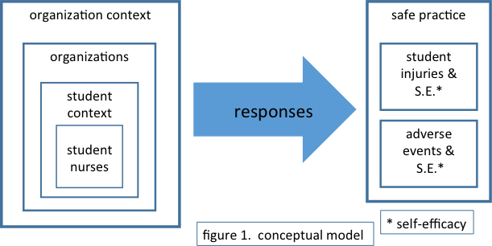

Recent Publications (minimum 5)
- Postma, J., Tuell, E., James, L., Graves, J. M., & Butterfield, P. (2017). Nursing Students’ Perceptions of the Transition to Shift Work: A Total Worker Health Perspective. Workplace Health & Safety, 2165079917719713.
- James, L., Samuels, C., Vincent, F. (2017). Evaluating the effectiveness of fatigue management training to improve police sleep health and wellness: A pilot study. Journal of Occupational and Environmental Medicine, 10.1097/JOM.0000000000001174.
- James, L., James, S., Vila, B. (2017). The Impact of Work Shift and Fatigue on Police Officer Response in Simulated Interactions with Citizens. Journal of Experimental Criminology doi:10.1007/s11292-017-9294-2.
- James, L., Bindler, R., Todak, N., Daratha, K. BMI and daytime sleepiness: The impact of weight status on subjective daytime sleepiness in a sample of school-aged children. Health Behavior and Policy Review, 4(5):446-453 (2017).
5. James, L., Todak, N, Best, S. (2017). The negative impact of prison work on sleep health. American Journal of Industrial Medicine, 60(5):449-456.



Biography (150 word limit)
Dr. Lois James is an Assistant Professor at the WSU College of Nursing. She has a BA in Psychology from Trinity College Dublin, and received her Ph.D. in Criminal Justice from WSU in 2011. During her time at WSU, Dr. James has brought in approximately $3,000,000 of extramural funding as PI or Co-PI. Dr. James focuses on the relationship between sleep, health, and performance in elite populations such as nurses, combat medics, military personnel, police officers, and top tier athletes. Through understanding the prevalence and impact of sleep deprivation and circadian disruption within these populations Dr. James creates fatigue management strategies to help build resilience and reduce the risk of performance deficits and chronic health issues. Examples of these strategies are shift-work related fatigue management plans for police officers and nurses, and jet lag management plans for athletes competing overseas.

Email: Lois_james@wsu.edu

