Title: Evaluating Sleep Hygiene in Military Field Settings
Denise A Smart, DrPH, MPH, BSN, RN, Associate Professor, Washington State University College of Nursing, USA.
Lois James, PhD, Assistant Professor, Washington State University College of Nursing, USA.
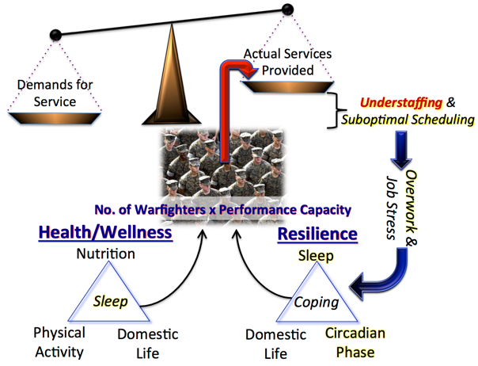

Abstract (300 word limit)

Statement of the Problem: While much is known about the science of sleep, little is known about National Guard medical personnel and their sleep habits. This study explores sleep during the transition from civilian to military duty, and during a training exercise that simulated real-world responses. We examined sleep deprivation in National Guard medical personnel who train and deploy to man-made and natural disasters. The population in this study had dual roles in that they live and work in civilian communities and train and serve for specific military missions when called to respond to disasters that exceed local resources. Our secondary aim was to describe the unique aspects of conducting research in military field settings.

Methodology: A multi-site, longitudinal study using generalized linear mixed models was used to explore the relationship between sleep hygiene, self-reported sleepiness, and any changes in cognitive effectiveness and critical skills performance over the course of the training exercise periods.

Findings: During the transition and disaster exercise period, participants’ sleep quantity dropped significantly from 7.2 hours at baseline to 5.9 hours and cognitive effectiveness dropped from 91% at baseline to 87%. Approximately 1/3 of the sample reported being very sleepy at the beginning of each training day, with 2/3 of the sample experiencing sleepiness by the end of each training day. Sleepiness was associated with decreased performance on critical skills performance over the course of the training exercise periods.

Conclusion & Significance: Conducting research with military medical personnel requires planning, and logistical coordination with contingencies and flexibility of research team. By measuring participant sleep using actigraphy data, sleep diaries, and sleepiness measures we were able to assess the impact of sleep deprivation on participant critical skills performance during the training exercise. Recommendations are made for sleep hygiene and strategies for improving sleep in austere environments.
Image

Figure 1 The theoretical orientation for understanding and managing sleep restriction for optimizing military capacity

Recent Publications (minimum 5)
- Smart, D., Odom-Maryon, T., James, L., Roby, A. (forthcoming) Development of a Critical Skills Assessment for Military Medical Field Settings. Nursing Practice & Research.
- James, L., Samuels, C., Vincent, F. (2017). Evaluating the effectiveness of fatigue management training to improve police sleep health and wellness: A pilot study. Journal of Occupational and Environmental Medicine, 10.1097/JOM.0000000000001174.
- Postma, J., Tuell, E., James, L., Graves, J. M., & Butterfield, P. (2017). Nursing Students’ Perceptions of the Transition to Shift Work: A Total Worker Health Perspective. Workplace Health & Safety, 2165079917719713.
- James, L., James, S., Vila, B. (2017). The Impact of Work Shift and Fatigue on Police Officer Response in Simulated Interactions with Citizens. Journal of Experimental Criminology doi:10.1007/s11292-017-9294-2.
5. James, L., Todak, N, Best, S. (2017). The negative impact of prison work on sleep health. American Journal of Industrial Medicine, 60(5):449-456.




Biography
Denise Smart has her expertise in military population health and occupational health. Her focus is on workplace safety during training and real-world military disaster responses for National Guard medical personnel. She has over 22 years as a Navy nurse and Public Health officer for the Air National Guard before retiring in 2012. She has been working closely with Dr. Lois James (Co-Investigator) on this two-year research project. Dr. James is an expert on sleep, circadian disruption, and fatigue. She has published sleep research on multiple populations, including nurses, police officers, correction workers, athletes, and military personnel. Dr. James creates fatigue management strategies to help build resilience and reduce the risk of performance deficits and chronic health issues. Examples of these strategies are shift-work related fatigue management plans for police officers and nurses, and jet lag management plans for athletes competing overseas.
Email: dsmart@wsu.edu Lois_james@wsu.edu

Notes/Comments:

