Title: Geriatric Outreach and Training with Care (GOT Care!): An Interprofessional Solution to Enhance Training for the Healthcare Workforce and Improve Outcomes for Vulnerable Older Adults
Name and Affiliation: Millicent M. Malcolm, DNP, GNP-BC, AGPCNP-BC, APRN, FAANP (University of Connecticut, USA)

Abstract (300 word limit)
Geriatric Outreach and Training with Care (GOT Care!), propelled with national grant funding, enhanced training for the geriatric workforce and improve outcomes for older adults. This academic-community partnership included geriatric faculty experts from nursing, medicine, dental medicine, pharmacy, physical therapy, social work, and public health. The team trained healthcare students for culturally sensitive, evidenced-based interprofessional geriatric care. The faculty-student team participated in a home visit outreach program to improve outcomes for older adults with multiple chronic conditions and high emergency department (ED) use. Using a comprehensive geriatric assessment, the team identified risk factors for hospitalization and made recommendations to primary care providers. This innovative quality improvement project, resulted in positive outcomes for students, faculty, patients and primary care providers. Interprofessional students (N=264) were trained together and data was collected using the Collaborative Practice Assessment Tool. A statistically significant increase (p<.000) in student pre and post scores were found in the community linkages, coordination of care, communication, and information exchange subscales. Contextual data revealed: a) mutual respect for team members, b) open dialogue and communication among disciplines, c) patient centered focus, d) strong desire for collaboration, e) members are given an active role, f) promotion of interprofessional care at post-conference discussions, and g) networking with agencies. The effectiveness of this project for older adults (N=60) followed the Institute of Medicine Triple Aim parameters. Data were collected with a mixed methods approach using PROMIS Global Health 10, the Modified Healthcare Effectiveness Data and Information Set (HEDIS) and an in-person interview. Results indicate GOT! Care to be cost-effective geriatric training program focusing on quality care and improved health for the older adults served, with high levels of satisfaction and decreased ED visits among the GOT! Care patients.

Image
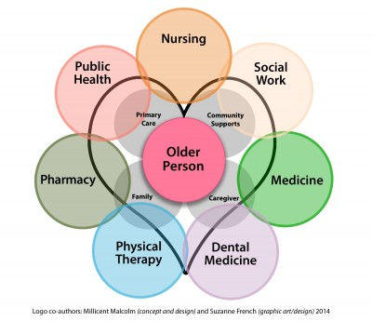
Recent Publications (minimum 5)

Malcolm, M. (2010) "Prevention of iatrogenic suffering in the elderly: Reducing inappropriate prescribing of medications with an evidence-based knowledge transfer project.” DoctoralDissertations.AAI3429225.
http://digitalcommons.uconn.edu/dissertations/AAI3429225

Malcolm, M. (2015). GOT Care! Interprofessional Practice Model. http://gotcare.uconn.edu/geriatric-outreach-and-training-with-care-got-care-interprofessional-practice-model/

Malcolm, M., Shellman, J., Elwell, J., & Rees, C. (Feb 20, 2017) Preparing the Geriatric Workforce for InterprofessionalCollaborative Practice. Health and Interprofessional Practice, 3(2), e1116, 1-12.

Malcolm, M., Shellman, & Rees, C. (March 18, 2017). Innovation for geriatric care with an academic-practice model. Geriatric Nursing, 38(2).

Shellman, J., Malcolm, M., & Cave, J.(Nov, 2015). GOT CARE! AN INTERDISCIPLINARY GERIATRIC OUTREACH AND TRAINING PROGRAM Poster Presentation at The Gerontological Society of America 68th Annual Scientific Meeting. The Gerontologist,55:supplement 2; 48-49.

Manuscripts Under Review:

Schain, A., Rees, C, Medina, C., Eyler, R., Glenney, S., Rodko, E., Cassese, J., Shellman, J., Malcolm, M. (Submitted June, 2017) Reducing Risks for Older Adults with an Interprofessional Community-Academic Partnership: A Case Study Exemplar. Home Health Care.

Shellman, J., Malcolm, M., LeClaire, A., Cave, J. (Submitted June 2017) Title: GOT Care!: Student, Patient, and Provider Perceptions of an Interprofessional Geriatric Education and Outreach Program. Journal of Interprofessional Education & Practice.

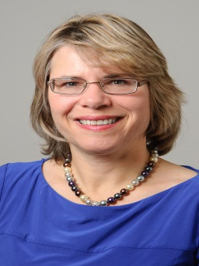
I am pending and appointment for a new head shot and will forward that if accepted
Biography (150 word limit)
Millicent M Malcolm, DNP, GNP-BS, AGPCNP-BC, APRN, FAANP, is an Assistant Clinical Professor at the University of Connecticut School of Nursing. She was the Primary Investigator for Geriatric Outreach and Training with Care (GOT Care!), a 3 year/1.4 mil government funded interprofessional Training and Outreach Project. This project showed promise for interprofessional collaborative education and practice as a means to improve vulnerable patient outcomes. Dr Malcolm has been a specialist in the care of older adults for over 30 years, board certified as a Gerontological Nurse Practitioner for the past 18 years. Dr.Malcolm’s clinical practice focuses on home visits for frail older adults. Her research interests include interprofessional training and practice, and reducing risks and preventing iatrogenic suffering for older adults. Dr. Malcolm was awarded the Connecticut Nurse Practitioner of the Year in 2015, and was inducted into the Fellows of the American Association of Nurse Practitioners in 2016.

Email: Millicent.Malcolm@uconn.edu

Notes/Comments:

