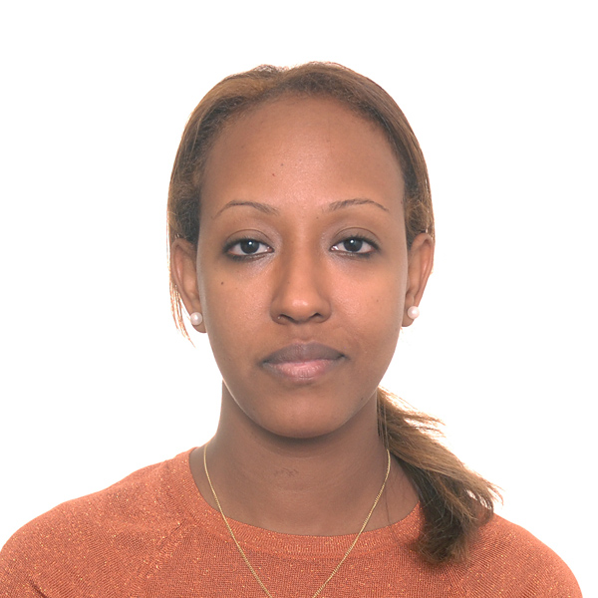

Title: Perceptions of Nursing Care to Promote Self-Management in Chronic Kidney Disease
Rahel Bahru, RN,BN,MScA(N)
Advisors: Dr. Margaret Purden, N., Ph.D.
Margaret Kerr, N, B.Sc.N
Hemodialysis Unit, St. Mary’s Hospital Center
Ingram School of Nursing, McGill University, 845 Sherbrooke W,
Montreal, QC H3A 0G4, Canada

Hemodialysis patients often deal with complex lifestyle changes such as diet and fluid restrictions that may alter their physical and emotional well-being. Nurses play an important role in promoting self-management and assisting patients to cope with these changes. Purpose: To explore hemodialysis patients’ perspectives of nursing care that enables or hinders their ability to manage their illness. Methods: A qualitative descriptive design was used. Six male and three female hemodialysis patients were interviewed during their outpatient dialysis treatment at a university affiliated hospital. Result: Three major themes emerged: 1) What it means to live with chronic kidney disease 2) Managing the illness and treatment regimen, and 3) Nature of the therapeutic relationship with nurses to promote self-management. Patients’ narratives also revealed six important features of the nurse-patient relationship. Conclusion: Patients identified the nurse’s friendly demeanour and being patient-centered as care that assisted them to self-manage. These findings underscore the importance of creating a nurturing and supportive environment, and focusing on patients’ individual needs. Reflective practice may be a helpful strategy to assist the nurse to consider the interpersonal aspect of the nurse-patient relationship. The nurse’s use of motivational interviewing may help to gain the patients’ perspective and engage them in their care.

Biography: Rahel Bahru has completed her masters of applied science in nursing at the age of 32 years from Ingram School of Nursing, McGill University. She has completed this qualitative research project as part of her nursing master’s programme and presented it at nursing exploration conference in Montreal on October, 2015. She currently works at Scripps Health, San Diego, CA in cardiac catheterization lab. She has done one poster presentation and involved in other health care quality improvement projects.
Presenting author details
Full name: Rahel Bahru
Contact number: 207 242 0013
Linked In account:

www.linkedin.com/in/rahel-bahru-08797236

Category: Poster Presentation

