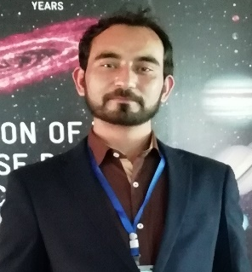
Title: Impact of Training in Clinical Sample Handling and Infection Control Practices among Nurses and other Allied Health Staffs
Name: Muhammad Aslam
University of Health Sciences, Lahore Punjab 5400
University of Health Sciences (UHS) in collaboration with Irish Government initiated the training program to strengthen the government hospital of Punjab Province. It is the largest province of Pakistan, and the initial focus was on the 40 hospitals. Out of 25 training programs our focus was on the phlebotomy, safe handling of clinical specimen, quality management (lab) and infection control. It covered around 5500 hospital staffs including doctors, nurses, medical technologists and technicians. Majority of the participants were nurses which ensure these services in government hospitals. GAP analysis in respective areas was conducted. Initial practices in these hospitals were fragmented and different across different settings of Punjab. The use of EDTA vial alone in blood sample collection, wage quality management of labs and undefined pre-analytical stage of sampling were some of the practices. Infection control practices was much improved but set procedures to respond in emergencies of needle stick and biological spills were unclear. The phlebotomy aspect improved the blood collection practices and the selection of different vacutainer according to the tests. Safe handling focused on improving the pre-analytical phase of clinical sampling, adopting uniform labelling criteria across these hospitals which is improving the therapeutic outcomes. Other aspect was to encourage the need for quality program and adopting healthcare related softwares to increase accuracy in reporting and external quality assurance program. The infection control practices strengthen the nurses and other allied health staffs to respond accordingly in emergency situations.
Biography
Muhammad Aslam is working as Researcher at National Institute of Biotechnology and Genetic Engineering (NIBGE) Faisalabad. He is affiliated with UHS Lahore and working as an Instructor to various hospitals of Punjab Government. He is also a Master Trainer at Pakistan Biological Safety Association (PBSA), an organization strengthening biosafety culture in Pakistan. He is member of Young Parliamentarian Pakistan-Gilgit Baltistan.
Presenting author details
Full Name: Muhammad Aslam
Contact number: +92-332-3418008
Twitter account: https://twitter.com/m_aslam008
LinkedIn account: https://www.linkedin.com/in/muhammad-aslam-0161a967/
Category: Oral Presentation.

