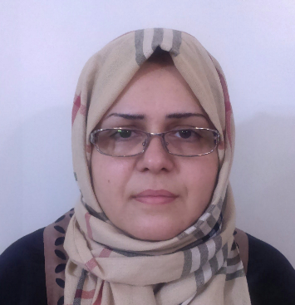

Morphology control of conducting polymer nanostructures in the emulsion polymerization

Name: Malihe Pishvaei
Department of Resin and Additives, Institute for Color Science and Technology, P.O. Box 16765-654, Tehran, Iran

Conducting polymer nanostructures with specific morphology were successfully synthesized using a simple emulsion polymerization procedure without hard templates or any special device (such as electrochemical cell). Chemical oxidative polymerization of monomers was performed in the presence of cetyl trimethylammonium bromide or sodium dodecyl sulfate as surfactants. Hydrochloric acid was used as dopant, and a solution of potassium peroxydisulfate was used as initiator. In the case of micellar nucleation, the micelles had a significant role (as soft template) on the final shape of particles. By using CTAB instead of SDS, fibrillar morphology of polymer particles was obtained. Besides the surfactant type, reaction parameters including feeding strategy and reaction temperature resulted in products with specific morphologies. In the case of micellar nucleation, by decreasing reaction temperature from 40 ○C down to 0 ○C, the morphology of resulted particles changed from spherical to fibrillar. Moreover, by using semibatch feeding system, nanostructured polymers with uniform morphology and relatively high conductivity were obtained whereas by using batch procedure, the morphology of resulted polymer particles became un-uniform with lower conductivity.

Biography

Malihe Pishvaei has completed her PhD in 2005 from Université Claude Bernard Lyon1, Lyon, FRANCE. She is assistant professor in Institute for Color Science and Technology, Tehran, Iran. She has published more than 23 papers in reputed journals. Her research interests are including emulsion and miniemulsion polymerization (waterborne resin, nanocomposite materials…) and rheology of polymeric compounds and materials.

Presenting author details
Full name: Malihe Pishvaei
Contact number: +98(0)9128070458
Twitter account:
Linked In account: Malihe Pishvaei
Session name/ number: Plenary speaker
Category: (Oral presentation/ Poster presentation)

