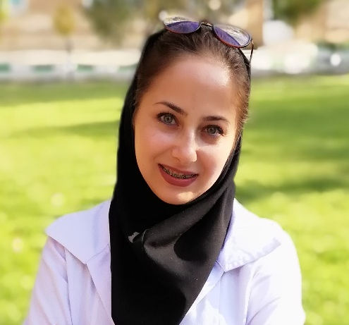


Nano-liposomal Galbanic acid in combination with Doxil® as a novel promising therapy for colon carcinoma
Maryam Ebrahimi Nik^{1,2}, Bijan Malaekeh-Nikouei^{3*}, Mehrdad Iranshahi⁴, Mahmoud Reza Jaafari^{3,5**}
¹ Nanotechnology Research Center, BuAli Research Institute, School of Pharmacy, Mashhad University of Medical Sciences, Mashhad, Iran.
² Student Research Committee, Mashhad University of Medical Sciences, Mashhad, Iran
³Nanotechnology Research Center, Institute of Pharmaceutical Technology, Mashhad University of Medical Sciences, Mashhad, Iran
⁴ Biotechnology Research Center, School of Pharmacy, Mashhad University of Medical Sciences, Mashhad, Iran
⁵Biotechnology Research Center, Nanotechnology Research Center, School of Pharmacy, Mashhad University of Medical Sciences, Mashhad, Iran
*Correspondence to: Prof. B. Malaekeh-Nikouei School of Pharmacy, Mashhad University of Medical Sciences, P.O. Box 91775-1365, Mashhad, Iran. Phone: 98 513 8823255, Fax: 98 513 8823251, E-mail: Malaekehb@mums.ac.ir

**Correspondence to: Prof. M.R. Jaafari, Biotechnology Research Center, Nanotechnology Research Center, School of Pharmacy, Mashhad University of Medical Sciences, Mashhad 91775-1365, Iran. Tel: +989153164001; E-mail: Jafarimr@mums.ac.ir

⁷Both authors contributed equally to this work.

Galbanic acid (GBA) is a sesquiterpene coumarin with anti-angiogenic and anti-cancer activities. Although GBA has many biological and medical properties, it has limited in vivo bioavailability due to poor water solubility. Nano-liposomal drug delivery system is one of the approaches that can overcome the solubility problem. The liposome formulation containing HSPC/ Cholesterol and MPEG2000-DSPE/ with a molar ratio of 55: 40: 5, respectively, was prepared by remote loading using calcium acetate gradient method. Physical characterization of liposomes was determined using dynamic light scattering (DLS), transmission electron microscope (TEM) and atomic force microscopy (AFM). The cytotoxicity of liposomal GBA against C-26 colorectal cancer and NIH-3T3 cell lines was evaluated in vitro by MTT assay. Furthermore, the antitumor therapeutic responses were studied on the mice bearing C26 colon carcinoma tumors. Observed results indicated that liposomal GBA with mean diameter of 102.5 ± 1.5 nm and polydispersity index of 0.143± 0.04 could effectively encapsulate GBA with an encapsulation efficacy of more than 75 %. In addition, cell proliferation was inhibited with about 25 ± 1.2 µM and 68 ± 1.8 µM of liposomal GBA in C-26 colorectal cancer and NIH-3T3 cell lines, respectively (P˂0.001). In vivo study showed that the lowest tumor volumes, highest time to reach end points (TTE: 44.5 ± 11.3 days) and tumor growth delay percent (TGD: 71.2%) were seen in mice that received combination of liposomal GBA and Doxil®, than whose received just Doxil® (TTE: 34.8 ± 2.2 days, TGD: 33.9%). In conclusion, tumor accumulation and therapeutic efficacy of Doxil® might be improved by using multiple administration of liposomal GBA.
Keywords: Galbanic acid, Nano-liposome, Combination cancer therapy

Biography
Maryam Ebrahimi Nik received her Doctorate of Veterinary Medicine (DVM) degree from Ferdowsi University Of Mashhad, Iran in 2014. She is currently a PhD. Candidate of Nanotechnology at Mashhad University Of Medical Sciences, Iran. Her professional interests focus on targeted drug delivery systems, liposome, anti-angiogenesis cancer therapy, animal study and nanomedicine, just to name a few. In recent years she have extensively worked in several projects on cancer therapy through targeted drug delivery systems, combination therapy and anti-angiogenic therapy, which results has published in reputed journals and conference presentations. Also, she has over 3 years experiences as an operation manager DLS (Dynamic light scattering) device. Currently, her project include “Preparation, characterization and antitumor effects of RGD targeted nanoliposomes containing galbanic acid on colon carcinoma”.

Presenting author details
Full name: Maryam Ebrahimi Nik
Contact number: +989388155572
Session name/ number: Pharmaceutical Nanotechnology
Category: Oral presentation

