Selective metabolic blackout in hepatocellular carcinoma cells by submiromolar iodoacetate loaded glactocylated nanoparticles
Ahmed A. Abd-Rabou, Asmaa M. Reda,#, Abdel-Rahman M. Khalifa, and Sameh S. Ali*, Egypt

Abstract
Targeting characteristic modes of metabolic pathways to drain bioenergetics in cancer cells has recently gained attention. However, to increase the potential of such strategy, drugs for metabolic interventions must be drastic inhibitors of all metabolic modes in cancer cell subpopulations, and more importantly, be targeting malignant cells selectively.We exploited enhanced expression of the asialoglycoprotein receptors on human hepatocellular carcinoma HepG2 cell membrane for specific delivery of an effective metabolic inhibitor loaded in nanoparticles conjugated with galactosylated chains as recognition termini. Submicromoles of iodoacetate-loaded nanoparticles (NIA) were sufficient to completely disrupt glycolytic as well as mitochondrial metabolism, resulting in substantial cytotoxicity of HepG2 cells within 4 h. To identify the mechanism of cell death by NIA, we carried out extensive metabolic investigations on substrate utilizations and mitochondria stress in intact-attached or permeabilized-suspended HepG2 cells as well as on freshly-isolated rat liver mitochondria. Metabolic, flow cytometric, and molecular studies provided converging evidence that NIA triggers cell death through ROS-mediated apoptosis induction concomitant with bioenergetic deprivation. Interestingly, NIA-induced metabolic inhibition, ROS levels and cytotoxicity in baby hamster kidney cells BHK-21 were significantly reduced relative to HepG2, which highlights lower uptake of NIA by normal cells and their mitochondria as confirmed by imaging studies. Overall, our results revealing the ability of relatively low NIA concentrations to completely disrupt various metabolic pathways that are crucial for proliferating as well as resilient cancer cells provide a new window on liver cancer treatment via targeted metabolic interventions.

Image
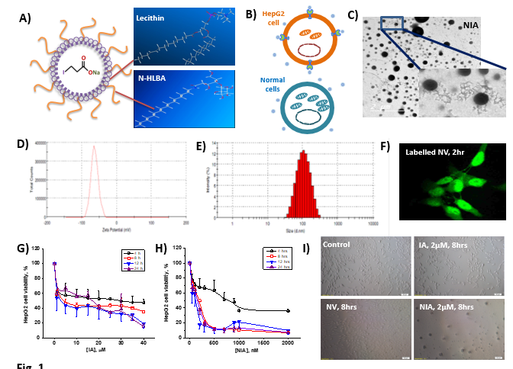

Recent Publications (minimum 5)

- El-Balshy, R.M. ; Abdel Hady, S.I. ; El-Hady, M.M ; and Asmaa.M.Reda:. Embryonic developmental study on eye of Columba livia. Bull.Fac.Sci-Zagazig Univ.32(2010).
- Asmaa.M.Reda. Reconstruction of columba livia chondrocraninum: Embryological and histolgogical study.1st ed. Germany. LAP LAMPERT Academic publishing.2012.print.
- Alaa Refaat ; Ahmed A. Abd-Rabou and Asmaa M. Reda : TRAIL Combinations: The new ‘trail’ for cancer therapy. Oncology Letters, (2014).
- From human mesenchymal stem cells to insulin-producing cells: comparison between bone marrow and adipose tissue-derived cells. Mahmoud M. Gabr, Mahmoud M. Zakaria, Ayman F. Refaie, Engy A. Abdel-Rahman, Asmaa M. Reda, Sameh S. Ali, Sherry M. Khater, Sylvia A. Ashamallah, Amani M. Ismail, Hossam El-Din A. Ismail, Nagwa El-Badri, and Mohamed A. Ghoneim. BioMed Research International.Volume 2017 (2017), Article ID 3854232, 9 pages.
- Effect of Plasma Activated Mist on Breast Cancer Cells. Mohamed A. El Shaer, Ahmed M. Zaki, Asmaa M. Reda, Mohamed A. Hamid, Mona K. Mobasher, Sameh S. Ali. IEEE Transactions on Radiation and Plasma Medical Sciences. (2017). DOI: 10.1109/TRPMS.2017.2754580



Asmaa M. Reda is currently a Ph.D. scholar at Zewail City of Science and Technology and Assistant lecturer at Faculty of Science, Benha University.
Asmaa received her Bachelor of Science degree “Excellent with honors” from Faculty of Science, Benha university. She received her Master of Science degree and published 6 peer reviewed articles. She pursued her academic career at Zewail City of Science and Technology as a Ph.D. scholar in the field of Molecular Cancer cell biology. She is qualified in cell culture techniques, Flow cytometry, imaging by fluorescence and confocal microscopy, molecular biology techniques like western blot and qRT-PCR. Furthermore, she has perfect experience in dealing with different metabolic approaches using oroborus “oxygen flux analyser” and monitoring glycolysis, mitochondrial respiration and fatty acid oxidation by Seahorse XF analyzer.
Email: areda@zewailcity.edu.eg
Phone: +20106284 6004

