Carbon nanotubes grown in situ on graphene nanosheets as efficient sulfur host for lithium-sulfur batteries
Zhen Wu and Yongsheng Fu, NNSF Foundation, China

Abstract
Lithium–sulfur (Li-S) batteries have been considered as a promising candidate for next-generation electrochemical energy-storage technologies because of their overwhelming advantages in energy density^{[1,2]}. Suppression of the polysulfide dissolution while maintaining a high sulfur utilization is the main challenge for Li–S batteries^{[3-5]}. Here, we have designed and synthesized carbon nanotubes grown in situ on graphene nanosheets (GN@CNTs) by mixing graphene oxide with dimethylimidazole and cobalt nitrate as a conceptually new sulfur host for Li–S batteries. Specifcally, GN@CNTs with stable in-situ structures and nitrogen doping, not only enhance the performance of rapid charge transfer, but also provide sufficient self-functionalized surfaces for chemically bonding with polysulfides to suppress their outward dissolution. As a result, the GN@CNTs /S composite cathode material remains a high discharge capacity of 394 mAh g⁻¹ after 700 cycles at a current density of 1 C (based on the mass of sulfur); this corresponds to a good capacity retention of 53.6% and capacity fading rate of 0.066% per cycle.
Image
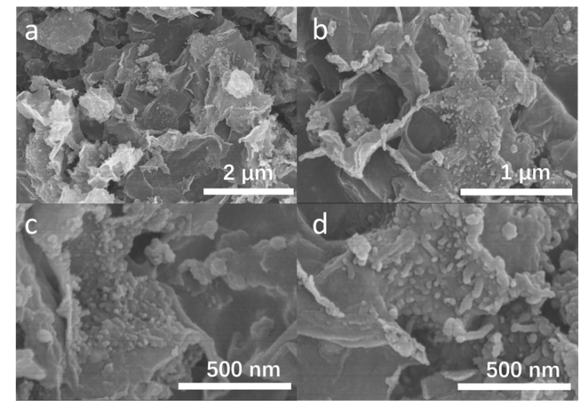
Figure 1. a,b,c,d SEM images of GN@CNTs.

Recent Publications
- Bruce PG, Freunberger SA, Hardwick LJ, Tarascon JM (2012) Li-O2 and Li-S batteries with high energy storage. Nature materials 11(1), 19-29. 11: 19–29.
- Zhou G, Li L, Ma C, Wang S, Shi Y, Koratkar N, Ren W, Li F, Cheng HM (2015) A graphene foam electrode with high sulfur loading for flexible and high energy Li-S batteries. Nano Energy 11: 356–365.
- Ji X, Nazar LF (2010) Advances in Li–S batteries, Advances in Li–S batteries. Journal of Materials Chemistry 20: 9821–9826.
- Mikhaylik YV, Akridge JR (2004) Polysulfide shuttle study in the Li/S battery system. Journal of the Electrochemical Society 151: A1969-A1976.
- Aurbach D, Pollak E, Elazari R, Elazari R., Salitra G., Kelley CS, Affinito, J (2009) On the surface chemical aspects of very high energy density, rechargeable Li–sulfur batteries. Journal of The Electrochemical Society 156: A694-A702.

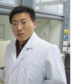 Biography
Yongsheng Fu received his B.S. and M.S. in chemistry from Shenyasng Normal University and Changzhou University, respectively, and his Ph.D. in materials science in 2013 from Nanjing University of Science & Technology. In 2015, he became a Professor at Nanjing University of Science & Technology. His current research interests include energy conversion and storage, advanced battery materials, and photoelectrochemistry.
Email: fuyongsheng0925@163.com
Phone: +86-25-84315054

