Status and Prospect of Al alloys for Additive Manufacturing
,
Srdjan Milenkovic, PhD, IMDEA Materials Institute, Spain Arturo Martin PhD, IMDEA Materials Institute, Spain
C. Cepeda-Jimenez, PhD, IMDEA Materials Institute, Spain
Teresa Perez-Prado, PhD, IMDEA Materials Institute, Spain

Abstract

Additive Manufacturing technology is being adopted in more and more industries and the focus of research and development is shifting to the materials in use. However, limited processability of high-performance Al alloys restrict the robustness of the process in some cases, while in other cases the best Al alloys for a given application cannot be processed at all. Currently only a few alloys can be reliably processed by this methodology, and in particular the number of different aluminium alloys available for AM is still rather limited. The main reason is that the strongest Al alloys, which get their strength from precipitation hardening, contain highly volatile elements such as Zn, Mg, etc. leading to turbulent pools, pores and low mechanical properties. In the first part, this talk will review the current state of the art of the Al alloys for AM. In the second part, the latest research on development of the innovative aluminium alloy specifically designed for SLM will be described. Two different approaches will be presented: on one hand, on tailoring the chemical composition to improve processability, specifically crack susceptibility of wrought aluminium alloys of the 7xxx series (Al-Zn alloys) and on the other, to increase mechanical resistance of weldable casting grade AlSi10Mg alloy. A special emphasis will be placed on powder production by gas atomization as a first and an important step in alloy development for additive manufacturing. It will be shown how the desirable compositions can be achieved and what are the main challenges faced. Also the properties of the powders will be assesed and processability by SLM demonstrated. Finally, the properties of the new alloys will be presented and compared with the traditional ones
Image

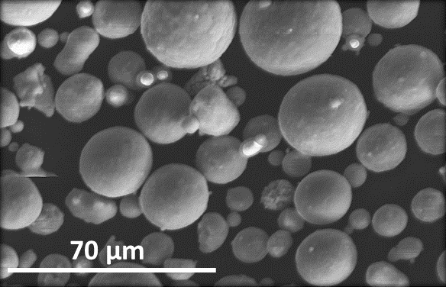  Figure 1. Highly spherical powder of an Al alloy | 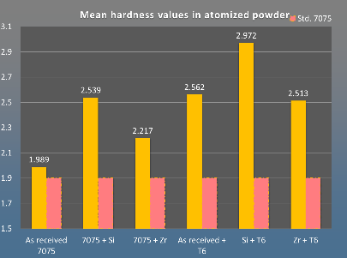  Figure.2 Hardness of the produced powders

Recent Publications (minimum 5)
- Martín A, San Sebastián M, Gil E, Wang CY, Milenkovic S, Pérez-Prado MT, Cepeda-Jiménez CM (2021) Influence of the Zr content on the processability of a high strength Al-Zn-Mg-Cu-Zr alloy by laser powder bed fusion. Materials Characterization, 182: 11513
- Martín A., San Sebastián M., Gil E., Wang C.Y., Milenkovic S., Pérez-Prado M.T., Cepeda-Jiménez C.M., (2021) Effect of the heat treatment on the microstructure and hardness evolution of an AlSi10MgCu alloy designed for laser powder bed fusion. Materials Science and Engineering A, 819 141487 (1-12).
- Galera-Rueda C, Montero-Sistiaga M, Vanmeensel K, Godino-Martínez M, Llorca J, Pérez-Prado MT, Milenkovic S. (2021) Icosahedral quasicrystal enhanced nucleation in Al alloys fabricated by selective laser melting. Additive Manufacturing, 44: 102053.
- Galera-Rueda C, Nieto-Valeiras E, Gardon M. Pérez-Prado MT, Llorca J (2021) Effect of ZrH₂ particles on the microstructure and mechanical properties of IN718 manufactured by selective laser melting. Materials Science and Engineering A, 813: 1-11.
- Requena G, Bugelnig K, Sket F, Milenkovic S, Roedler G, Weisheit A, Gussone J, Haubrich J, Barriobero-Vila P, Pusztai T, Gránásy L, Theofilatos A, Da Silva JC, Hecht U (2020) Ultrafine Fe-Fe₂Ti eutectics by directed energy deposition: Insights into microstructure formation based on experimental techniques and phase field modelling, Additive Manufacturing, 33: 101133.


Biography
Having obtained a PhD in 2002 from the State University of Campinas, Brazil Dr, Srdjan Milenkovic joined the department of Materials Technology at the Max-Planck-Institute for Iron Research (MPIE) in Düsseldorf, Germany, as a research associate. Since March 2011, appointed as a head of the Solidification Processing and Engineering group at the IMDEA Materials Institute. His research expertise includes advanced solidification processing techniques with special emphasis on gas atomization of powders for additive manufacturing and development of novel high-throughput casting methods. Publication record: published over 60 papers in JCR journals, among which two in Nano Letters with impact factor >10. Email: Srdjan.milenkovic@imdea.org

