Thermomechanical and Thermoresponsive Reactions in Shape Memory Alloys
Osman Adiguzel, Firat University, Department of Physics, Elazig, Turkey

Abstract
Shape memory alloys take place in a class of adaptive structural materials called intelligent or smart materials by giving stimulus response to changes in the external conditions. These alloys exhibit dual characteristics, shape memory effect (SME) and superelasticity (SE) with the recoverability of two certain shapes at different conditions. These alloys are functional materials with these properties and used as shape memory elements in many interdisciplinary fields such as medicine, pharmacy, bioengineering, metallurgy. Shape memory effect is initiated thermomechanical treatments by cooling and deformation and performed thermally on heating and cooling. Deformation in low temperature condition is plastic deformation, with which strain energy is stored in the materials and released on heating by recovering the original shape. This phenomenon is based on martensitic transformation, which is a solid-state phase transformation and governed by the remarkable changes in internal crystalline structure of materials. With the thermomechanical treatment, ordered parent phase structures turn into the twinned martensite structures along with lattice twinning, by means of thermal induced martensitic transformation on cooling, and twinned structures turn into detwinned martensite structures by means of stress induced martensitic transformations with deformation. On heating after these treatments, detwinned martensite structures turn into the ordered parent phase structures, by means reverse austenitic structures. Thermal induced martensitic transformations occur on cooling with cooperative movement of atoms in <110 > -type directions on a {110} - type plane of austenite matrix which is basal plane of martensite. Superelasticity is performed in only mechanical manner by stressing the material and releasing in the parent austenite phase region, by recovering the original shape. Superelasticity is also result of stress induced martensitic transformation, with which the ordered parent phase structures turn into the detwinned martensite structures. Superelasticity is performed in non-linear way, unlike normal elastic materials behavior, loading and releasing paths are different, and cycling loop refers to the energy dissipation. The strain energy is stored after releasing, and these alloys are mainly used as deformation absorbent materials in control of civil structures subjected to seismic events, due to the absorbance of strain energy.
Copper based alloys exhibit this property in metastable beta-phase region. Lattice invariant shear and twinning is not uniform in copper-based alloys and cause the formation of unusual complex layered structures.
In the present contribution, x-ray diffraction and transmission electron microscopy (TEM) studies were carried out on two copper based CuZnAl and CuAlMn alloys. X-ray diffraction profiles and electron diffraction patterns reveal that both alloys exhibit super lattice reflections inherited from parent phase due to the displacive character of martensitic transformation.
Keywords: Shape memory effect, martensitic transformation, thermoelasticity, superelasticity, twinning, detwinning.

Recent Publications

- O. Adiguzel, Phase Transitions and Microstructural Processes in Shape Memory Alloys, Materials Science Forum Vol. 762 (2013) pp 483-486, (2013) Trans Tech Publications, Switzerland
- O. Adiguzel, Self-accommodating Nature of Martensite Formation in Shape Memory Alloys, Solid State Phenomena Vol. 213 (2014) pp 114-118, © (2014) Trans Tech Publications,
- O. Adiguzel, Nanoscale Aspects of Phase Transitions in Copper Based Shape Memory Alloys, Nanotechnology in the Security Systems, NATO Science for Peace and Security Series C: Environmental Security 2015, pp. 131-134
- O. Adiguzel, Phase Transitions and Elementary Processes in Shape Memory Alloys, Advanced Materials Research Vol. 1101 (2015) pp 124-128, Trans Tech Publications, Switzerland
- O. Adiguzel, Nano-Scale Mechanisms in the Formation of Displacive Transitions in Shape Memory Alloys, Physics, Chemistry and Applications of Nanostructures - Proceedings of the International Conference Nonmeeting - 2013. Edited by Borisenko Victor E et al. Published by World Scientific Publishing Co. Pte. Ltd
- O. Adiguzel, Ageing dependence and martensite stabilization in copper based shape memory alloys, IOP Conf. Series: Materials Science and Engineering 60 (2014) 012001, Proceedings of International Symposium on Advanced Materials (ISAM2013), 23-27, September 2013, Islamabad, Pakistan
- O. Adiguzel, Thermoelasticity, Superelasticity and Nanoscale Aspects of Structural Transformations in Shape Memory Alloys. In: Struble L., Tebaldi G. (eds) Materials for Sustainable Infrastructure (2018), GeoMEast 2017.Sustainable Civil Infrastructures. Springer,

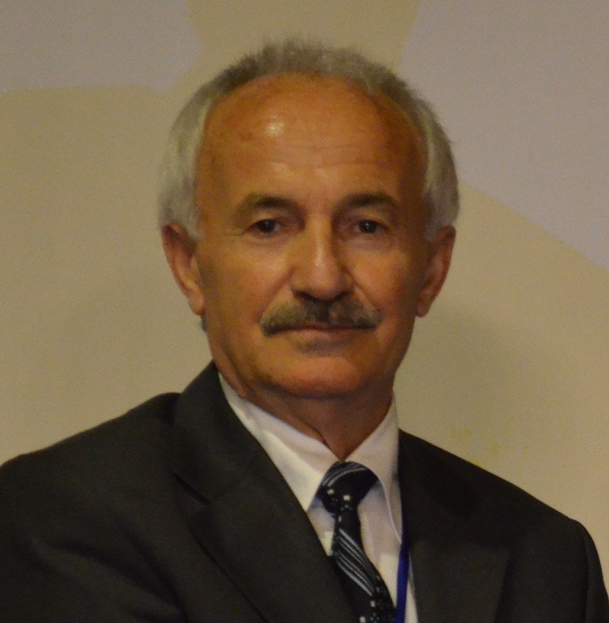 Biography
Dr Adiguzel graduated from Department of Physics, Ankara University, Turkey in 1974 and received PhD- degree from Dicle University, Diyarbakir-Turkey. He has studied at Surrey University, Guildford, UK, as a post-doctoral research scientist in 1986-1987, and studied on shape memory alloys. He worked as research assistant, 1975-80, at Dicle University and shifted to Firat University, Elazig, Turkey in 1980. He became professor in 1996, and he has already been working as professor. He published over 60 papers in international and national journals; He joined over 100 conferences and symposia in international and national level as participant, invited speaker or keynote speaker with contributions of oral or poster. He served the program chair or conference chair/co-chair in some of these activities. In particular, he joined in last seven years (2014 - 2020) over 80 conferences as Keynote Speaker and Conference Co-Chair organized by different companies. He supervised 5 PhD- theses and 3 M.Sc.- theses.
Dr. Adiguzel served his directorate of Graduate School of Natural and Applied Sciences, Firat University, in 1999-2004. He received a certificate awarded to him and his experimental group in recognition of significant contribution of 2 patterns to the Powder Diffraction File – Release 2000. The ICDD (International Centre for Diffraction Data) also appreciates cooperation of his group and interest in Powder Diffraction File.
Email: oadiguzel@firat.edu.tr

