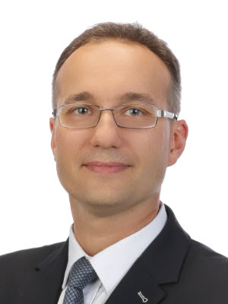
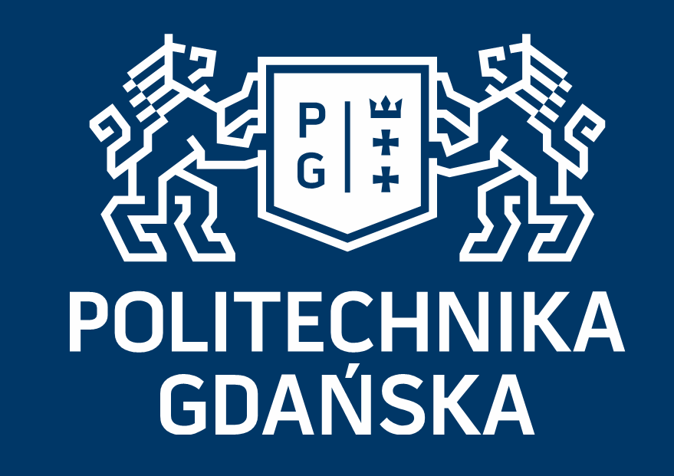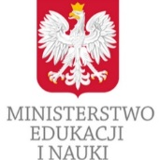
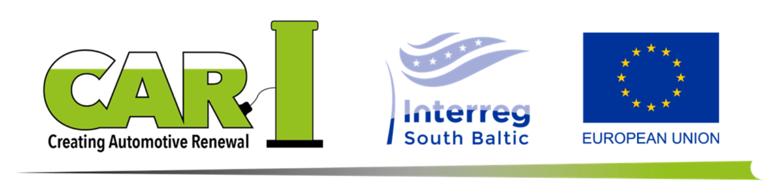

Title: Advances in procurement of direct-recycling materials from lithium-ion batteries
Name: Lukasz Hupka*, Jan Hupka*, Jacek Gebicki*, Mats Larsson^, Kamil Zajaczkowski^

*Gdansk University of Technology, Poland
^ Industrial Development Centre South, Sweden

The Gdansk University of Technology has developed laboratory for testing the amenability of materials obtained from lithium-ion batteries to direct recycling and enrichment. Type of Li-ion batteries, composition, surface development, and material characteristics make the technological indicators for the recycling procedure. The extent of material liberation influences heavily the separators type and the number of necessary upgrading separation stages toward procurement of desired fractions. The procedure developed at the Gdansk Tech allows to decide whether multiplication of unit elements or enlargement of equipment is preferable for the recycling process scale-up.
Our investigation has been completed within the Creating Automotive Renewal (CAR) project which aims at sharing knowledge and promoting electric mobility in the European Union, South Baltic region. Project partners come from Sweden, Denmark, Germany and Poland.

To be presented at the: 28th International Conference on Advanced Materials, July 21-22, 2021, New York

Biography

Lukasz Hupka has completed his PhD in 2008 at the University of Utah. He has over 10 years of semiconductor R&D experience. Currently he is working on Li-ion batteries recycling at the Gdansk University of Technology, Poland. Dr. Hupka is co-inventor of 12 patents, and co-author of 3 books chapters and 13 articles in scientific journals.

