Synthesis of fibrous and non-fibrous mesoporous silica magnetic yolk–shell microspheres for immobilization of Lipase
The mesoporous yolk-shell nanoparticles (MYSNs), with a movable Fe₃O₄ core inside the hollow capsules, with two different morphologies (1)Fe₃O₄@SiO₂@hollow@fibrous SiO₂ (Yolk Shell-1) (2)Fe₃O₄@SiO₂@hollow@mesoporousSiO₂(Yolk Shell-2) were fabricated as carriers for Candida rugosa lipase (CRL) immobilization, through a template-assistant selectively etching method. Firstly the hydrophobic Fe₃O₄ nanoparticles were synthesized according to the solvothermal method. Then, SiO₂ shell was coated on the Fe₃O₄ nanoparticle surface by a sol–gel reaction. Subsequently, the resorcinol farmaldehyde (RF) shell was covered on the surface of as-prepared Fe₃O₄@SiO₂ composites and sandwiched Fe₃O₄@SiO₂@RF composites were formed, which were finally provided with mesoporous fibrous (KCC) in the Yolk Shell-1 and mesoporous Silica in the Yolk Shell-2(non fibrous ). After selectively etching CTAB and the middle RF layer, the two kinds of yolk/shells composites were obtained. By utilization of their large and open mesopores (20-50nm) with good surface area (457.78-625.54 m²/g,) CRL was immobilized after amino functionalization using glutaraldehyde as a linker. The ICRL on Y.S-1, Y.S-2 showed good loaded (797-501 mg/g) and enzyme activity of (1503-837 U/g) respectively, thermal stability, resistance to pH, recycling and storage capacity were improved as compare to free lipase.
Fig.1 Schematic diagrams, showing synthesis of yolk shell-1 and immobilization of lipase
Fig.2 Schematic diagrams, showing synthesis of yolk shell-2 and immobilization of lipase
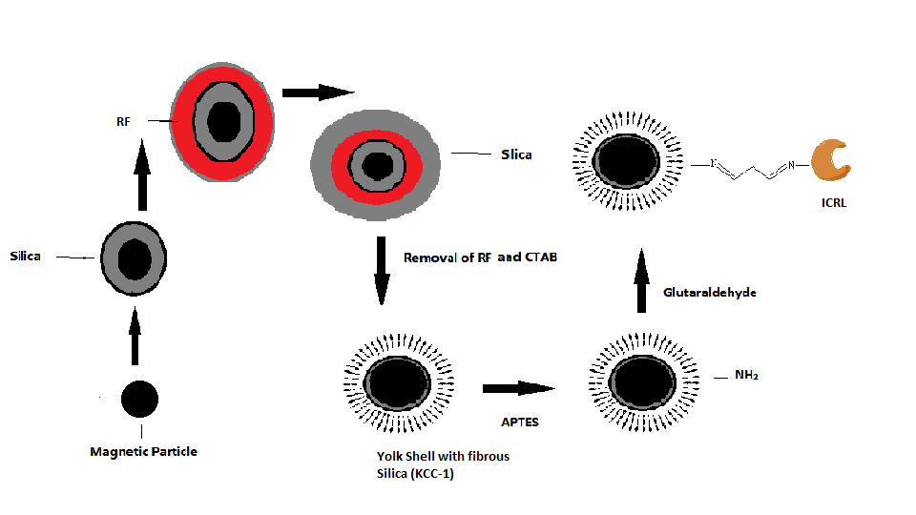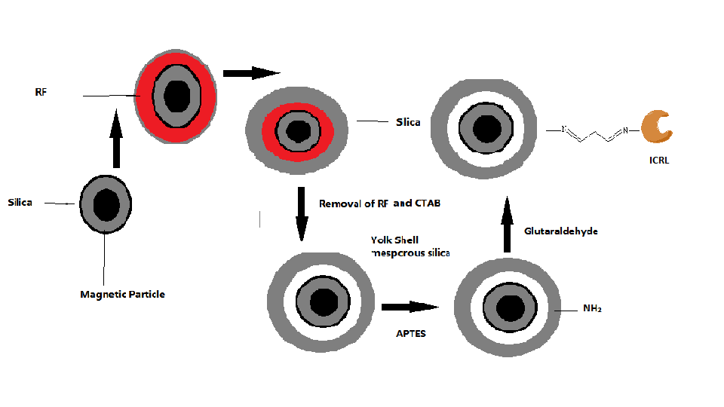
Fig.1 Fig.2

Recent Publications:
- Zafar Ali, Lei Tian, Panpan Zhao, Baoliang Zhang, Nisar Ali, Muhammad Khan,Qiuyu Zhang, Immobilization of lipase on mesoporous silica nanoparticles with hierarchical fibrous pore,Journal of Molecular Catalysis B: Enzymatic 134 (2016) 129135.
- Zafar Ali, Lei Tian, Baoliang Zhang, Nisar Ali, Muhammad Khan, Qiuyu Zhang,Synthesis of fibrous and non-fibrous mesoporous silica magnetic yolk–shell microspheres as recyclable supports for immobilization of Candida rugosa lipase,Enzyme and microbial technology,103,2017,4245.
3 Zafar Ali, Lei Tian, Panpan Zhao, Baoliang Zhang, Ali Nisar, Xiangjie Li, Hepeng Zhang and Qiuyu Zhang.Micron-sized flower-like Fe₃O₄@PGMA magnetic Porous microspheres for lipase immobilization,RSC Adv.,5, 2015, 92449.
- Zafar Ali, Lei Tian, Baoliang Zhang, Nisar Ali, Muhammad khan and Qiuyu Zhang,Synthesis of paramagnetic dendritic silica nanomaterials with fibrous pore structure (Fe₃O₄@KCC-1) and their application inimmobilization of lipase from Candida rugosa with enhanced catalytic activity and stability,New J. Chem., 2017, 41, 8222-8231
- Zafar Ali, Lei Tian, Muhammad khan, Nisar Ali and Qiuyu Zhang, Immobilization of lipase on iron oxide organic/inorganic hybrids particles. Review on advance material science, 53, 2018, 106-117.

 Biography

Dr.Zafar Ali has worked on the immobilization of enzymes. He designed different types of magnetic and nonmagnetic mesoporous composite with different morphologies of nano spheres and microspheres silica materials as carrier for the process of immobilization of lipase. These materials were analyzed for the industrial reactions catalyzed by the lipase. His research work opened new ways for the synthesis of porous materials. The applications of the silica porous materials were expanded. The novel nano/mesoporous material can be utilized in medical and environmental fields of applied sciences.
Email: mrizafar@yahoo.com

