Synergism of Combustion Synthesis, High-Energy Ball Milling and Spark Plasma Sintering for Producing Advanced Materials
Alexander S. Rogachev^{1,2*},Dmitry O. Moskovskikh¹, Andrey A. Nepapushev¹, Sergei G. Vadchenko,² Aleksey Sedegov¹, Nikolay A. Kochetov², and Alexander S. Mukasyan^{1,3}
¹ National University of Science and Technology “MISIS”, Russia
² Merzhanov Institute of Structural Macrokinetics and Materials Science Russian Academy of Sciences (ISMAN), Russia
³ Department of Chemical and Biomolecular Engineering, University of Notre Dame, USA
*Corresponding author, e-mail: rogachev@ism.ac.ru

Abstract (300 word limit)
Combined using of such prospective methods as Combustion Synthesis (CS), High Energy Ball Milling (HEBM) and Spark Plasma Sintering (SPS) alloys significant extending the borders for each method, producing synergetic effect. Thus, high-energy planetary ball milling of the reactive powder mixtures allows expanding limits of combustion synthesis in low-exothermal systems, e.g., Si-C, B-C, and the following SPS consolidation leads to formation of pore-free ceramic nanocrystalline material on the base of SiC and B₄C with improved properties. The HEBM can be used also for mechanical alloying of high entropy alloys (HEA), such as CoCrFeNiMn, AlCoCrFeNi, nanocrystalline pseudo-alloys CuCr (Fig. 1), CuMo, etc., and ceramic-metal composites TiC-HEA. There are two main routes for the combined process: combustion synthesis of the powder materials from mechanically activated mixtures, followed by SPS consolidation, and in-situ synthesis of the desired material during SPS process.
Direct synthesis of SiC nanopowders (50–200 nm) becomes possible after short-term (minutes) HEBM of the powder mixture Si + C. Changing the intensity of mechanical treatment, one may prepare a completely amorphous reactive mixture containing carbon and silicon, or gradually change the ratio of (Si/C)–SiC phases and finally produce pure silicon carbide powder during the milling process. The influence of MA on the combustibility of the Si/C mixture possesses a critical character: the self-sustained reaction becomes feasible only after a critical time of ball milling. Some new results of combination of MA with combustion synthesis, hot pressing and spark plasma sintering was applied also for obtaining consolidated ceramics and ceramic-metal composites on the base of refractory carbide and HEA binder (Fig. 2). This work is supported by Ministry of Education and Science of the Russian Federation under the Competitiveness Enhancement Program of NUST MISiS (Grant no. K2-2018-013).

Image
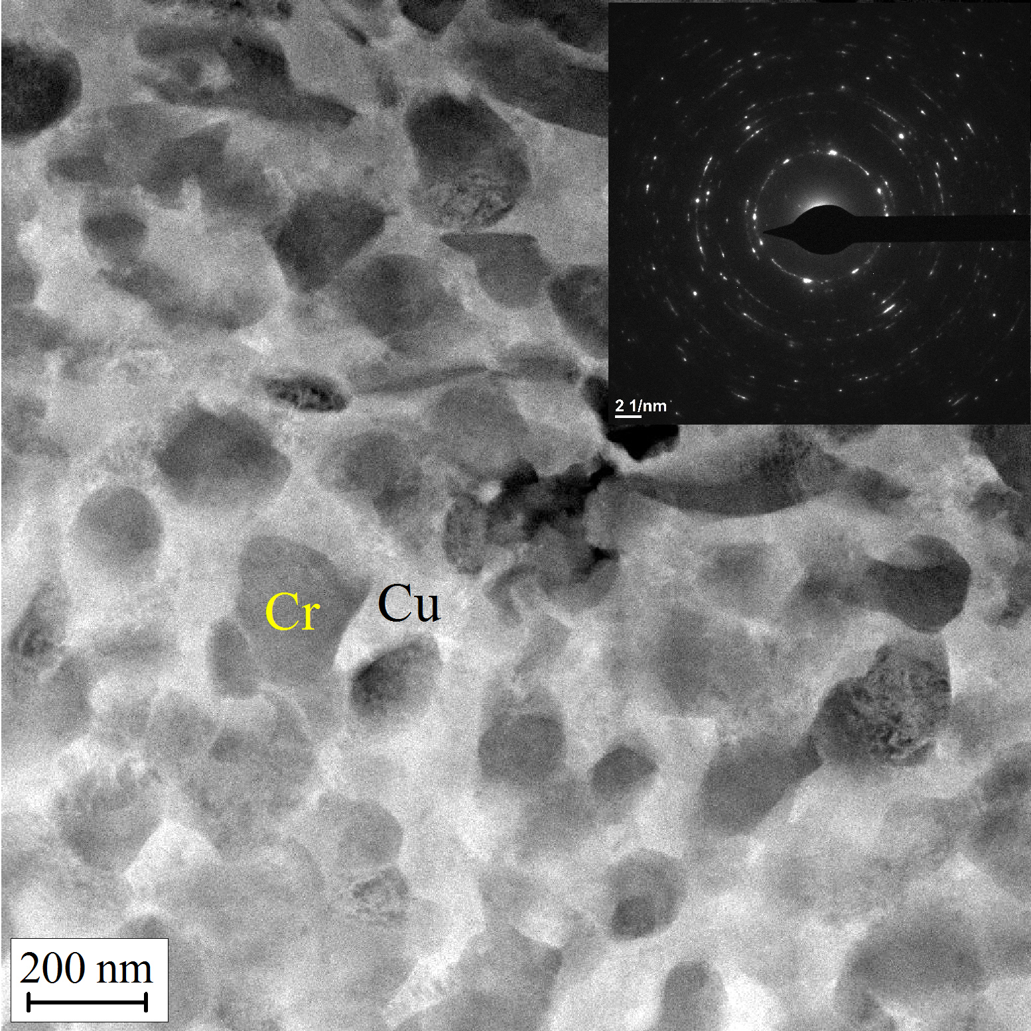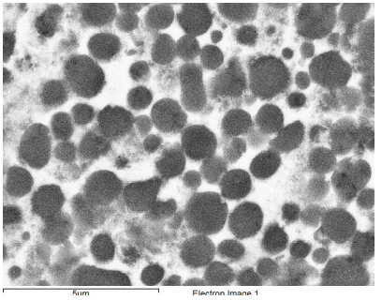
Figure 1: Pseudo-alloy CuCr with hierarchic structure (TEM) | Figure 2: Cermet TiC + high entropy alloy CoCrFeNiMn.

Recent Publications (minimum 5)
- Rogachev A.S., Mukasyan A.S. Combustion for Material Synthesis; CRC Press Taylor & Francis Group, 2015, 397 p.
- Rogachev A.S., Kuskov K.V., Shkodich N.F., Moskovskikh D.O.,. Orlov A.O, Usenko A.A., Karpov A.V., Kovalev I.D., Mukasyan A.S. (2016) Influence of high-energy ball milling on electrical resistance of Cu and Cu/Cr nanocomposite materials produced by Spark Plasma Sintering Journal of Alloys and Compounds 688:468-474.
- Mukasyan A.S., Lin Y-Ch, Rogachev A.S., Moskovskikh D.O. (2013) Direct Combustion Synthesis of Silicon Carbide Nanopowder from the Elements. J. Am. Ceram. Soc. 96:111-117.
- Kuskov K.V., Rogachev A.S, Vadchenko S.G., Shkodich N.F., Rouvimov S., Shchukin A.S., Illarionova E.V., Kudryashov V.A., Mukasyan A.S. (2018) Resistance of microcrystalline and nanocrystalline CuCr pseudo alloys to vacuum discharge. J. of Alloys and Compounds 750:811-818.
- Nepapushev A.A., Rogachev A.S.; Mukasyan A.S. (2018) The influence of high-energy ball milling on the heterogeneous reaction kinetics in the Ti-Si system. Intermetallics 93:366-370.
- Mukasyan A.S., Rogachev A.S.(2017) Combustion synthesis: mechanically induced nanostructured materials. Journal of Materials Science. 52:11826-11833.

 Biography (150 word limit)
Dr. Alexander Rogachev is a professor of the National University of Science and Technology “MISiS”, head of Laboratory for Dynamics of Micro-heterogeneous Processes in the Merzhanov Institute of Structural Macrokinetics and Materials Science (ISMAN), Russian Academy of Sciences, member of the World Academy of Ceramics. His research work focuses on dynamics of phase and structure transformations during high-temperature processes in micro-heterogeneous, nano-heterogeneous and amorphous systems; mechanisms of combustion wave propagation; mechanical activation of heterogeneous reactions; self-propagating high temperature synthesis (combustion synthesis) of advanced materials. He is an author of more than 200 scientific articles and several books.
Email: rogachev@ism.ac.ru

Notes/Comments:

