Spinel nanoparticles: from synthesis, functionalization and characterization toward applications
Masih Darbandi, Nanomaterials research laboratory, Department of physical chemistry, Faculty of chemistry, University of Tabriz, Tabriz, Iran

Abstract (300 word limit)
Spinel nanoparticles have been extensively studied and are attracting growing interest within the scientific community in the recent years due to their unique intrinsic properties combined with the nano-size effects. It is well-known that these nanostructured materials have great potential for many useful applications ranging from information storage and electronic devices to biomedical applications and drug delivery.
We demonstrate a novel method by which uniform-sized, well-crystallized spinel nanoparticles are prepared modifying the water in oil (W/O) microemulsion method and functionalization is performed within the same reactor (one-pot), adding the desired amount of coupling agent to the microemulsion system at room temperature. Particle size control has been attained by careful adjustment of the preparation conditions.
The phase, shape, size, and structure of the product are well characterized using TEM, EDX, XAS, SAED, BET techniques. Zeta-potential measurements indicate the colloidal stability of the final product and presence of the modified functional group on top of the surface layer.
Furthermore, MRI results as a prerequisite for clinical and biological application indicates good signal enhancement in final product.

A particular effort has been devoted to study the effect of the size of these nanoparticles by Mössbauer spectroscopy at low temperature (4.2 K) and presences of field. The sample with the smallest diameter exhibits a markedly different Mössbauer spectrum compared to bigger one. Most importantly separation of surface/volume contribution for capped nanoparticles with Mössbauer spectroscopy will be reported.

Image

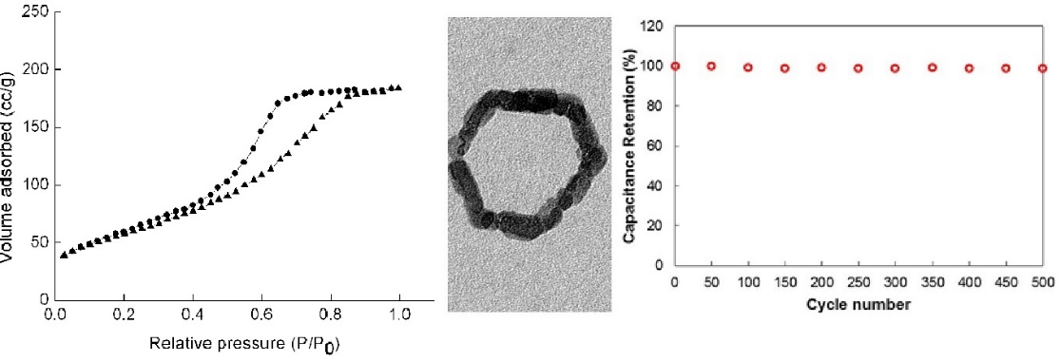

Recent Publications (minimum 5)
- M. Darbandia, B. Shaabani, A. Alizadeh, P. Yardani, E. Shahryari, M. Hosseini, “Preparation and characterization of hexagonal mesoporous β-Co(OH)2 Nanorings”, Microporous Mesoporous Mater, 2019, 284, 421
- C. Antoniak, D. Schmitz, A. Warland, M. Darbandi, S. Bhandary, B. Sanyal, O. Eriksson, H. Wende, “Suppression of the Verwey Transition by Charge Trapping” Ann. Phys, 2018, 530, 1700363
- M. Darbandi, J. H. Dickerson, “Nanoscale engineering of TiO₂ nanoparticles: tuning the shape, phase and morphology enclosed by active facet ” Mater Lett, 2016, 180, 212
- D. Schmitz, C. Antoniak, A. Warland, M. Darbandi, S. Haldar, S. Bhandary, O. Eriksson, B. Sanyal, H. Wende, “The dipole moment of the spin density as a local indicator for phase transitions” Sci. Rep. (by Nature), 2014, 4, 5760.

5. M. Darbandi, T. Gebre, L. Mitchell, W. Erwin, R. Bardhan, M. D. Levan, M. D. Mochena, J. H. Dickerson, “Nanporous TiO2 Nanoparticle Assemblies with Mesoscale Morphologies: Nano-cabbage Vs nano-sea anemone” Nanoscale, 2014, 6, 5652.


Biography (150 word limit)
Masih Darbandi received his PhD in 2007 from Freiburg University, Germany, where he worked on semiconductor nanoparticles (QDs). Thereafter, he spent several years as a postdoctoral scientist in Bochum, Duisburg-Essen and Uppsala (Sweden) universities working on different topics from MOF to magnetic nanoparticles. In 2012 he moved to USA as senior scientist (staff) working at Vanderbilt and Brown Universities. His research area was ceramic nanoparticles, fabrication and the characterization of freestanding films of ceramic nanoparticles via electrophoretic deposition. During his career he received multiple grants from national and international funding agencies (like NSF, DFG, STINT). Then he joined as faculty member in University of Tabriz, Iran. He is a member of ACS (American chemical society) and RCS (Royal society of chemistry). In addition, he was invited as guest editor of some ISI journals and as a member of editorial board in some international journals

Email: Masih.darbandi@gmx.de, masih.darbandi@tabrizu.ac.ir

Notes/Comments:

