Thermo-optically responsive solid-solid phase change materials as passive temperature-controlling building enclosures.

Pramod Mishraª, Giuseppe Ardito^{b}, Mingjiang Tao^{b}, Steven Van Dessel^{b}, Sergio Granados-Focil*ª,
- Gustaf Carlson School of Chemistry and Biochemistry, Clark University, Worcester, MA., U.S.A.
- Civil Engineering Department, Worcester Polytechnic Institute, Worcester, MA., U.S.A.

Abstract
Stimuli-responsive foams based on Solid-Solid phase change materials (SS-PCMs) have been synthesized and evaluated for their use in passive temperature-controlling building enclosures. The transparency of these foams changes as a function of temperature, enabling the design of building enclosures capable of regulating their reflectivity as a function of temperature, thus increasing the efficiency of the thermally regulating layer. The polymeric matrices were synthesized by radical polymerization of mixtures containing a crosslinker, a mechanically-reinforcing monomer and a polymerizable phase-changing motif. The effect of matrix composition on the heat-storing capacity and the temperature-responsive optical contrast will be described. A series of solvent- and porogen-mediated foaming protocols were tested and evaluated as optimal methods to produce large area coatings. Optimized compositions can generate coatings with latent heats above 100 J/g and temperature-dependent transmission contrast ratios higher than 800:1. These properties confirm our finite-element calculations indicating that incorporation of these “smart” coatings into building enclosures is a promising path to the development of more energy efficient buildings.¹ This study provides the experimental data on polymeric PCMs that is required to close the design loop and produce working prototypes of these devices.

Image

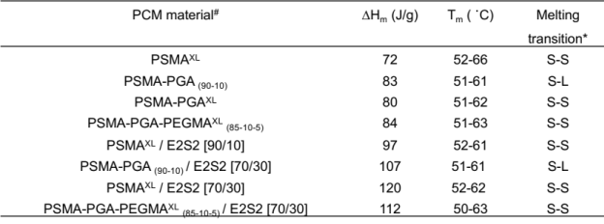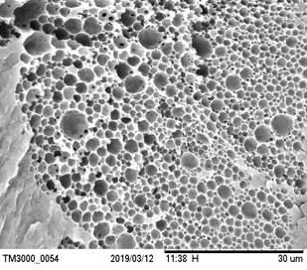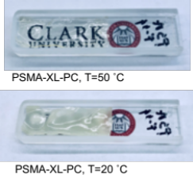

Recent Publications
- Guldentops, G.; Ardito, G.; Tao, M.; Granados-Focil, S.; Van Dessel, S., A numerical study of adaptive building enclosure systems using solid–solid phase change materials with variable transparency. Energy and Buildings 2018, 167, 240-252.
- Fallahi, A., Guldentops, G.#, Tao, M., Granados-Focil, S., Van Dessel, S., Review on solid-solid phase change materials for thermal energy storage: Molecular structure and thermal properties. Applied Thermal Engineering, 2017, 127, 1427-1441.
- Mishra, P.,K., Stockmal, K.A., Ardito, G., Tao, M., Van Dessel, S., Granados-Focil, S., Optical and thermal properties of selected solid-liquid phase-change materials. Submitted.
- Oktay, B., Poly(ethylene glycol)/Polyvinyl chloride composite Form-stable Phase-Change materials by the Azide-alkyne click reaction. Chemistry Select, 2018, 3, 11737.
- Umair, M.M., Zhang, Y., Iqbal, K., Zhang, S., Tang, B., Novel strategies and supporting materials applie to shape-stabilize organic phase change materials for thermal energy storage-A review., Applied Energy, 2019, 235, 846.

Biography
Prof. Granados-Focil completed a Ph.D. in Macromolecular Science and Engineering in 2005 from Case Western Reserve University and postdoctoral studies at the University of Massachusetts, Amherst. He is an associate professor in the Gustaf Carlson School of Chemistry and Biochemistry at Clark University. Prof. Granados-Focil's focuses on synthesis of new macromolecules to study transport phenomena within polymeric matrices, with a particular interest in the development of better energy storage, chemical sensors, gene therapy, and novel materials for construction of sustainable buildings. He has published 27 papers in peer-reviewed publications and is listed as an inventor in 3 U.S. Patent applications.
Email: sgranadosfocil@clarku.edu

Notes/Comments:

