Hybrid mesoporous silica-polymer composites as solid electrolytes for lithium-ion batteries.

Valeria Gutiérrez-Venegas, Alma Araujo, Yuxin Yang, Luis J. Smith, Sergio Granados-Focil*
Gustaf Carlson School of Chemistry and Biochemistry, Clark University, Worcester, MA., U.S.A.

Abstract
Sulfonate-bearing mesoporous silica particles have been synthesized by grafting alkyl sulfonate motifs to the surface and the inner pore walls of mesoporous silica, MPS, prepared via sol-gel methods. Solid lithium conductors were prepared by attaching varying amounts of oligomeric polyethylene oxide, PEO, along the alkyl sulfonates. These functional nanoparticles were then blended with a lithium solvating PEO-grafted polyethyleneimine, PNE, to produce flexible self-standing films. The ionic conductivity can be controlled by tuning the O/Li ratio within the silica mesopores, changing the pore size distributions, and by changing the relative amounts of silica particles to PNE in the hybrid films. The resulting nanocomposites are thermally stable up to 140 °C and showed no electrochemical degradation within a -5V to 5V window. Optimized hybrid film compositions exhibited lithium conductivities above 0.5 mS/cm at room temperature, indicating that both ion transport and ion-pair dissociation benefit from mesopore nanoconfinement. The ion mobilities observed for these materials indicate that nanostructured composites constitute a promising pathway towards highly conductive, mechanically robust, solid electrolytes compatible with lithium-metal surfaces. ⁷Li-NMR experiments and preliminary battery tests will be discussed.

Image

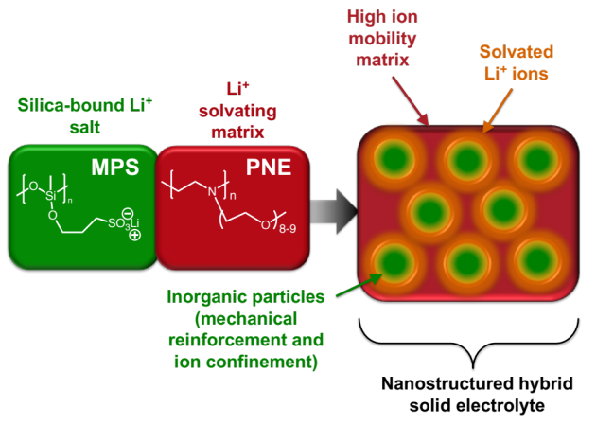

Recent Publications
- Doyle, R., P. Chen, X., Macrae, M., Srungavarapu, A., and Granados-Focil, S., Poly(ethyleneimine)-based polymer blends as lithium single-ion conductors. Macromolecules, 2014, 47, 3401.
- Lago, N., Garcia-Calvo, O., Lopez del Amo, J.M., Rojo, T., Armand, M., All-solid state Lithium-ion batteries with grafted ceramic nanoparticles dispersed in solid polymer electrolytes, ChemSusChem., 2015, 8, 3039.
- Ma, Q., et al., Single Lithium-ion conducting polymer electrolytes based on a super delocalized polyanion. Angew. Chem. Int. Ed., 2016, 55, 2521.
- Kim, Y., Kwon, S.J., Jang, H-K., Jung, B.M., Lee, S. B., Choi, U. H., High ion conducting nanohybrid solid polymer electrolytes via single-ion conducting mesoporous organosilica in poly(ethylene oxide). Chem. Mater., 2017, 29, 4401.
- Jeong, K., Park, S., Lee S. Y., Revisiting polymeric single lithium-ion conductors as an organic route for all-solid-state lithium ion and metal batteries. J. Mater. Chem. A, 2019, 7, 1917.

Biography
Prof. Granados-Focil completed a Ph.D. in Macromolecular Science and Engineering in 2005 from Case Western Reserve University and postdoctoral studies at the University of Massachusetts, Amherst. He is an associate professor in the Gustaf Carlson School of Chemistry and Biochemistry at Clark University. Prof. Granados-Focil's focuses on synthesis of new macromolecules to study transport phenomena within polymeric matrices, with a particular interest in the development of better energy storage, chemical sensors, gene therapy, and novel materials for construction of sustainable buildings. He has published 27 papers in peer-reviewed publications and is listed as an inventor in 3 U.S. Patent applications.
Email: sgranadosfocil@clarku.edu

Notes/Comments:

