Corrosion inhibition effect of nano hybrid hydrotalcite/graphene oxide containing 2-benzothiazolythio-succinic acid on carbon steel
Thuy Duong Nguyen, Reseacher, Institute for Tropical Technology-Vietnam Academy of Science and Technology, Hanoi, Vietnam

Abstract
Nano hybrid hydrotalcite/graphene oxide containing 2-benzothiazolythio-succinic acid (HTC/GO-BSA) was successfully synthesized by co-precipitation method. These obtained HTC/GO-BSA were characterized employing infrared spectroscopy (IR), X-ray diffraction (XRD) and scanning electron microscopy (SEM). The release ability of BSA from HTC/GO-BSA was checked by UV-Vis spectroscopy in sodium chloride solution at different concentrations (0 M, 0.1 M and 0.5 M). The corrosion inhibition action of HTC/GO-BSA nanoparticles on carbon steel in NaCl solution was evaluated by electrochemical measurements (electrochemical impedance spectroscopy (EIS) and potentiodynamic polarization). Then the effect of HTC/GO-BSA on the protection properties of solvent free epoxy coatings (with concentration of 1 wt% powder) deposited onto carbon steel substrate was studied by salt spray test and adhesion measurement. It was shown that GO and BSA were intercalated in hydrotalcite structure and BSA content was about 19.7 wt%. The release of BSA from HTC/GO-BSA was depended on chloride ion concentrations. After 72 h immersion in 0 M, 0.1 M and 0.5 M NaCl solutions, the BSA release were about 6.4 %, 19.3 % and 61.0 % respectively. The obtained results by electrochemical measurements showed that HTC/GO-BSA is an anodic corrosion inhibitor with the inhibition efficiency about 94 % at 1 g/L concentration. The addition of HTC/GO-BSA into the solvent free epoxy coatings enhanced their corrosion resistance and adhesion. The corrosion protection performance of coatings containing HTC/GO-BSA was higher in comparison to the coating containing HTC-BSA.

Image

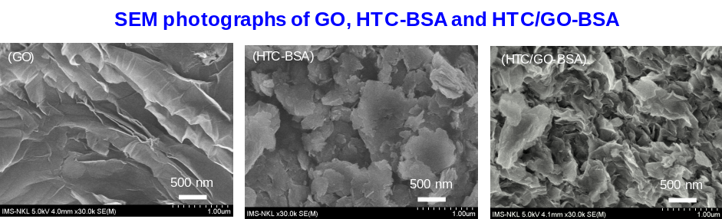

Recent Publications (minimum 5)
- Thuy Duong Nguyen, Boi An Tran, Ke Oanh Vu, Anh Son Nguyen, Anh Truc Trinh, Gia Vu Pham, Thi Xuan Hang To, Minh Vuong Phan, Thanh Thao Phan (2018) Corrosion protection of carbon steel using hydrotalcite/graphene oxide nanohybrid. Journal of Coatings Technology and Research 16: 585-595.
2. Nguyen Thuy Duong, To Thi Xuan Hang, Gervasi Julien, Paint Yoann, Gonon Maurice, Olivier Marie-Georges (2018) Corrosion inhibition of carbon steel by hydrotalcites modified with different organic carboxylic acids for organic coatings. Progress in Organic Coatings 124: 256-266.
3. Nguyen Thuy Duong, To Thi Xuan Hang, Arnaud Nicolay, Yoann Paint, Marie-Georges Olivier (2016) Corrosion protection of carbon steel by solvent free epoxy coating containing hydrotalcites intercalated with different organic corrosion inhibitors. Progress in Organic Coatings 101: 331-341.
4. To Thi Xuan Hang, Nguyen Thuy Duong, Trinh Anh Truc, Thai Hoang, Dinh Thi Mai Thanh, Siriporn Daopiset, Anothai Boonplean (2015) Effects of hydrotalcite intercalated with corrosion inhibitor on cathodic disbonding of epoxy coatings. Journal of Coatings Technology and Research 12: 375-383.
5. To Thi Xuan Hang, Ngo Thanh Dung, Trinh Anh Truc, Nguyen Thuy Duong, Bui Van Truoc, Pham Gia Vu, Thai Hoang, Dinh Thi Mai Thanh, Marie-Georges Olivier (2015) Effect of silane modified nano ZnO on UV degradation of polyurethane coatings. Progress in Organic Coatings 79: 68–74.

 Biography
Thuy Duong Nguyen was born in Vietnam. She received Doctor of Materials Science in 2018 from University of Mons (Belgium). She performed her doctor thesis in the framework of ARES-CUD project between University of Mons (Belgium) and Institute for Tropical Technology (Vietnam) with the main topic concerning to the synthesis of hydrotalcite containing corrosion inhibitors and their application in the solvent free epoxy coatings for corrosion protection of carbon steel. Since 2009, she has worked as a researcher at Department of Protective coatings - Institute for Tropical Technology, Vietnam Academy of Science and Technology, Hanoi, Vietnam. She works mainly on polymer nanocomposite coatings system based on the nanoparticles containing corrosion inhibitors for carbon steel.
Email: ntduong@itt.vast.vn

Notes/Comments:

