Studies on Natural Rubber Nanocomposites by incorporating

Amine functionalized Graphene oxide
Jophy Jose¹,Susamma A. P.^{2*}
1 Research Department of Chemistry, Maharaja’s College Ernakulam, Kerala, India -682011
2 Kerala University of Fisheries and Ocean Studies, Kochi, Kerala, India – 682 506

Abstract
The present work has the objective of synthesising amine functionalised Graphene Oxide(GO) by two different methods, one by modified Bucherer reaction(AGO) and the other by using dodecyl amine(DGO). The synthesised amine functionalised Graphene oxide were characterised by FTIR, XRD, SEM, TEM and Raman Spectroscopy. The SEM, TEM, FTIR, Raman Spectroscopy and XRD results indicate that amine groups can be successfully grafted on the surface of GO. A series of Natural Rubber(NR) – AGO and NR - DGO nanocomposites with varying compositions of AGO and DGO ranging from 0 – 1.5 per hundred rubber (phr) were prepared by latex mixing method. The morphology of nanocomposites were analysed by SEM and TEM and the mechanical and dielectric properties were studied by using Universal Testing machine and impedance analyser. The SEM and TEM measurements shows the well distribution of AGO and DGO in the NR matrix. The NR-AGO and NR-DGO nanocomposites exhibited a tremendous improvement of mechanical properties like tensile strength and tearstrength which were ascribed to the uniform dispersion of AGO and DGO in the NR matrix and enhanced interfacial interaction between the filler and the matrix. For both NR-AGO and NR–DGO nanocomposites, 0.5 phr composition was optimised as the best compared to others (0.05, 0.1, 0.3, 0.5,0.75,1.0,1.5) in terms of mechanical properties. The presence of AGO and DGO can also increase the dielectric properties of NR nanocomposites. Compared to AGO, DGO showed more enhancements in mechanical and electrical properties. It may be due to the presence of long alkyl groups in dodecyl amine which increases the interfacial interaction with the NR matrix. These amine functionalised GO based NR nanocomposites find applications in coatings, automotives, aerospace and as dielectric materials for electronic appliances.

Graphical Abstract
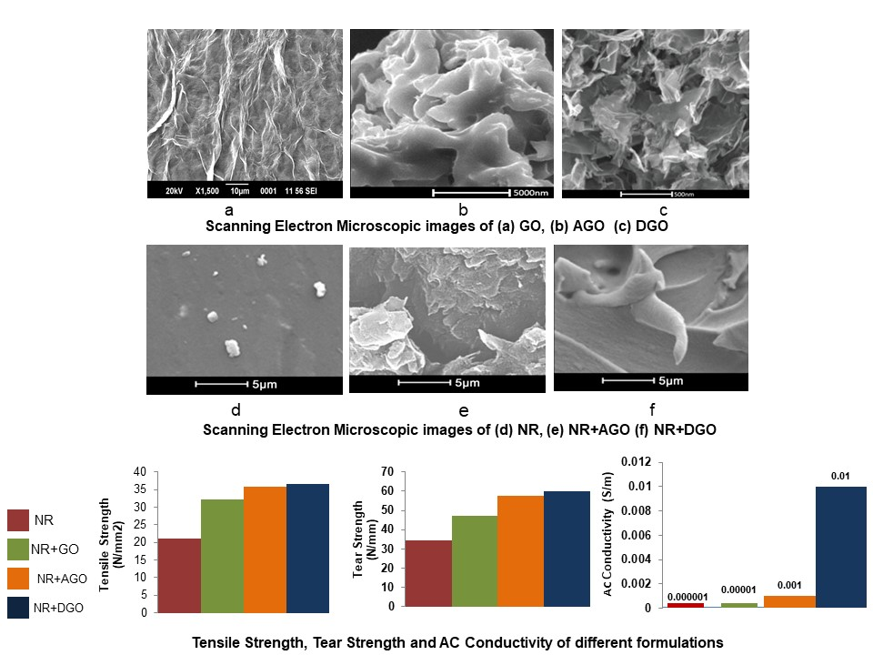

Recent Publications
- Wang, Z.H.; Liu, J.; Wu, S.Z., Wang, W.C.; Zhang, L.Q. “Novel percolation phenomena and mechanism of strengthening elastomers by nanofillers”. Phys. Chem. Chem. Phys. 2010, 12, 1.
- J. R. Potts, D. R. Dreyer, C. W. Bielawski, barrier and and R. S.Ruoff,“Graphene-basedpolymernanocomposites,” Polymer, 2011, vol. 52, no. 1, pp. 5–25, .
- Dreyer, D. R. et al. “The chemistry of graphene oxide”. Chem. Soc.2009, Rev. 39, 228–240.
- K. K. Sadasivuni, D. Ponnamma, S. Thomas, and Y. Grohens, “Evolution from graphite to graphene elastomer composites,” Progress in Polymer Science, 2014 vol. 39, no. 4, pp. 749–780.
- Bhattacharya, M., Biswas, S., Bhowmick, A.K., “Permeation characteristics and modeling of barrier properties of multifunctional rubber nanocomposites”.Polymer (Guildf) 2011,52, 1562–1576.
- AsoNavaee andAbdollahSalimi “Efficient amine functionalisation of GO through the Buchererreaction:an extraordinary metal -free electrocatalyst for the oxygen reductionreaction”RSC Adv.2015,5,59874-59880.

Biography 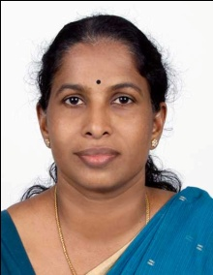

Dr.Susamma A.P has over 32 years’ experience in teaching Chemistry in various colleges lecturer/Associate professor, under Collegiate Education, Government of Kerala, India. She had also functioned as an Administrator in education sector by serving as Principal of Government Colleges of Thrissur and Thrippunithura. Dr.Susamma had completed her M.Sc in Chemistry from S.B.College, Changanassery with Kerala University First Rank and Ph.D in Polymer Science and Rubber Technology from Cochin University of Science and Technology (CUSAT). She further perused six months post doctoral research in the Department of Chemical Engineering, Imperial College, London, UK in 2009 through the Commonwealth Academic Fellowship Programme. Dr.Susamma had ten international research papers in her credit and is a recognized Research Guide in M.G.University, Kottayam, Kerala,India. She is a Reviewer of four International Peer reviewed Journals.

