Protecting BiVO₄ Heterojunction Photoanode for Enhanced Solar-driven Photoelectrochemical Water Splitting with The Incorporation of rGO Interlayer and Electrocatalyst Thin Films

Meng Nan Chong, School of Engineering, Chemical, , Engineering Discipline, Monash University Malaysia, Bandar Sunway, Selangor DE 47500, Malaysia

Abstract (300 word limit)
Effective photoelectrochemical (PEC) water splitting to convert solar energy to directly dissociate water molecule into chemical hydrogen energy through semiconductor photocatalysis has attracted considerable attention. BiVO₄ has been investigated as one of the most promising materials for PEC water splitting by harnessing substantial portion of visible light spectrum with its relatively narrow band gap of 2.5 eV. As the performance of BiVO₄ photoanodes continues to improve and explore, the photostability of BiVO₄ becomes an important issue. The photocorrosion of BiVO₄ can be suppressed by increasing the rate of interfacial charge transfer and incorporating a protection layer on the BiVO₄. In this study, we proposed a rational design of novel vanadium pentoxide (V₂O₅)/BiVO₄ heterojunction photoanode structure with reduced graphene oxide (rGO) interlayer and topping with dual transition-metal electrocatalysts (FeOOH and NiOOH) for PEC water splitting. We demonstrated that interlayer rGO enhanced the interfacial charge transfer rate between V₂O₅ and BiVO₄ which that can kinetically suppressed photocorossion. While the incorporation of FeOOH and NiOOH as the protection layer in preventing the BiVO₄ surface from direct contact with electrolyte. Results showed that the FTO/V₂O₅/rGO/BiVO₄/FeOOH/NiOOH heterojunction photoanode achieved a significantly improved photocurrent density of 3.06 mA/cm² at 1.5 V vs Ag/AgCl which is 12.2 times more photoactive than the pristine BiVO₄. This study provides insights into preventing anodic photocorrosion of BiVO₄ and improving the consumption photogenerated charge carriers for PEC water splitting.

Image

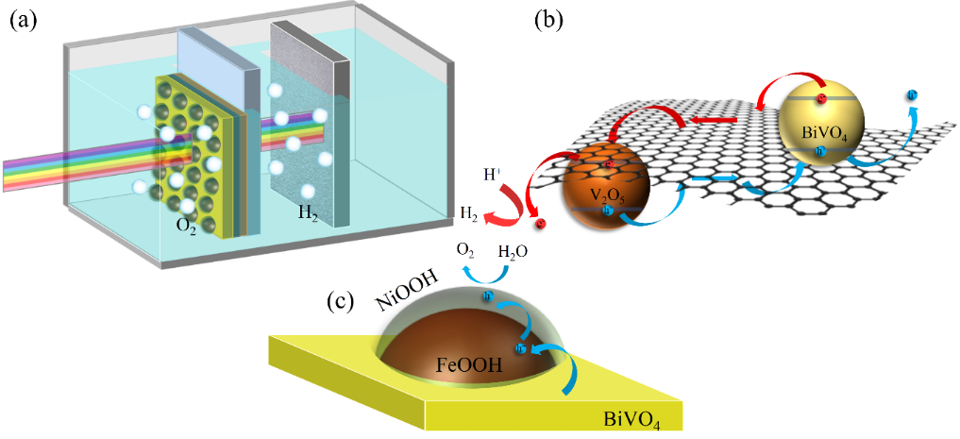

Recent Publications (minimum 5)
- Leong JYC, Balan P, Chong MN, Poh PE (2019) Life-cycle assessment and life-cycle cost analysis of decentralised rainwater harvesting, greywater recycling and hybrid rainwater-greywater systems. J. Clean. Prod. 229: 1211-1224.
- Yaw CS, Ruan Q, Tang J, Soh AK, Chong MN (2019) A Type II n-n staggered orthorhombic V₂O₅/monoclinic clinobisvanite BiVO₄ heterojunction photoanode for photoelectrochemical water oxidation: Fabrication, characterisation and experimental validation. Chem. Eng. Sci. 364: 177-185.
- Zhu T, Chong MN, Chan ES, Ocon JD (2018) Electrochemically-synthesized tungstate nanocomposites γ-WO₃/CuWO₄ and γ-WO₃/NiWO₄ thin films with improved band gap and photoactivity for solar-driven photoelectrochemical water oxidation. J. Alloys Compd. 762: 90-97.
- Zhu T, Chong MN, Chan ES, Ocon JD (2018) Synthesis and characterisation of a novel bilayer tungsten trioxide nanojunction with different crystal growth orientation for improved photoactivity under visible light irradiation. J. Alloys Compd. 749: 268-275.
- Chang JS, Tan JK, Savan NS, Alina M, Jennifer S, Poh PE, Chong MN (2018) Morphological tunable three-dimensional flower-like zinc oxides with high photoactivity for targeted environmental Remediation: Degradation of emerging micropollutant and radicals trapping experiments. J. Taiwan Inst. Chem. E. 81: 206-217.


Meng Nan Chong is an Associate Professor in Chemical Engineering, and a Research Leader for the Sustainable Water Alliance funded by the Advanced Engineering Platform at Monash University Malaysia. He graduated with a Bachelor of Engineering (Chemical) with First Class Honours and a Ph.D from the University of Adelaide, South Australia. Currently he holds a number of important visiting positions at universities and research centers around the world, including; (1) Royal Society Newton Advanced Fellowship at University College London, (2) Visiting Professor at University of Ulsan, South Korea, (3) Visiting Professor at University of Philippines Diliman, The Philippines, (4) Visiting Scientist at Max-Planck Institute for Chemical Energy Conversionm Germany, and (5) Adjunct Senior Research Fellow at Centre for Water Management and Reuse, University of South Australia. He also serves in his capacity as an Associate Editor for Water Science & Technology as well as the Founding & Editor- in- Chief for Water Conservation Science & Engineering journals. His research interests are focused on nanotechnology, environmental photocatalysis, sustainable energy & water technology, water resources management and sustainability.
Email: chong.meng.nan@monash.edu

Notes/Comments:

