Redox Gated Polymer Memristive Processing Memory Unit
Fei Fan, Bin Zhang, Xiangyu Tian, Yu Chen*
Key Laboratory for Advanced Materials, Institute of Applied Chemistry, School of Chemistry and Molecular Engineering, East China University of Science and Technology, Shanghai 200237, China. Email: chentangyu@yahoo.com

Abstract (300 word limit)

Memristor devices with enormous storage capacity and superior processing efficiency are of critical importance to overcome the Moore’s Law limitation and von Neumann bottleneck problems in the big data and artificial intelligence era. In this contribution, we report the first proof-of-concept polymer memristor based processing-memory unit that demonstrates programmable information storage and processing capability. By introducing redox active moieties of triphenylamine (TPA) and ferrocene (Fc) onto the pendants of fluorene skeletons, the conjugated polymer of PFTPA-Fc exhibits triple oxidation behavior and interesting memristive switching characteristics. Associated with the unique electrochemical and electrical behavior, the ITO/PFTPA-Fc/Pt device is capable of executing multilevel memory and four basic decimal arithmetic operations of addition, subtraction, multiplication and division. Redox gating of the device also endows it with simple binary Boolean logic operations. The integration of multilevel memory and computing capability into a single memristor device through molecular design and electronic properties tuning of polymer promises an essential strategy of obtaining high-performance electronic device that satisfies the increasing demands of data storage and processing nowadays.
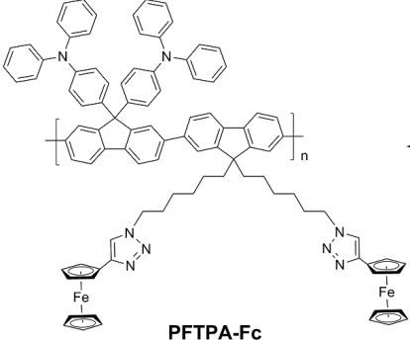
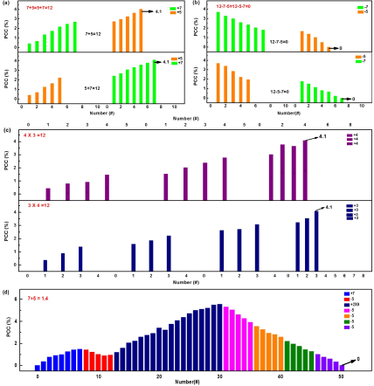

Figure 1. (Left) Structure of PFTPA-Fc; and (Right) Demonstration of arithmetic computing with the PFTPA-Fc memristor. (a) Commutative addition, (b) subtraction and (c) multiplication, as well as (d) fractional division conducted with the ITO/PFTPA-Fc/Pt device.
Recent Publications

- Y. Cao, X. Tian, J. Gu, B. Liu, B. Zhang, S. Song, F. Fan, Y. Chen(2018) Covalent functionalization of black phosphorus with conjugated polymer for information storage. Angew. Chem. Int. Ed. 57:4543-4548
- B. Zhang, F. Fan, W. Xue, G. Liu, Y. Fu, X. Zhuang, X.-H. Xu, J. Gu, R.-W. Li, Y. Chen (2019) Redox-gated polymer memristive processing-memory unit, Nature Commun. 10:736/1-736/11
- Y. Chen, B. Zhang, G. Liu, X. Zhuang, E.-T. Kang (2012) Graphene and its derivatives: Switching ON and OFF. Chem. Soc. Rev. 41(13): 4688–4707
- F. Fan, B. Zhang, S. Song, B. Liu, Y. Chen(2018)Pyrolytically modified polyacrylonitrile-covalently grafted MoS₂ nanosheets for nonvolatile rewritable memory device. Adv. Electron. Mater. 4:1700397
- X.-D. Zhuang, Y. Chen, G. Liu, P.-P. Li, C.-X. Zhu, E.-T. Kang, K.-G. Neoh, B. Zhang, J.-H. Zhu,Y.-X. Li(2010)Conjugated polymer functionalized graphene oxide: synthesis and nonvolatile rewritable memory effect. Adv. Mater. 22(15): 1731–1735


Biography for the corresponding author
Yu Chen is a full professor at East China University of Science and Technology. He received his Ph.D. in Organic Chemistry at Fudan University in July 1996. In 2000, he joined Prof. Michael Hanack's group at the University of Tuebingen as Alexander von Humboldt research fellow. At the end of October 2002, he moved to the University of Washington, and worked with Prof. Alex K.Y. Jen as research associate. In February 2004, he joined the Professor Osamu Ito’s group at the Institute of Multidisciplinary Research for Advanced Materials, Tohoku University at Sendai as a research scientist. He has published more than 210 papers, reviews and communications in Chem. Soc. Rev., Prog. Mater. Sci., Nat. Commun., Angew. Chem. Int. Ed., J. Am. Chem. Soc., Adv. Mater., Adv. Funct. Mater., Mater. Horizons, Chem. Mater. and others.
Email: chentangyu@yahoo.com

