Superhydrophbic melamine sponge derived from poly(dimethyl siloxane)-modified crosslinked polyurea

Chin-Hsiang Chung, M.S., Department of Materials and Optoelectronic Science, National Sun Yat-sen University, Kaohsiung, Taiwan 80424, ROC

Abstract

Poly(dimethyl siloxane) (PDMS)-based crosslinked networks have attracted considerable attention for the superior hydrophobic properties. To prepare PDMS-based crosslinked network, a one-step preparation route was developed by us, by heating isocyanate-terminated PDMS (i-PDMS) at ambient temperature, to result in well-qualified, polyurea films with good hydrophobicity. Among three hexamethylene, isophorone and methylenediphenyl diisocyanates (HDI, TDI and MDI) used, MDI-based networks are the best products superior in oil and solvent absorptions. We therefore fabricated superhydrophobic melamine sponges (sMS) by coating and heating the MDI-based i-PDMS on the surface of the sponge skeleton. The resultant sMS is superhydrophobic with a detected water contact angle of 152 ºC. Moreover, sMS can selectively remove wide varieties of organic solvents and oils from water. The resultant gravimetric sorption capabilities of chloroform, used motor oil, lubricant oil and edible oil are superior in comparison to the reported values and are 191, 102, 94 and 106 g/g, respectively.

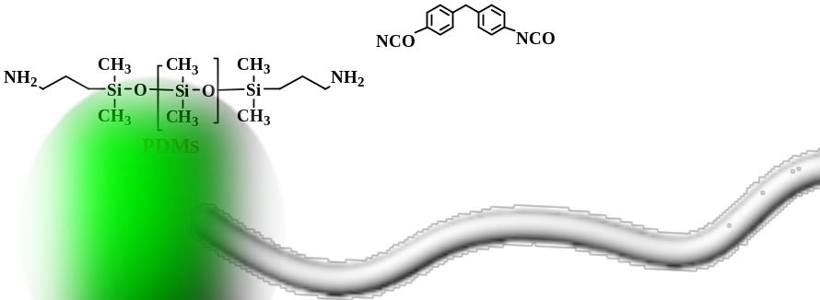

Recent Publications
1. Chih-Hsiang Chung and Wan-Chen Liu (2018) Superhydrophobic Melamine Sponge Modified by Cross-Linked Urea Network as Recyclable Oil Absorbent Materials, Ind. Eng. Chem. Res. 57, 8449.
2. Chun-Yi Tsai and Chin-Hsiang Chung (2018) Pyrene-Terminated, Amphiphilic Polypeptide and Its Hydrogen-Bonded Interpolymer Complex as Delivery Systems of Doxorubicin, ACS Omega 34, 4423.

3. Wan-Chen Liu, Chih-Hsiang Chung, and Jin-Long Hong (2018) Highly Stretchable, Self-Healable Elastomers from Hydrogen-Bonded Interpolymer Complex (HIPC) and Their Use as Sensitive, Stable Electric Skin, ACS Omega 3, 11368.
4. Jhen-Yan Gao, Wen-Chih Huang, Pei-Yi Huang and Cheng-Yu Song (2017) Light-Up of Rhodamine Hydrazide to Generate Emissive Initiator for Polymerization and to Afford Photochromic Polypeptide Metal Complex, Polymers 9, 419.
5. Pei-Yi Huang, Jhen-Yan Gao and Cheng-Yu Song (2017) Ionic complex of a rhodamine dye with aggregation-induced emission properties, Faraday Discuss. 196, 177.



Chin-Hsiang Chung completed a M.S. in Department of Materials and Optoelectronic at the National Sun Yat-Sen University (NSYSU) and currently, he joints the PhD program of NSYSU. Before the completion of his master degree, he received the Bachelor degree in Fiber and Composites Department of Feng chia University. His main expertise is on the polymers and composites, from which several research fields including hydrophobic/hydrophilic materials, tri-block copolymer, biomass materials, carbon/nanocomposites, porous materials for CO₂ absorption and supercapacitor and recently, magnetic material used in Military equipment had been developed.
Email: sky200450123@gmail.com

