The homogenous dispersion of large amounts of multi-walled carbon nanotube by a tannic acid-terminated polymer
Jin-Long Hong, Dr Professor, Department of Materials and Optoelectronic Science, National Sun Yat-sen university, Kaohsiung, Taiwan, R.O.C.

Given that the extraordinary electrical and mechanical properties, multi-walled carbon nanotubes (MWCNTs) provided versatile routes for the preparations of advanced materials, such as MWCNT/polymer composites. Nevertheless, homogenous MWCNT/polymer composites are difficult to prepare due to the strong aggregation tendency of MWCNT. In this study, a tannic acid (TA)-terminated polymer JTA synthesized in our lab was found to have excellent dispersion power for MWCNTs, from which JCTx (x: refers to the weight percentage of MWCNT) composites with low ( x =10) to high (x = 96) MWCNT contents can be prepared and characterized. With the inherent aromatic pi-pi and hydrogen bond (H bond) interactions, pure JTA already is a self-healing elastomer, and moreover, the aromatic rings of JTA exclusively bind to the carbon rings of MWCNT, resulting in self-healable elastomeric or conductive plastic composites. In the presence of different amounts of MWCNT, the resulting JCTx composites could be healable elastomers (when x < 40) with high stretchablity (fracture strain up to 813%) or could be plastics with high conductivity (up to 1.21x10 S m⁻¹). Mechanical modulus and conductivity of JCTx can also be predicted by theoretical approaches based on Kolarik model and scaling law, respectively. With the superior mechanical and conductive properties, the JCTx composites are excellent sensors used for detecting minor (i.e. pulse beating), medium (elbow bending) and high strain deformations.

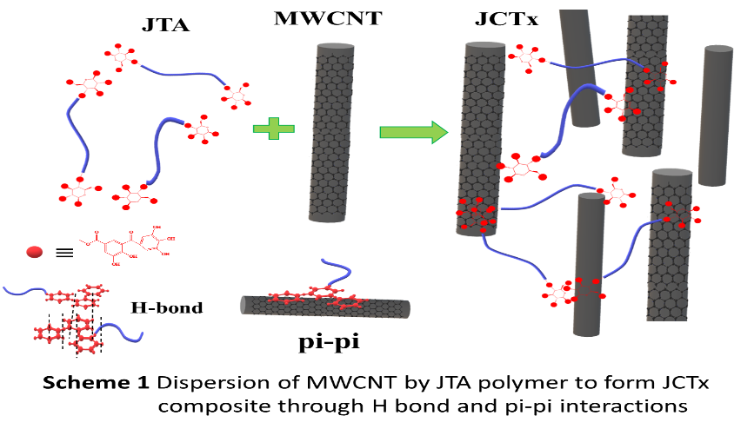

- Liu W.-C., Chung C.-H., Hong J.-L. (2018) Highly stretchable, self-Healable elastomers from hydrogen-bonded interpolymer complex (HIPC) and their use as sensitive, ACS Omega 3: 11368.
- Chung C.-H., Liu W.-C., Hong J.-L (2018) Superhydrophobic melamine sponge modified by cross-linked urea network as recyclable oil absorbent materials, Ind. Eng. Chem. Res. 57: 8449
- Tsai C.-Y., Cheng C.-H., Hong J.-L., (2018) Pyrene-terminated, amphiphilic polypeptide and its hydrogen-bonded interpolymer complex as delivery systems of doxorubicin, ACS Omega 3: 4423.
365: 519-530.
4. Lin L.-Y., Huang P.-C., Yang D.-J., Gao J.-Y., Hong J.-L. (2016) Influence of the secondary structure on the AIE-related emission behavior of an amphiphilic polypeptide containing a hydrophobic fluorescent terminal and hydrophilic pendant groups, Polym. Chem. 7: 153.
5. Gao J.-Yan, Huang W.-C, Huang P.-Y., Song C.-Y., Hong J.-L. (2017) Light-up of rhodamine hydrazide to generate emissive initiator for polymerization and to afford photochromic polypeptide metal complex, Polymers 9: 419.


Jin-Long Hong completed a Ph.D. in Polymer Chemistry at the University of Massachusetts, Amherst, and served as a postdoctoral fellow at the Institute of Materials Science, University of Connecticut, Storrs, before joining National Sun Yat-Sen University (NSYSU), Kaohsiung as an associate professor. Currently, he is a full professor at the Department of Materials and Optoelectronic Science of NSYSU. His main expertise is on the synthesis of organic and macromolecular materials, based on which several research fields, including recently in carboneous materials used in lithium-ion batteries, CO₂ absorption, chemical purification, and solar steam-generation, and previously in conjugated polymers, liquid crystals and liquid crystalline polymers, polymeric crosslinked networks, and luminogenic materials with aggregation-induced and -enhanced properties.
Email: jlhong@mail,nsysu.edu.tw

Notes/Comments:

