Preparation, Characterization and anti-tumor effect of Sorafenib in inclusion complex with β-Cyclodextrin
Chiuyen Phan, Jie Shen, Xiurong Hu, Guping Tang
Chemistry Department, Zhejiang University, PR China

Abstract
Sorafenib (Sor) is an oral multikinase inhibitor for the treatment of various cancers. But its bioavailability is very low due to its low aqueous solubility and high daily dose [1-2]. In order to enhance the drug’s solubility, dissolution and bioavailability, the inclusion complex between Sor and β -cyclodetrin (β -CD) had prepared by co-crystallization. The structure of Sor- β -CD was characterized by thermal analysis, powder X-ray diffraction, Single-crystal X-ray diffraction, Infrared Spectroscopy and Nuclear Magnetic Resonance. The results showed that the ratio of host-mate and guest drug was 1:1 and the tested crystal belonged to the space group C2 with the space group of a = 19.1281(12) Å, b = 24.4901(12) Å, c = 15.6182(10) Å, β = 109.51º, V= 6896.12 Å³. The ureido-phenoxy-N-methylpyridine-2-carboxamide group of drug inserted into the β -CD cavity, and the terminal trifluoromethyl-phenyl ring of Sor was located above the β -CD cavity.
Phase-solubility study revealed the higher solubility and complexing ability of β -CD with Sor. The solubility and dissolution of Sor- β -CD was significantly enhanced in pH 1.2 medium and distilled water compared to Sor and Sor-Tos. In vivo distribution and antitumor studies revealed that the anti-tumor effect of Sor- β -CD was almost as good as free Sor and Sor-Tos despite that its concentration was only half of free or Sor-Tos, showing the bioavailability of Sor- β -CD was increased when β -CD mated with Sor and. Therefore, these findings could provide a suitable pharmaceutical dosage to enhanced therapeutic activity.

Image
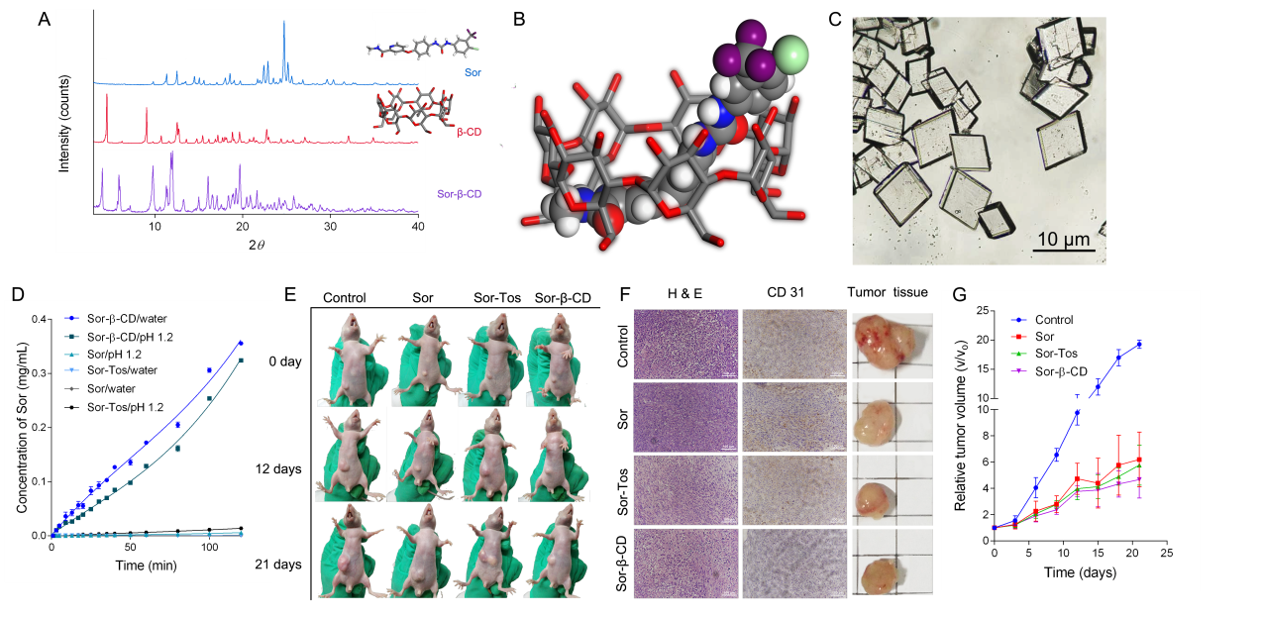
Fig.1. (A) PXRD pattern of Sor- β -CD, β -CD and Sor (B) simulated of Sor- β -CD crystal, (C) Sor- β -CD crystal image, (D) dissolution rate of Sor- β -CD, Sor-Tos and Sor in water and pH 1.2 gastric juice, (E) HepG2 tumor-bearing mice model and tumor tissues, (F) tumor tissues and H&E staining, CD31 assay of tumor tissues and (G) Antitumoral therapeutic effects of PBS, free Sor, Sor-Tos, Sor- β -CD in tumor-bearing BALB/c: Relative tumor volume with increasing time.

References
[1] Maria Luisa Bondì, Angela Scala, Giuseppe Sortino, Erika Amore, Chiara Botto, Antonina Azzolina, Daniele Balasus, Melchiorre Cervello, and Antonino Mazzaglia. Biomacromolecules, 16, 3748-3791 (2015).
[2] Xiurong Hu , Mengying Sun, Yang Li, Guping Tang . Colloids and Surfaces B: Biointerfaces, 153, 61–68 (2017)

