In-vitro evaluation of silver nano particle coated Fe₂O₃ and NiO co-doped CaO-SiO₂-P₂O₅ bioceramics and their response in inflammation, bacterial attack and drug release.
Vikas Anand*^{1,5}, K.J. Singh,¹, Kulwinder Kaur¹, Gaurav Bhatia², Namarta Kalia²,Jatinder Singh³, Lovedeep Nim⁴ and Daljit Singh Arora⁴

¹Department of Physics, ²Department of Molecular Biology and Biochemistry, ³Department of Human Genetics, ⁴Department of Microbiology, Guru Nanak Dev University, Amritsar-143005 , ⁵ Thakur PG College of Education Dhaliara, H.P. 177103, India
vikasanand00@gmail.com

Abstract

Silver coated and uncoated ferromagnetic bioactive ceramics have been prepared by using sol gel method. A comparative studies for bone regeneration ability, degradation, drug release profile, antimicrobial, cytotoxicity, cell culture and anti-inflammatory response have been undertaken. Different characterization techniques like TEM, XRD, VSM and UV-Vis have been used to investigate the samples. It has been observed that the presence of silver nano particles help to control the degradation rate and also improve the drug release profile of sample. Drug release profile of samples has also been investigated in the presence of external AC magnetic field and found 10-15 % commutative increase in the drug release. Presence of silver nanoparticles also provide the protection against six different microorganisms including one resistive microorganism MRSA and also reduce the inflammatory response of surrounding tissues. If further investigated then the presence of ferromagnetic material may also be useful for the treatment of cancerous bone in the presence of external AC magnetic field under hyperthermia method.

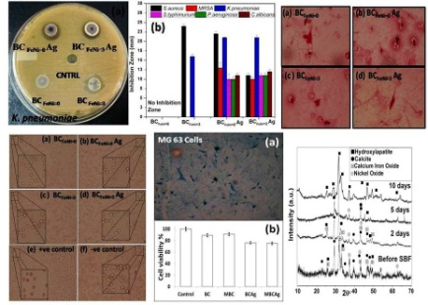
Image

Recent Publications (minimum 5)
- K Kaur, KJ Singh, V Anand, G Bhatia, AP Singh, M Kaur (2019) Elucidating the Role of Size of Hydroxyl Apatite Particles towards the Development of Competent Antiosteoporotic Bioceramic Materials: In Vitro and In Vivo Studies Journal of Biomedical Materials Research Part A( Under Press)
- Mridula Dogra, KJ Singh, Kulwinder Kaur, Vikas Anand (2019) Gamma ray shielding properties at 129· 5 MBq and structural investigations of the Bi2O3–B2O3–K2O–Li2O–V2O5 glass system Physics and Chemistry of Glasses-European Journal of Glass Science and Technology Part B 59(6) 293-300
- N Sarin, KJ Singh, K Kaur, V Anand, R Kaur, J Singh (2018) Investigation of the effect of doping of Cr2O3 on bioactivity properties of the SiO2-CaO-P2O5bioceramics AIP Conference Proceedings 1953 (1), 090073
- M Dogra, KJ Singh, K Kaur, V Anand, P Kaur, P Singh, BS Bajwa (2018) Investigation of gamma ray shielding, structural and dissolution rate properties of Bi2O3-BaO-B2O3-Na2O glass system Radiation Physics and Chemistry 144, 171-179
- K Kaur, KJ Singh, V Anand, N Islam, G Bhatia, N Kalia, J Singh(2018) Lanthanide (= Ce, Pr, Nd and Tb) ions substitution at calcium sites of hydroxyl apatite nanoparticles as fluorescent bio probes: Experimental and density functional theory study Ceramics International 43 (13), 10097-10108
- K Kaur, KJ Singh, V Anand, G Bhatia, R Kaur, M Kaur, L Nim, DS Arora (2017) Scaffolds of hydroxyl apatite nanoparticles disseminated in 1, 6-diisocyanatohexane-extended poly (1, 4-butylene succinate)/poly (methyl methacrylate) for bone tissue engineering

Biography
I am working in the field of biomaterials since 2016. I have completed my Doctorate from Guru Nanak Dev University, Amritsar India. Topic of my research was “Silica based bioceramics for bone regeneration Applications.” Currently along with research, presently I am enjoying the teaching of Physics for Master level students. I have conquered twice the Best Poster Award in International Conferences. I also grave the Scholarship opportunity from UGC (MHRD), Govt. of India for my research on biomaterials. Email: vikasnand00@gmail.com

