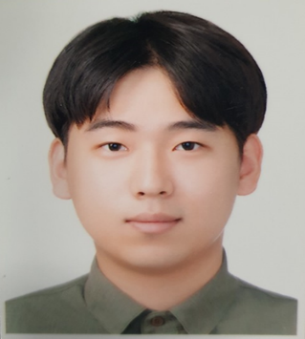
Title: Numerical Analysis for Robust Design of FACVD Chamber

Name: Hyo.Seong.Lee
School of Mechanical System & Automotive Engineering, Chosun University, 309 Pilmun-daero, Dong-gu, Gwangju 61452, Korea

The conventional polymer thin film deposition CVD (Chemical Vapor Deposition) system has a limitation in deposition of various substrates as a deposition system in a high temperature environment (Especially High temperature and high pressure environment). FACVD (Filament Assisted Chemical Vapor Deposition) is a method of causing a radical reaction of an initiator by a filament and reacting with a monomer and being deposited on a surface at room temperature. It is possible to form an organic thin film under low temperature and low vacuum process conditions. Therefore, it is an advanced thin film deposition system capable of depositing on a substrate sensitive to temperature, such as cotton, paper, and etc. This study aims to derive optimal chamber design by numerically analyzing the behavior of monomer in gas phase during FACVD process.
Through the visualization of the gas flow in the chamber and the thin film deposition, the analysis was carried out using the Commercial FEA tool (COMSOL®) for the process conditions and optimum design of the chamber. For the analysis, the heat transfer module, convection diffusion module and the chemical reaction module were sequentially used to visualize entire process which are flow of the initiator and the monomer gas, thermally decomposed by the filament and the deposition reaction respectively. A parametric study has been performed to design an optimal chamber structure that achieves uniform thin film thickness distribution.
As a result of analysis, it is confirmed that the optimized chamber produces uniform thin film area of 300mm X 300mm. The numerical approach to chamber design was well validated by compare the thickness of thin film between FEA and experimental result. Thin film thickness difference between analyzed and actual deposited was found less than 5%.

Biography
Hyo Seong Lee is currently 25 years old and is in the process of obtaining a master's degree from Chosun University. He is currently working on the optimization of ICVD (Initiated Chemical Vapor Deposition) reactor, a functional polymer Nano thin film process. He is studying the reliability improvement of the ICVD Reactor system through numerical analysis.

Presenting author details
Full name: Hyo Seong Lee
Contact number: +82622307095
Twitter account: x
Linked In account: x
Session name/number: Industrial Applications of Nanotechnology/Track 7
Category: Oral presentation

