BIOMIMICRY BASED ON LEPIDOPTERS AS AN INSPIRATION FOR THE DESIGN AND CONSTRUCTION OF AN ECOLOGICAL PROTOTYPE.
Mojica L, SF UNIMETA, COL
Quiñonez F, SF UNIMETA, CO

Abstract
The materials to make ecological or environmentally friendly buildings are called ecomaterials, either because they come from sustainable crops or from sustainable production processes. When proposing activities of environmental bioengineering and sustainable architecture, we took on the task of looking for materials that were apt to be used in constructions that were sustainable, that is, with an ecological functionality; inspired by nature. As defined by the concept of biomimicry (Rinaldi, 2007) is "The science that [...] reference to the process of understanding and applying to human problems, solutions coming from nature in the form of biological principles, biomaterials, or of any other nature”Colombia is one of the countries with the greatest diversity of diurnal butterflies, with approximately 3,500 species described so far, of which 300 are endemic (Heppner, 1991). This wealth is due to the topographical variety, combined with its geographical position, which includes habitats linked to the Amazon, rainy plains, Andean altitudes, deserts and forests. Specifically in the eastern plains, this convergence of ecosystems provides special environments that allow great variability of lepidopteran species. What facilitates the approach of environmental projects of environmental bioengineering, sustainable architecture and bioclimatic that are related to the analysis and characterization of native species. These actions are fundamental to carry out biomimicry activities based on our biodiversity. If we want to biomimetize in the three levels the natural form, the natural process and the natural system, we must start by doing what all well-adapted organisms have learned to do, which is to create conditions.(Benyus, 2008). The constructed prototype comes from the bioinspiration of the lepidopters, and the biomimetic base of the structure was based on the wing of the butterfly, both for its design and for its construction.

Image

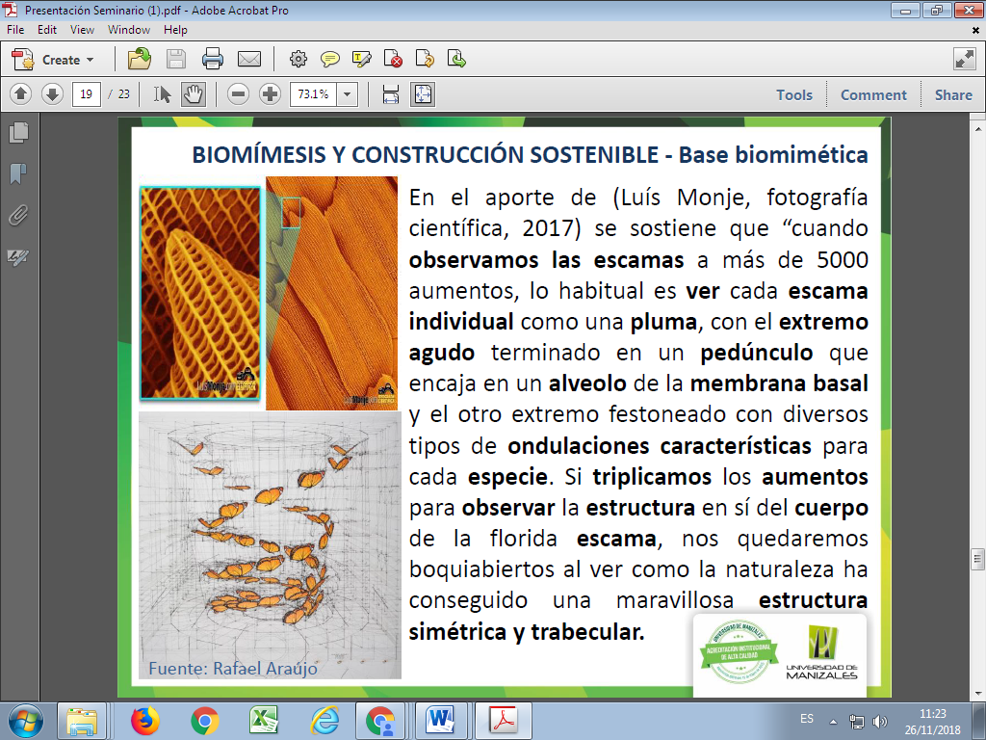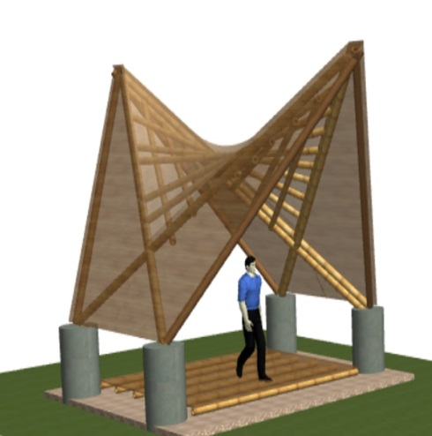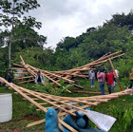

Figura 1: Luís Monje, 2017 – butterfly scales Figura 2: Render, Lina Mojica, Francisco Quiñonez, 2017 Figura 3: Guadua structure Lina Mojica, Francisco Quiñonez, 2017
Recent Publications

1. Sánchez LM, Quiñonez MF (2017) Iriartea deltoidea & Socratea exhorriza: Sustainable production alternatives for integrated Biosystems ISSN 2168 – 0022.
2. Mojica L, Castañeda A (2015) Climate change and sustainable development, Universidad Autónoma de Nuevo León – Monterrey – México: Analysis and projection of climate change in the ecosystems of Meta department ISBN 978-3-659-09093-6:271.

3. Mojica L, Castañeda A (2010) young researches - INICE Salamanca - España: Influence of climate change on the ecosystems of Meta department in Colombia ISBN 978-84-937854

4. Quiñonez F, (2016) TERRA Contemporary architecture on land: Contemporary architecture in heritage contexts in Colombia
ISBN 978-958-8939-52-0:183-191
5. Quiñonez F, (2011) Smithsonian folklife festival, Colombia, Peace Corps, Rhythm AND BLUES: Desing and Architecturea. Smitsonian ISSN 1056-68055:78

Biographies

Lina Fernanda Mojica Sánchez: Colombian environmental engineer specializing in the formulation and evaluation of projects from UNIMETA. She is currently doing her research thesis on biomimicry and ecourbanism of her master's degree in environment and sustainable development at the age of 33 years old from Manizales University. She is the director of the Environmental Research Department - CIAM, which promotes the approach and execution of proposals for sustainable development.
Email: lina.mojica@unimeta.edu.co, Ingambiental.urbanistic@gmail.com

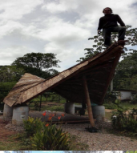
Francisco Alberto Quiñonez Mosquera: Colombian architect specialized in Environmental Planning and Integral Management of Natural Resources, advanced courses in landscaping, bioclimatic and builder in guadua and wood. Elementary school teacher in architectural drawing and construction. Researcher professor at UNIMETA focuses on the innovation and development of clean, sustainable, ecological and bioclimatic construction techniques, seeking the optimization of resources, as well as the search for a balance between social-ancestral and technological-autonomous. Construction of the Colombia Pavilion The Nature of Culture at the Smithsonian Folklife Festival W ashington D.C. 2011. Email: francisco.quinonez@unimeta.edu.co gerencia.arquiguadua@gmail.com

