High temperature tribological properties of surface hybrid Cu-Ni-W composite fabricated via friction stir processing

Mohsen Pezeshkian^{1,*}, Iman Ebrahimzadeh², Farhad Gheravi³,

^{1,2}Advanced Materials Research Center, Department of Materials Engineering, Najafabad Branch, Islamic Azad University, Najafabad, Iran.
³Department of Materials Engineering, Sirjan Branch, Islamic Azad University, Sirjan, Iran

Abstract
In this study, the Friction Stir Processing was used for the production of surface hybrid composites on pure copper to provide a solution for improving wear resistance and reducing adhesion in mechanisms made of pure copper with rotational (cyclical) nature that are also in contact with steel counterpart. To this end, a combination of nickel and tungsten particles with micrometer dimensions and volume percentages of 70vol% Ni + 30vol% W and 40vol% Ni + 60vol% W were used as reinforcement particles in the composites. The SEM images and EDS analysis of the stir zone of produced composite samples for evaluation of the microstructure generated from the process indicated some nickel has remained in agglomerated form in the stir zone of composited samples. Also, in addition to proper distribution in the processed region of the samples, the tungsten particles are also trapped in areas rich in nickel. The pin-on-disc test was also used to assess the resistance to abrasion of generated hybrid metal matrix composites. The test results indicated that with the increase in volume percent of tungsten, the stick-slip phenomenon dramatically decreased in the Cu / Ni / W composite. The SEM images of the worn surfaces among composited samples and counterparts suggested the developing of four wear mechanisms of abrasion, delamination, adhesion, and thermal softening individually or as combined in wear tests at high temperatures.

Image

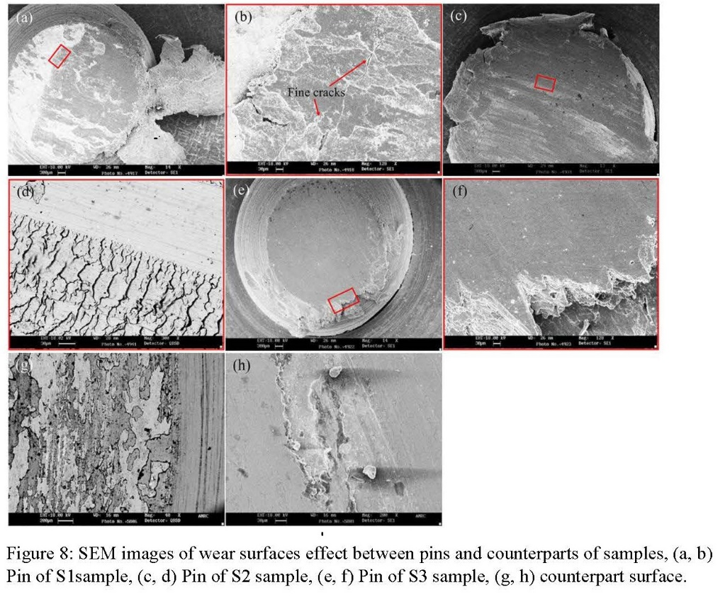

Recent Publications

- Mohsen Pezeshkian, Iman Ebrahimzadeh, Farhad Gharavi (2017), Fabrication of Cu surface composite reinforced by Ni particles via friction stir processing: microstructure and tribology behaviors, ASME Journal of Tribology, DOI: 10.1115/1.4037069.
- Mohsen Pezeshkian, Saeideh Shafaiepour (2015-2), Heat input effects on microstructure quenched and tempered steel ASTM A517 to stainless steel AISI 316L, Journal of welding and joining, South Korea welding society, Vol. 33, Issue 1, pp. 41-48, DOI: 10.5781/JWJ.2015.33.1.41.
- Mohsen Pezeshkian, Saeideh Shafaiepour (2014), Groove Angles Influence on Mechanical and Microstructural Properties of P460N Steel in SMAW, Advanced Materials Research Vols. 891-892, pp 1551-1558.
- Mohsen Pezeshkian, M. Tafazoli, M. Mirjani (2007), VSR Technique in Marine Pressure Vessel Industry, 4th Conference of Underwater Science & Technology (ffcoust), Iran.
- Mohsen Pezeshkian (2006), C – Scan Immersion Testing Technique, 7th Metallurgical Conference, Iran.


Biography
Mohsen Pezeshkian is graduated in the engineering of welding materials. He is currently working as a researcher and inspection officer at TECHIN Inspection and Corrosion Control Company. He has been collaborating with the Advanced Materials Research Center at Najafabad University since 2014. He is engaged in the construction and installation of refinery and petrochemical complex equipments and marine structures, too.

* Corresponding Author Email: r.m.pezeshkian@gmail.com

Notes/Comments:

