Ni-Based Nanowire Co-catalysts Integrated with a Si Photoanode for Efficient Water Oxidation
Meshal S.AlJohani, Researcher, King Abdulaziz City for Science and Technology, Saudi Arabia.
Talal AlJohani, Abduljalil AlJadani, Mohammed AlThehaiban, and Bandar AlOtaibi*

Abstract (300 word limit)

Photoelectrochemical water splitting is a sustainable pathway to produce clean hydrogen fuel. Due to the slow kinetics of the oxidation evolution reaction (OER), the realization of an efficient photoanode remains a great challenge. To lower the overpotential (η) for OER, crystalized and amorphous metal oxides integrated with photoanodes have been recently utilized as excellent co-catalysts. Considering the high cost of noble metal oxide catalysts due their scarcity, such as IrO2 and RuO2, earth-abundant transition metal oxides, such as Ni-based nanowire electrocatalysts, hold promises for cost-effective and yet efficient water splitting. Compared to the limitation in charge extraction capability and light blocking of the conventional particle-based co-catalysts, the flexibility of engineering the morphology and the surface properties of templated Ni-based nanowire co-catalyts is enormous. That is, highly-ordered templated Ni-based nanowire co-catalyts can be advantageous for their light trapping, large surface-to-volume ratio, rapid carrier extractions, anti-reflection properties beside lowering the overpotential (η).

We demonstrate that engineering the morphology of templated Ni-based nanowire co-ctaltysts on Si photoanode can lead to efficient OER. We shall further show that optimizing the surface properties of the nanowire co-catalysts by incorporating other divalent metal dopants such as Co and Fe can lead to efficient and stable water oxidation with low overpotentials.

In this work, Ni-based nanowires arrays are deposited electrochemically and physically on various substrates using ultrathin anodic aluminum oxide (AAO) template. The length, diameter and thickness of nanowires can be varied depending on the pores’ dimensions and thickness of the AAO membrane leading to controllable co-catalysts morphology. Shown in Fig. 1 is the scanning electron microscopy (SEM) image of pristine NiO nanowires deposited electrochemically on ITO substrate. We shall further show that by optimizing the surface charge properties through the deposition techniques and incorporating Co and Fe dopants, the overpotential for OER can be substantially reduced. Full electrochemical properties using three-electrode configuration in NaOH electrolyte will be presented. Further elemental and structural properties of the nanowire co-catalysts shall be thoroughly discussed.

In brief, the use of such nanowire co-catalysts integrated with Si photoanode for high efficient and stable photoelectrochemical water splitting shall be demonstrated. This detailed study confirms that the morphology and surface Ni-based nanowire co-catalysts doped with Co and Fe can lead to lower OER overpotential.

Image

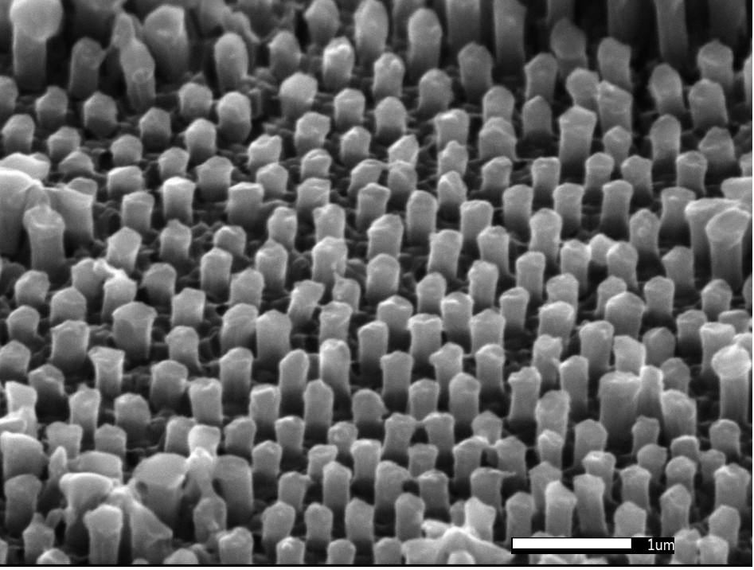
Fig. 1. SEM image of NiO nanowire arrays electrochemically deposited on ITO substrate.

Recent Publications (minimum 5)
- Asif Mahmood, Shahid Mahmood Ramay, Yousef S. Al-Zaghayer, Muhammad Imran , Shahid Atiq, Meshal S. Al-Johani. " Magnetic and photocatalytic response of Ag-doped ZnFeO nano-composites for photocatalytic degradation of reactive dyes in aqueous solution" Journal of Alloys and Compounds, 614 (2014) 436–442.
- Meshal S.Al-Johani, Yousef S.Al-Zaghayer, Sulaiman I.Al-Mayman, “TiO2/ZnO Photocatalytic Activity for Hydrogen Production’’, International Conference on Environment and Renewable Energy, Vienna, May 20-21, 2015.
- Almayman Sulaiman, Imed Ghiloufi, Ibrahim AlShunaifi, Abdullah Albeladi, Meshal AlJohani, “ Treatment of fly ash from power plant using thermal plasma”, European Materials Research Society, Lille, Spring meeting 02-06 May 2016.
- Sulaiman I. Al-Mayman, Meshal S. Al-Johani, Mohamed Mokhtar Mohamed,Yousef S. Al-Zeghayer ,Shahid M. Ramay, Abdulrahman S. Al-Awadi, Moustafa A. Soliman. "TiO2-ZnO photocatalysts synthesized by sol-gel auto-ignition technique for hydrogen production” International Journal of Hydrogen Energy, 42 (2017) 5016-5025.

5. Sulaiman Al-Mayman, Meshal Al-Johani, Kirill Borisevich, Naif Al-Abbadi, Abdullah Al-Musa, Andrey Krauklis Pavel Stanovoi. "Syngas Production at Methane Decomposition in the Plasma of Atmospheric Pressure High-Voltage Discharge” Heat transfer Research, (2018), accepted to publish.


Biography (150 word limit)
Meshal Aljohani has been working as an academic researcher at King Abdulaziz City for Science and Technology since 2016. He received his master’s degree in Chemical engineering from King Saud University in 2015. His master degree entitle Photocatalytic production of hydrogen from ethanol-water solution using TiO2 – ZnO.. He has been accomplishing in many projects interest in hydrogen production from hydrocarbons by partial oxidation and thermal plasma. Meshal is currently working on Fabrication of a Solar Water-Splitting Device project collaboration with the University of Cambridge, which is aiming to produce hydrogen from renewable energy sources. Current work focus on oxides and perovskite-based materials to achieve highly efficient and stable solar to fuel with low cost and high scalability.
Email: maljuhni@kacst.edu.sa

Notes/Comments:

