Advances in 3D Printing in Biomaterials for Orthopaedic Applications

Dan Li^{1, 2}, Pravin Vence¹, Yaoyi Huang², Hong Shen², Yunlong Ma², Yuanzheng Ma²
¹ Northwestern University, Chicago, Illinois
² 309th Hospital of the PLA, Beijing, China
3D Printing aims to deliver intricate biomedical devices based upon advanced diagnostic imaging. With the current upsurge in public interest and increasing access to low-cost printers, efforts are underway to produce patient-specific anatomical models, customized implants, and individualized instrumentation. Examples include the development of disposable surgical saw guides and cutting blocks in total knee arthroplasty. These devices help minimize tissue loss and optimize the native biomechanics of the patient. This review explores the evolution of 3D Printing technology in the context of biomaterials. It also aims to critiques the major challenges ahead in optimizing bioinks and biologic performance in bringing 3D bioprinting to clinical practice.
Common materials include metals, bioceramics, synthetics, and natural polymers; each have specific mechanical properties, processing methodology, and cell-material interaction. Biofunctional biomaterials are an emerging class of materials that display adaptability and activity at every phase of bone growth. These biomaterials have been shown to promote osteogenic differentiation, improve calcium phosphate (CaP) precipitation, and regulate osteoblast gene expression. When crafted to emulate the specific micro-environment of bone, polymer-surface modifications accelerate bony ingrowth.

3D printing holds promise as a scaffold for bone regeneration as precise control of the overall geometry and internal porous structure. The accompanying biomaterials may be successfully embedded within multi-cellular co-cultures and specific growth factors modulated to optimize growth and fixation [2, 6]. Bioceramics such as hydroxyapatite (HA), calcium phosphate, and bioglass, are osteogenic and promote cell proliferation, though they have been shown to lack appropriate mechanical strength.
Composite scaffolds of HA and tricalcium phosphate and polycaprolactone (PCL)-HA with carbon backbones have been investigated to optimize biocompatibility and architecture to improve the porosity and mechanical strength of these constructs. Furthermore, microscale manipulation of biomaterials allow for integration of antimicrobial properties to combat infection.
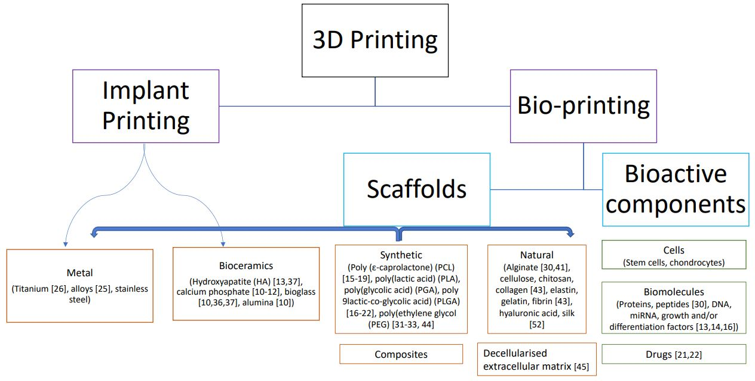
Publications:
Turin SY, Li D, Fine NA, Vaca E. “Nitroglycerin Ointment for Reducing the Rate of Mastectomy Flap Necrosis in Immediate Implant Based Breast Reconstruction.” Plastic and Reconstructive Surgery, June 2018, E-published ahead of print.
Butler BA, Fitz DW, Lawton CD, Li D, Balderama ES, Stover, MD. “Early Diagnosis of Septic Arthritis in Immunocompromised Patients.” Journal of Orthopaedic Science, vol. 23, no. 2, 5 Mar. 2018
Li D, Pengfei L, Linfeng F, Huang Y, Yang F, Mei X, Wu D. “The Immobilization of Antibiotic-Loaded Polymeric Coatings on Osteoarticular Ti Implants for the Prevention of Bone Infections.” Biomaterials Science, vol. 5, no. 11, 2017, pp. 2337–2346.
Li D, Li L, Ma Y, Zhuang Y, Li D, Shen H, Wang X, Yang F, Ma Y, Wu D. “Dopamine-Assisted Fixation of Drug-Loaded Polymeric Multilayers to Osteoarticular Implants for Tuberculosis Therapy.” Biomaterials Science, vol. 5, no. 4, 2017, pp. 730–740.
Kuiken TA, Bennet BA, Sharkey T, Ivy AD, Li D, Peabody TD. “Novel Intramedullary Device for Lengthening Transfemoral Residual Limbs.” Journal of Orthopaedic Surgery and Research, vol. 12, no. 1, 2017
Fu S, Rossero J, Chen C, Alzgheir R, Li D, Takoudis, C. “On the Wetting Behavior of Ceria Thin Films Grown by Pulsed Laser Deposition.” Applied Physics Letters, vol. 110, no. 8, 2017

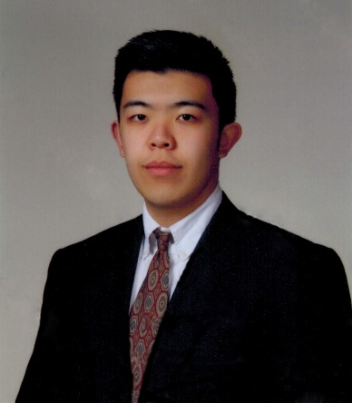
Daniel (Dan) Li has participated in a wide variety of both basic and clinical research regarding biomaterials in the context of orthopaedic applications, such as the use of hydrogels as a novel drug-eluting mechanism to combat osteomyelitis and tuberculosis infection. He has spent significant time overseas with the orthopaedics department at the 309th Hospital of the PLA in Beijing, China, working under the team of Dr. Yuanzheng Ma, as well as completing his undergraduate degree in Materials Science and Engineering at the University of Illinois. There, he conducted research under the John Rogers Research Group investigating novel biodegradable electronics. Currently, he is performing clinical outcomes research at Northwestern University regarding the evaluation of prosthetic joint infection.

Daniel.li1@northwestern.edu
630-917-5096
Poster Presentation

