Developing Superhydrophobic Copper/Graphene Nanoplatelets Coatings by Plasma Spraying
T. Forati¹, F. Ben Ettouil¹, T. Kaydanova², N. Moghimian²,
C. Moreau¹, M. Pugh¹, and A. Dolatabadi¹
1. Concordia University, Canada
2. Nanoxplore Inc., Canada

Abstract

Water vapor condensation is frequently used as an effective method of transferring heat using drop-wise condensation on non-wetting surfaces demonstrating enhanced heat transfer when compared to film-wise condensation. The aim of this study is to develop hierarchical surface morphologies on superhydrophobic coatings with high water repellency and mobility using atmospheric plasma spraying (APS). The novelty of this work lies in the processing of the plasma sprayed copper/graphene nanoplatelets (GNPs) composite coatings. Retention of the GNPs was made successful by controlling the plasma power and particle injection angle to minimize the temperature and consequently prevent the combustion of GNPs. Several coatings were developed with different surface morphologies. By isolating the effect of surface chemistry using a stearic acid treatment the significance and effect of the achieved morphologies on the wetting behavior of the coatings were investigated. Experimental results demonstrated that coatings produced by the APS process showed excellent water repellency and water mobility: water contact angles as high as 162° as well as water sliding angles less than 1° were achieved due to the hierarchical roughness attributed to the submicron size particles in the feedstock. Moreover, results indicated that Cu/GNPs is a promising surface coating to promote dropwise condensation of water in industrial conditions due to its robust chemical stability with the potential for scalable applications while maintaining low thermal resistance.

Image

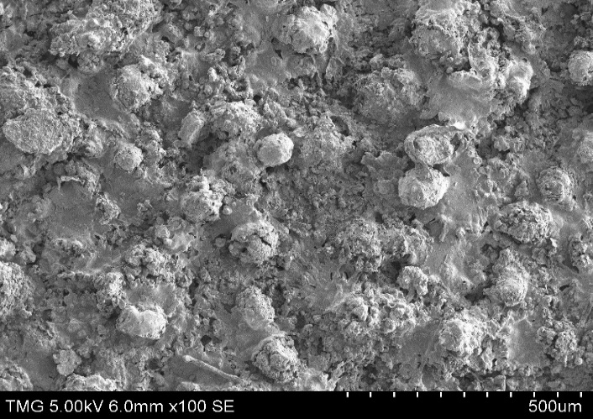
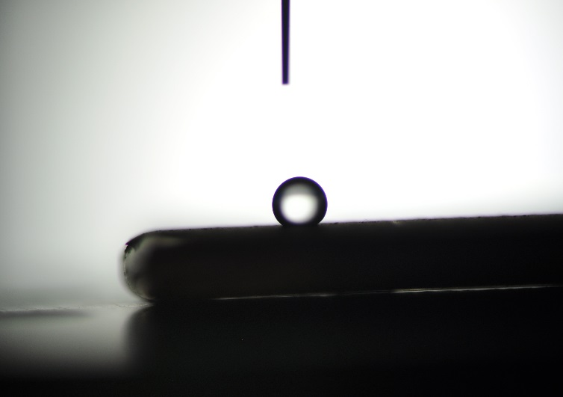
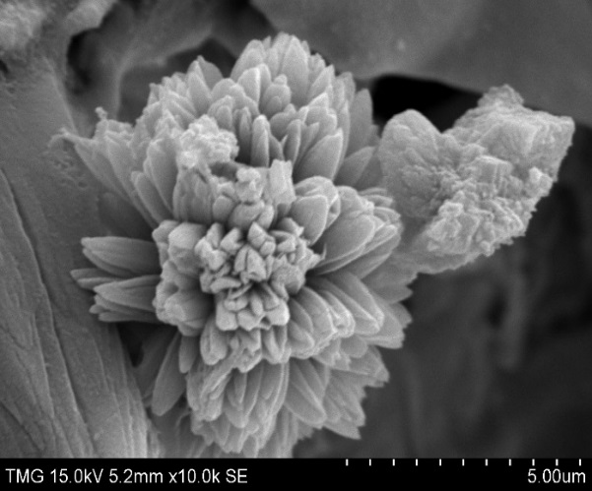
$Ɵa$ve≈162°

Figure 1: The SEM micrographs of the Cu-GNPs coating. Inset: a sessile drop of water on this surface.

Recent Publications
- Daniel J. Preston, Daniela L. Mafra, Nenad Miljkovic, Jing Kong, and Evelyn N. Wang" Scalable Graphene Coatings for Enhanced Condensation Heat Transfer", Nano Lett. 2015, 15, 2902−2909.
- Gun-Tae Kim, Su-Ji Gim, Seung-Min Cho, Nikhil Koratkar, and Il-Kwon Oh “Wetting-Transparent Graphene Films for Hydrophobic Water-Harvesting Surfaces”, Adv. Mater. 2014, 26, 5166–5172
- Tong Y, Bohmb S, Song M. "Graphene-based materials and their composites as coatings", Austin J Nanomed Nanotechnol. 2013, 1(1), 1-16.
- Singh Raman RK, Chakraborty Banerjee P, Lobo DE, Gullapalli H, Sumandasa M, Kumar A, et al. “Protecting copper from electrochemical degradation by graphene coating.”Carbon N Y. 2012, 50, 4040–40453.
- David Ward, Ankur Gupta, Shashank Saraf, Cheng Zhang, Tamil Selvan Sakthivel, Swetha Barkam, Arvind Agarwal, Sudipta Seal “Functional NiAl-graphene oxide composite as a model coating for aerospace component repair” Carbon, 2016, 105, 529-543

 Biography

Tahmineh Forati has expertise in the field of surface engineering, materials analysis, surface characterization and applications of nanostructured functional materials. She is particularly experienced in various thermal spraying coating techniques. And this work is part of a MITACS project in collaboration with Thermal Spray & Multiphase Flow Laboratory at Concordia University and Nanoxplore Inc. (industrial partner) in Montreal, Canada
Email: Tahmineh.forati@gmail.com

Notes/Comments:

