In silico study of the self-assembly and gelation of sugar derivatives

Dr. Dafna Knani, ORT Braude College, Karmiel, Israel

Abstract (300 word limit)

Low molecular weight gelators are molecules capable of forming gels in which they are self-assembled into a physical 3D network of fibers, held together by noncovalent interactions like hydrogen bonds, van der Waals forces, and π−π-interactions. The organic gelator 1,3(R):2,4(S)-dibenzylidene-D-sorbitol (DBS) self-organizes to form a 3-D network at relatively low concentrations in a variety of nonpolar organic solvents and polymer melt. DBS could be transformed into a hydrogelator by introduction of hydrophilic groups, which facilitate its self-assembly in aqueous medium. In this work, the self-assembly of DBS and its derivatives was investigated by molecular modeling. A dynamic molecular simulation was carried out using atomistic and quantum tools included in the Material Studio 8.0 (by Biovia) software. Various properties (Cohesive Energy Density, Mixing energy, Radial Distribution Function) were calculated to illustrate the interactions that govern the self-assembly of the examined compounds. The results of the simulation indicate that the interaction between DBS-COOH molecules is stronger than DBS-CONHNH₂ and DBS and its water compatibility is the highest. Therefore, DBS-COOH seems to be a better hydrogelator than DBS-CONHNH₂ and DBS. Intermolecular H-bonding interactions are formed between the three molecules as pure substances, and they dramatically decrease in the presence of water. In contrast, the intramolecular interactions increase in water. This result indicates that in aqueous environment the molecular structure tends to be more rigid and fixed in the preferred conformation. Due to H-bonds, DBS and its derivatives form a rigid structure which might explain their tendency to create nanofibrils. In order to obtain effective hydrogelators, fine-tuning of the balance between the hydrophilic (soluble) and hydrophobic (insoluble) parts is essential.

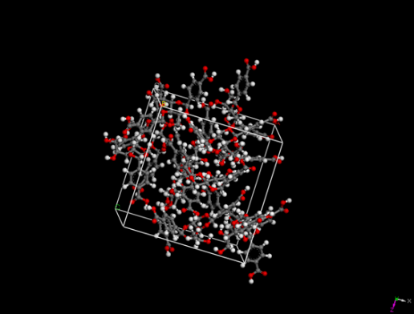
Fig .1: Periodic cubic cell of DBSCOOH, after 500ps dynamic simulation

Recent Publications (minimum 5)
1. D. Alperstein, D. Knani, N. Borchmann, M. Spekowius, C. Hopmann. Prediction of environmental stress cracking in polycarbonate by molecular modeling, Polymers for Advanced Technologies , 25 ,1433–1438 (2014). DOI: 10.1002/pat.3384
2. D. Knani, D. Alperstein, Th. Kauth, D. Kaltbeitzel, Ch. Hopmann. Molecular modeling study of CO₂ plasticization and sorption onto absorbable polyesters, Polymer Bulletin, 72 (6), 1467-1486 (2015). DOI: 10.1007/s00289-015-1349-9
3. D. Alperstein, D. Knani. Design of novel plasticizers for Nylon: from molecular modeling to experimental verification, Polymers for Advanced Technologies, 28(1), 53-58 (2017). DOI: 10.1002/pat.3856
4. D. Knani, Hilla Barkay-Olami, David Alperstein, Meital Zilberman. Simulation of novel soy protein-based systems for tissue regeneration applications, Polymers for Advanced Technologies, 28(4), 496–505 (2017). DOI: 10.1002/pat.3918
5. D. Knani, D. Alperstein. Simulation of DBS, DBS-COOH and DBS-CONHNH2 as hydrogelators. The Journal of Physical Chemistry Part A, 121(5):1113-1120 (2017). Doi: 10.1021/acs.jpca.6b11130.

Biography (150 word limit)
Dafna Knani is a senior lecturer at the department of Biotechnology Engineering, ORT Braude College. Currently she is the head of MSc program in biotechnology. She is an organic polymer chemist, graduated from the chemistry faculty, Technion- Israel Institute of Technology. In the past, she worked for Surgical bio-polymeric materials start-up company (developing adhesives for hard tissues) and as a research chemist and project leader at Israel Chemicals Ltd. Her current research focuses on molecular modeling of materials and biomaterials, especially simulation of systems used for controlled drug release and tissue engineering.

Email: dknani@braude.ac.il

Notes/Comments:

