Study of Fragmentation and Ultrasonic flow impacts of several metal-based alloys

W. Du ¹, B. Wang ^{1,2}, T. L. Lee ^{1,3}, J. C. Kong ^{1,4}, B. Koe ^{1,5}, D. Tan ¹, W. Zhang ¹, C. Wang ¹, Y. Zhao ¹ T. Manuwong ¹, A. Sumayli ¹, T. Connolley ⁵, A. J. Bodey ⁵, J. Fife ⁶, K. Fezzaa ⁷, A. Rack ⁸, J. Mi ^{1*}

Abstract (300 word limit)
We present a number of highlight cases in our recent projects funded by the Royal Society and the EPSRC. Our focus is to study in real-time and in-situ the dynamic evolution of solidification microstructures under ultrasonic waves [1, 2] and pulse magnetic fields [3]. We have used the speciality beamlines from the Diamond Light Source, Advanced Photon Source, European Synchrotron Radiation Facility, and Swiss Light Source for our studies and worked closely with the relevant beamline scientists when did the work. We also used the high performance supercomputer, Viper, housed at Hull University to process and analyze the many hundreds of TB data acquired from the experiments. Our research demonstrates that real-time and in-situ visualisation of the dynamic microstructural evolution is absolutely essential for elucidating some of the ambiguities or missing links in the classical theories concerning the solidification processes of metal alloys. Real-time evidence shows that the shock wave created at ultrasonic bubble implosion and the pinch stresses produced by the electromagnetic pulse are very effective in causing the fragmentation of dendrites or intermetallic phases, promoting greatly the grain multiplication effect, and therefore enhancing grain refinement.

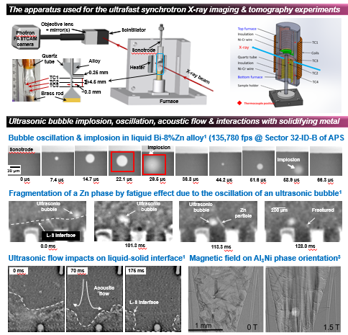

Reference
[1] B. Wang & J. Mi (2018) Ultrafast synchrotron X-ray imaging studies of microstructure fragmentation in solidification under ultrasound, Acta Materialia, Vol.144, 505-515
[2] F. Wang & J. Mi (2017) A synchrotron X-radiography study of the fragmentation and refinement of primary intermetallic particles in an Al-35 Cu alloy induced by ultrasonic melt processing, Acta Materialia, Vol.141, 142-153
[3] W. Du & J. Mi (2018) Real-time synchrotron X-ray imaging and tomography studies of the dynamic evolution of intermetallic in solidification under pulse electromagnetic fields, Acta Materialia, submitted in June 2018

Biography
My name is Abdulrahman Sumayli. I am a Ph I am PhD student in Advanced Materials group, School of Engineering and Computer science, University of Hull. I am in the second year of my PhD studies. My research is fund by Saudi Arabian Cultural Burea in London. I did a ~Bachelor at King Abdulaziz University in Mechanical Engineering and I did Master degree at Sheffield University in Advanced Mechanical Engineering.
My PhD research will be focus on corrosion resistance of bulk glasses metallic (BMGs) amorphous alloys and the likelihood to use them as biocompatible materials.

Email: A.I.Sumayli@2016.hull.ac.uk

Abdulrahman Sumayli
PhD Students
University of Hull

