SOME FEATURES OF THE DUCTILE AND GRAY IRON MICRUSTRUCTURES PROVIDING INCREASE OF THEIR IMPACT RESISTANCE

Igor Tkachenko, Kostyantyn Tkachenko, Victoria Miroshnichenko
Priazovsky State Technical University, Mariupol 87500, Ukraine

Low impact resistance of the ductile and especially gray irons is well known problem of their performance. Commonly accepted statements concerned with the problem are dominant graphite particle morphology ill effect on the resistance and impossibility to improve the morphology by means of any type of heat treatment. Aim of the report is to outline basic microstructure features for the above industrial pearlite matrix irons in their states with high impact resistance provided by developed novel heat treatment. The treatment comprised typical austenitizing, 2…7 hours isothermal holding at 600…900 ⁰C during cooling or heating and final air-cooling. The Ménage impact tests were conducted at room temperature. The results obtained showed considerable increase in the impact strength of both the above optimally heat treated irons (up to KCU ∼ 550 kJ/m² ) comparing with their conventionally normalized states: KCU∼ 65 kJ/m² and ∼120 kJ/m², respectively, for the gray and ductile iron. The revealed performance improvements are attributed to the phase transformations preferable development on the hetero-phase interfaces with further cementite decomposition and initial graphite particle partial solution among the ferrite fine grain surroundings. Initial and resulted microstructures of the investigated irons are shown on the figures.
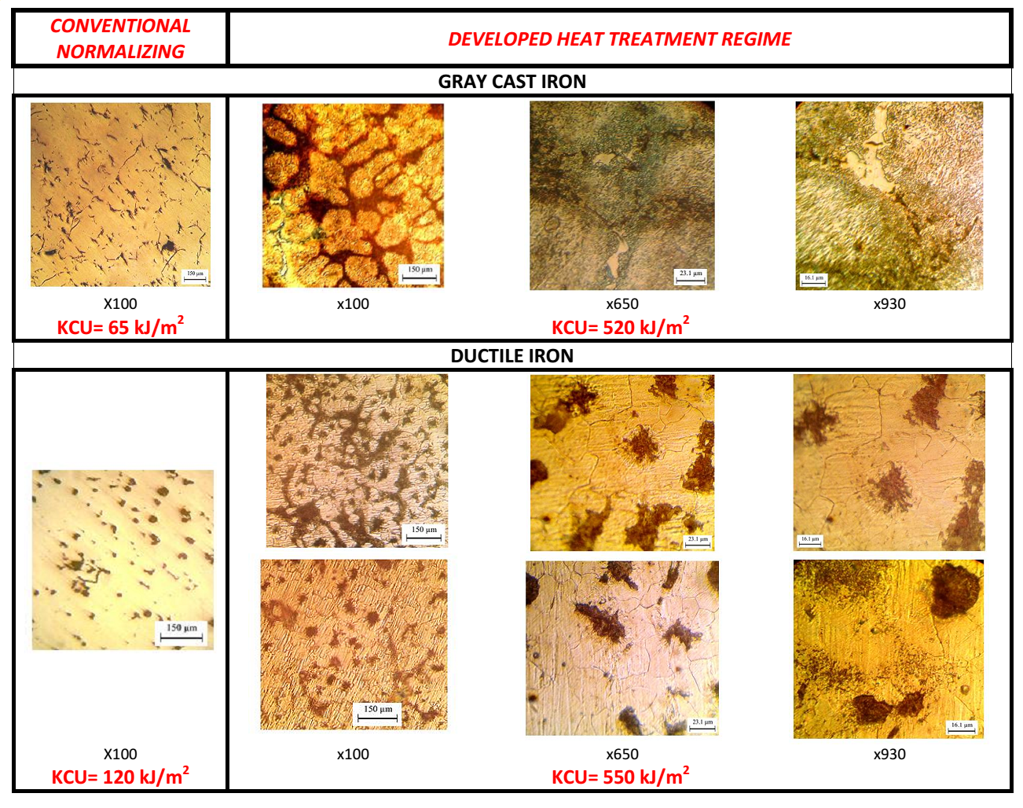

Biography

Igor Tkachenko is Doctor of Technical Science (DSc(Eng)), Professor of Material Science Department of Priazovsky State Technical University (Mariupol, Ukraine). He has over 30 year experience in improving quality and reliability of bulk structural alloy steel industrial products for demanding applications. He developed a number of novel research techniques and implemented some novel thick sheet manufacturing technologies in I&S Works of former USSR.
The reported results are particular findings within the frame of a novel metallic alloy heat treatment approach early theoretically grounded and industrially verified by him with the coauthors. The approach has provided: refinment and homogenizing microstructures; eliminating chemical inhomogeneities; drastically increasing the impact resistance for multi-element as cast and as hot deformed conventional low alloy steels.
Another area of his R&D efforts is computer statistically based revealing and simulations of significant effects of manufacturing and service invironments on industrial product performance with further multi-purpose optimization of currently applied technologies. Some relevant optimized steel chemical compositions and manufacturing technologies have been implemented in industry, providing increase effectiveness and promote sustainable development of steel metallurgy.

Kostyantyn Tkachenko is PhD since 2012. Except the research experience obtained within the the frame of the commonly developed approach, he has experimental and theoretical findings in prevention the hydrogen embrittlement and flake formation in steels. He developed a novel universal model allowing to describe the phenomena common mechanism, calculate “dangerous” hydrogen content in a steel product and predict the preventing treatment necessary duration, He designed a computer software package to quantitative modeling the hydrogen evacuation from steel parts of arbitrary form and size.

Victoria Miroshnichenko is MSc(Eng) and has research experience in mathematical simulations of grain boundary segregation kinetics, computer statistical investigations, computer aided control of various steel product cooling processes with focus on air-mist cooling

Presenting author details
Full name: Igor Tkachenko
Contact number: +380676088269, ift955@gmail.com
Twitter account:
Linked In account:
Session name/ number:
Category: (Oral presentation/ Poster presentation) Poster presentation

