Reheating Characteristics of Semi-solid Al alloy Fabricated by Cooling Slope Method
Ahruem Beck, Sedong Lee, Duckgyun Kim, Sugun Lim Dept. Metallurgical and Material Engineering , Gyeongsang National Unive., Jinju, South Korea

Abstract (300 word limit)
The production of the Semi-solid alloy can improve the mechanical properties and moldability of the alloy by forming fine granular structure by stirring or non-stirring the equiaxed grain produced upon dissolution / solidification of the alloy.
In this study, we fabricated semi-solid Al alloy by cooling plate and investigated the reheating characteristics for thixo-forming. The cooling plate angle is 30 degrees and length of 250mm. For the reheating of semi-solid Al alloys, fabricated alloys are reheated by using an electric resistance heating device. Optical microscopy, Scanning electron microscopy and Electron backscatter diffraction were performed to evaluate the microstructural behaviors of the alloys during reheating treatment. And the reheating treatment of semi-solid Al alloy for thixo-forming were proper to set liquid fraction within 10% after reaching target reheating temperature in order to control outflow of liquid metal in semi-solid forming.

Image

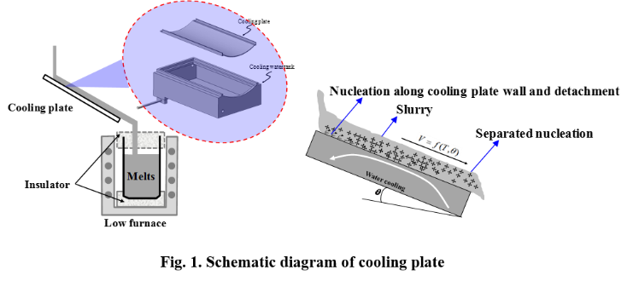

Recent Publications (minimum 5)
- E. Tzimas, A. Zavaliangos. (2000). Evaluation of volume fraction of solid in alloys formed by semi-solid processing. Journal of materials science 35. 5319-5329
- Sung-Young Shim. (2010) Fabrication of Semi-solid Al-Zn-Mg alloy by Cooling Plate Method and Characteristics of its Thixo-extruded.
- C. G. Kang, J. C. Choi, W. B. Bae. (2000). Semi-solid Forming, Casting and Forging Technology of lightweight material. Journal of the Kprean Society of Precision Engineering. Vol 7. No4, pp.7-21
- Dae-Hwan Kin, Seung-Hwa Choi, Hee-Kyung Kim, Sung-Yong Shim and Su-Gun Lim. (2010). J. Kor. Foundrymen’s Soc., Vol.30(6), pp. 235-240
5. J. Gilbert Kaufman, Elwin L. Tooy. (2004) Aluminum Alloy Castings-properties, process, and applications.

 Sugun Lim, Prof. Dr. Eng.

Understanding the effects of microstructure, morphology and composition on the properties of light materials

Utilizing these knowledge to design improvement including Al- and Mg- base alloys, Development of high performance light materials via microstructure control
Email: Suglim@gnu.ac.kr

Notes/Comments:

