Dynamic Analyses of Damping Alloy Sleeves for Boring
Yuto, Horigome, Gunma University, Japan
Fumihito Sakurai, National Institute of Technology, Gunma College, Japan
Shinichi Nishida, Gunma University, Japan

Abstract (300 word limit)
The NC lathe is one of the major metal cutting machine tool. The overhang amount of the tool become large at boring with the NC lathe. The tool vibration often become a problem at boring. The surface roughness and tool life are affected by the tool vibration. Therefore, it is necessary to reduce the tool vibration at boring with NC lathe. In this study, the application of damping alloy for the NC lathe sleeve was proposed. The characteristic of damping alloy is absorb vibration by transforming dynamic energy of the vibration into heat energy. A cutting experiment was operated by using the new type sleeve made of only damping alloy and the traditional type sleeve made of steel. The results such as vibration, surface roughness and tool life are compered between the both tools. The tool vibration became small and the tool life became long with new type sleeve compared to the traditional type sleeve. However the surface roughness became large by using new type sleeve. It is supposed that the rigid of new type sleeve is smaller than that of traditional type sleeve.
Therefore, the composite sleeve that was combined with damping alloy and steel was developed for improving the rigidity. As a result, the tool vibration using the composite sleeve indicated one fifth and the surface roughness became half compared to the steel sleeve. The vibration analysis based on this experimental results was studied to clarify the vibration mechanism. The modal analysis was operated with the structural analysis software by using 3D models. And the FFT analysis was operated by the vibration data. As a result, it was revealed that the natural frequency of cutting tool system with new type sleeve was changed compared to the traditional system. And it was revealed that the bending mode frequency was closed to the twist mode frequency.

Image
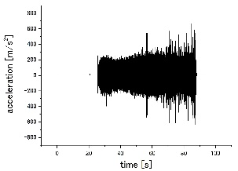
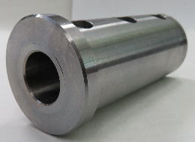
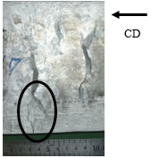
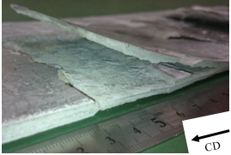

(b) Tool vibration of composite sleeve
(a) Composite sleeve

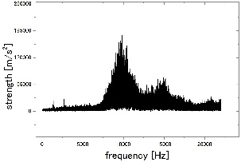
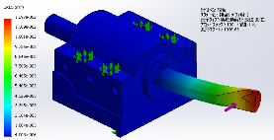

(d) FFT analysis
(c) Modal analysis
Fig.1 The composite sleeve, the tool vibration of the composite sleeve, the modal analysis and the FFT analysis

Recent Publications (minimum 5)
- Shivaraj S. Vadgeri, Sunil R. Patil and Sandip T. Chavan, Static and Fatigue Analysis of Lathe spindle for Maximum Cutting Force, materialstoday: PROCEEDINGS, Vol.5, Issue 2, Part 1, 4438-4444(2018).
- Vadim Khoroshailo, Viktor Kovalov and Predrag Dašić, Improving of Vibration Resistance of Boring Tools by Big Diameter Holes Tooling on Lathe, Procedia Technology, Vol.22, 153-160(2016).
- G. L. Chern and Jia-Ming Liang, Study on boring and drilling with vibration cutting, International Journal of Machine Tools and Manufacture, Vol.47, Issue 1, 133-140(2007).
- K. Venkata Rao, B. S. N. Murthy and N. Mohan Rao, Prediction of cutting tool wear, surface roughness and vibration of work piece in boring of AISI 316 steel with artificial neural network, Measurement, Vol.51, 63-70(2014).
- Satoshi Ema and Etsuo Marui, Suppression of chatter vibration of boring tools using impact dampers, International Journal of Machine Tools and Manufacture, Vol.40, Issue 8, 1141-1156(2000).



Biography (150 word limit)
Yuto Horigome is pursuing master degree program. He studied the characteristics of the damping alloy sleeve for boring at National Institute of Technology, Gunma College (NITGC). He entered Gunma University after graduating from NITGC, and he studies Machining Science.
Email: t181b069@gunma-u.ac.jp

Notes/Comments:

