Cold plastic forming of ABS plastic pipe: ABS plastic pipe
Kentaro Tsunoda, Gunma University, Japan
Shinichi Nishida, Gunma University, Japan
Junshi Ichikawa, Gunma University, Japan
Yuta Kashitani, Gunma University, Japan
Yuto, Horigome, Gunma University, Japan
Naoki Ikeda, Gunma University, Japan
Daichi Uematsu, Gunma University, Japan
Makoto Hagiwara, Gunma University, Japan
Hideto Harada, Gunma University, Japan
Nobuyuki Kamei, DIP Inc., Japan

Abstract (300 word limit)
This paper describes about cold plastic forming of ABS plastic pipe. Experiment and Finite element method (FEM) analysis of pipe expansion process were operated. The application of ABS plastic pipe for air conditioner is under consideration instead of metal pipe in Japan because of weight saving of air conditioner for lowering the gravity point against earthquake. The parts of ABS plastic pipe is generally produced by injection molding. The processes need the cooling time, and it takes much time. In addition, expensive mold die is needed for each application. Thus, cold plastic forming of ABS plastic pipe was proposed. The cold plastic forming of ABS plastic pipe chosen for this study is hardly studied by other authors. Product ability of cold plastic forming is higher than the injection molding or hot working. And the punch and die shape is simple comparing to these process. In this study, pipe expansion process was operated. The ABS plastic pipe has a 10 mm diameter and 8mm inner diameter and 1 mm thickness. At first, true stress and true strain curves at any strain rate were measured by ring compression test. Obtained flow stresses was used to FEM analysis. Experimental device for pipe expansion process was made by Dip Inc.. Objective inner diameter was 10 mm. FEM analysis was operated to clarify the deformation behavior such as load-stroke diagram. It was possible to produce the expanded ABS pipe. The whitening of worked pipe and strain recovery was observed. Analysis result was indicated the good agreement comparing to experimental result in load-stroke diagram.

Image
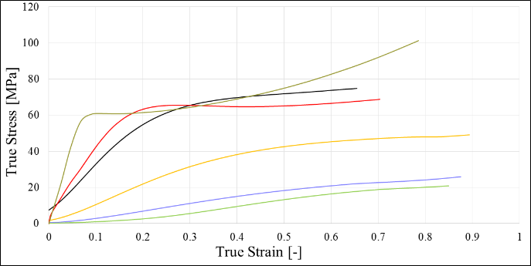
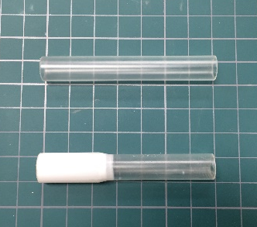
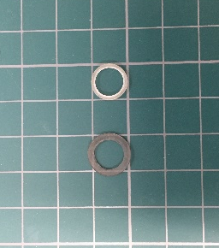
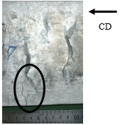
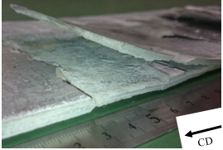

Fig.2 ABS pipe
Fig.1 Ring compression test
Fig.3 Flow curve
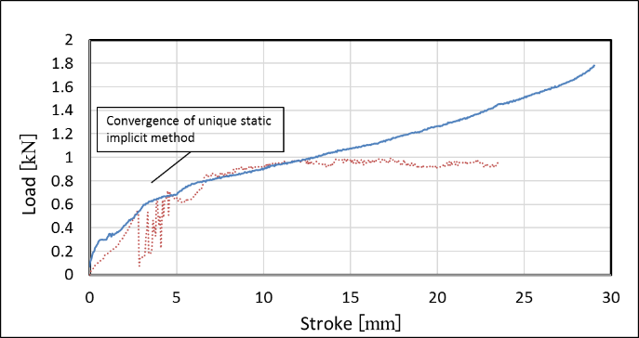

Fig.4 Load-stroke diagram

Recent Publications (minimum 5)
- Ryosuke Okushima, Shinichi Nishida, Junshi Ichikawa, Yuta Kashitani, Yujiro Nitta, Atsuhiro Aoki, Yuto Takigawa, Hayato Aso, Hideto Harada and Akihiro Watanabe, FEM Analysis of Cold Flaring Process of SGP Pipe, International Journal of Advanced Engineering, Management and Science, Vol. 3 Issue 2, 75-76 (2017).
- Nao Ozawa, Shinichi Nishida, Toshio Haga, Junshi Ichikawa, Yuta Kashitani, Ryosuke Okushima, Yujiro Nitta, Atsuhiro Aoki, Yuto Takigawa, Hayato Aso, Hideto Harada and Akihiro Watanabe, Forgeability of AZ Series Magnesium Alloy produced by Twin Roll Casting, International Journal of Advanced Engineering, Management and Science, Vol. 3 Issue 2, 77-80 (2017).
- Sueji Hirawatari, Hisaki Watari, Shinichi Nishida, Yuki Sato and Mayumi Suzuki, Evaluation of Friction Properties of Magnesium Alloy during Hot Forging by Ring Compression Test, Materials Science Forum, Vol.889, 119-126 (2017).
- Y. Kamakoshi, S. Nishida, K. Kanbe and I. Shoji, Finite element method analysis of cold forging for deformation and densification of Mo alloyed sintered steel, IOP Conference Series: Materials Science and Engineering, Vol.257, (2017).
- Shinichi Nishida, Junshi Ichikawa, Yuta Kashitani, Kentaro Tsunoda, Yusuke Takeuchi, Yujiro Nitta, Yuto Takigawa, Atsuhiro Aoki and Yutaka Sato, FEM Analysis of Cold Flaring Process of SUS304 Pipe, Defect and Diffusion Forum, Vol.382, 120-126(2018).



Biography (150 word limit)
Kentaro Tsunoda is pursuing his 4th undergraduate. He studied cold plastic forming of plastic pipe at Gunma University, Japan. He has done his research at the Faculty of Mechanical engineering of the Gunma University. He has attended two conferences presenting his research works.

Email: snishida@gunma-u.ac.jp

Notes/Comments:

