Horizontal twin roll casting of aluminum alloy A7075
Yuta Kashitani, Gunma University, Japan
Shinichi Nishida, Gunma University, Japan
Junshi Ichikawa, Gunma University, Japan
Yuto, Horigome, Gunma University, Japan
Kentaro Tsunoda, Gunma University, Japan
Naoki Ikeda, Gunma University, Japan
Makoto Hagiwara, Gunma University, Japan
Daichi Uematsu, Gunma University, Japan
Hideto Harada, Gunma University, Japan
Toshio Haga, Osaka Institute of Technology, Japan

Abstract (300 word limit)
This paper describes a horizontal type twin roll strip casting process for producing aluminum alloy strip of A7075. Twin roll casting process is able to produce a strip from molten metal directly. Thus this process has a possibility to reduce total cost of sheet making comparing to conventional rolling process. Strip casting process has some disadvantages. Casting speed depends on the material properties. It is difficult to determine the casting conditions. Aluminum alloy A7075 has high tensile strength, and it is known as a material for aerospace application. The sheet is manufactured in small quantities comparing to the other sheet aluminum alloy. Because A7075 alloy sheet is generally needed to a number of rolling and annealing process after hot extrusion. It is supposed that the demand of high tensile strength aluminum sheet such as A7075 is going to increase for weight saving of structural material. In this study, the effect of pouring temperature on the strip was investigated. Castability, surface conditions microstructure and strip thickness were estimated. It was possible to produce strip at any pouring temperature by horizontal twin roll strip casting process. Each surfaces of produced strip were transcribed form the roll surface, and the surfaces had a metallic luster. Minor cracks occurred at pouring temperature 710°C. Solidification cracking occurred at a pouring temperature of 740℃. Generally, the strip thickness tends to decrease as the pouring temperature increases. However, the strip thickness of pouring temperature of 710℃ and 740℃ increased compared with the pouring temperature of 680℃. Moreover, the strip thickness decreased at the pouring temperature of 770℃. As a result of observing the microstructure, equiaxed crystals were produced at any pouring temperature.

Image
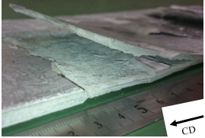
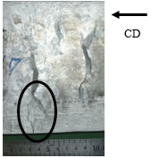

(b) Cracks (Pouring temperature was 740 ℃)
(a) Cracks (Pouring temperature was 710 ℃)

Fig.1 Solidification cracks of produced A7075 aluminum alloy strip by twin roll caster

Recent Publications (minimum 5)
- Yuta Kashitani, Shinichi Nishida, Junshi Ichikawa, Hiroto Ohashi, Nao Ozawa, Ryosuke Okushima, Tomoya Suzuki, Yuto Takigawa and Hideto Harada, Twin Roll Casting of Aluminium Alloy ADC12, A3003, A7075, Key Engineering Materials, Vol.735, 18-23 (2017).
- Hiroto Ohashi, Shinichi Nishida, Yuta Kashitani, Junshi Ichikawa, Nao Ozawa, Tomoya Suzuki, Ryosuke Okushima, Atsuhiro Aoki and Hideto Harada, Direct Molten Metal Rolling of Aluminum Alloy A3003, Key Engineering Materials, Vol.735, 13-17 (2017).
- Yuta Kashitani, Shinichi Nishida, Junshi Ichikawa, Hiroto Ohashi, Nao Ozawa, Ryosuke Okushima, Tomoya Suzuki, Yuto Takigawa and Hideto Harada, Twin Roll Casting of Aluminium Alloy ADC12, A3003, A7075, Key Engineering Materials, Vol.735, 18-23 (2017).
- T. Haga, K. Okamura, H. Watari and S. Nishida, Casting of Clad Strip of Al-SiCp, Magnesium Alloy Hard-Brittle Light Material by a Twin Roll Caster, Materials Science Forum, Vol.893, 262-266 (2017).
- Toshio Haga, Ryosuke Kozono, Shinichi Nishida and Hisaki Watari, Casting of aluminum alloy clad strip by an unequal diameter twin-roll caster equipped with a scraper, Advances in Materials and Processing Technologies, Vol.4, 511-521 (2017).

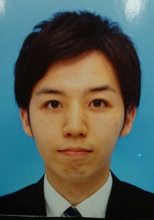

Biography (150 word limit)
Yuta Kashitani is pursuing his 1st year postgraduate degree. He studied Metal Strip Casting at the Gunma University, Japan. He has done his research at the Faculty of Mechanical Science and Technology of the Gunma University. He has attended six conferences presenting his research works and has published three papers in high impact journals.
Email: snishida@gunma-u.ac.jp

Notes/Comments:

