FEM analysis for burring process of large diameter SUS304 tube
Junshi Ichikawa, Gunma University, Japan
Shinichi Nishida, Gunma University, Japan
Yuta Kashitani, Gunma University, Japan
Kentaro Tsunoda, Gunma University, Japan
Yuto, Horigome, Gunma University, Japan
Naoki Ikeda, Gunma University, Japan
Daichi Uematsu, Gunma University, Japan
Makoto Hagiwara, Gunma University, Japan
Hideto Harada, Gunma University, Japan
Yutaka Sato, MSK Co.,Ltd., Japan

Abstract (300 word limit)
This paper describes a finite element method (FEM) analysis for cold burring process of large diameter SUS304 pipe. The large diameter pipes such as 216.3 mm are used for a plant as a flow channel of gas and liquid. A burring process of pipe is generally for forming the branch. Burring molding is one of the typical molding techniques for branch pipes. The burring process is achieved by drawing of die from prepared hole. And the branch pipes are generally joined by welding.
However this process has some problem. First, the burring process is depending on the forming limit of pipe. Second, the wall thickness and strain distribution of formed branch edge is unequal. These problem is caused the pre-hole shape. It generally has difficulty to determine the optimum pre-hole shape. Many try and error is needed. In this study, we proposed that the method of estimation for optimum pre-hole shape of mother pipe by finite element method analysis. The nominal diameter of mother pipe is 200A. And the target nominal diameter of branch pipe is 100A. The diameter is 114.3 mm, and the wall thickness is 3.0 mm. And target burring wall height is 10 mm with uniformly wall height around the edge. The height 10 mm means that is not needed the machining after burring process and is easy to weld to join the branch pipe to mother pipe. Initial pre-hole shape of analysis model is simple circle. After FEM analysis, the height of burring position was measured. Then the diameters of longitudinal direction and circumferential direction was adjusted. After optimum diameter of both direction diameter was determined, the diameter of 45 °direction was analyzed by using point tracking function to estimate of initial optimum diameter. Eventually, the burring formed shape had an uniform 10 mm height. It was clarified that the method of estimation for optimum pre-hole was effective.

Image
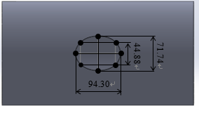
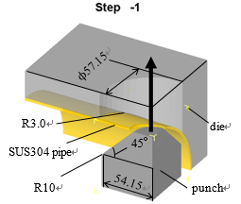
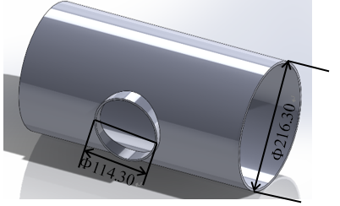
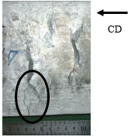
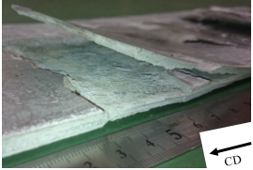

Fig.3 Estimated optimum pre-hole shape
Fig.2 Schematic illustration of FEM model
Fig.1 Target shape after burring process

Recent Publications (minimum 5)
- Ryosuke Okushima, Shinichi Nishida, Junshi Ichikawa, Yuta Kashitani, Yujiro Nitta, Atsuhiro Aoki, Yuto Takigawa, Hayato Aso, Hideto Harada and Akihiro Watanabe, FEM Analysis of Cold Flaring Process of SGP Pipe, International Journal of Advanced Engineering, Management and Science, Vol. 3 Issue 2, 75-76 (2017).
- Nao Ozawa, Shinichi Nishida, Toshio Haga, Junshi Ichikawa, Yuta Kashitani, Ryosuke Okushima, Yujiro Nitta, Atsuhiro Aoki, Yuto Takigawa, Hayato Aso, Hideto Harada and Akihiro Watanabe, Forgeability of AZ Series Magnesium Alloy produced by Twin Roll Casting, International Journal of Advanced Engineering, Management and Science, Vol. 3 Issue 2, 77-80 (2017).
- Sueji Hirawatari, Hisaki Watari, Shinichi Nishida, Yuki Sato and Mayumi Suzuki, Evaluation of Friction Properties of Magnesium Alloy during Hot Forging by Ring Compression Test, Materials Science Forum, Vol.889, 119-126 (2017).
- Y. Kamakoshi, S. Nishida, K. Kanbe and I. Shoji, Finite element method analysis of cold forging for deformation and densification of Mo alloyed sintered steel, IOP Conference Series: Materials Science and Engineering, Vol.257, (2017).
- Shinichi Nishida, Junshi Ichikawa, Yuta Kashitani, Kentaro Tsunoda, Yusuke Takeuchi, Yujiro Nitta, Yuto Takigawa, Atsuhiro Aoki and Yutaka Sato, FEM Analysis of Cold Flaring Process of SUS304 Pipe, Defect and Diffusion Forum, Vol.382, 120-126(2018).

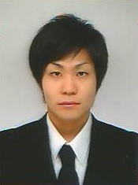

Biography (150 word limit)
Junshi Ichikawa is pursuing his 1st year postgraduate degree. He studied Metal Plastic Forming and FEM Analysis at the Gunma University, Japan. He has done his research at the Faculty of Mechanical Science and Technology of the Gunma University. He has attended six conferences presenting his research works and has published three papers in high impact journals.
Email: snishida@gunma-u.ac.jp

Notes/Comments:

