Synthesis of Pt-WO₃@W/GNs as a bifunctional electro-photo catalyst for catalyzing methanol oxidation and oxygen reduction reaction

Zhongshui Li, Shuhong Xu, Shen Lin*
College of Chemistry and Materials Science, Fujian Normal University, China

Abstract
Direct methanol fuel cells (DMFCs) have attracted increasing attention due to its low cost, high power density, ease of handling, and low operating temperature. And the multifunctional electro-catalysts which can be used simultaneously in both the anode (methanol oxidation reaction, MOR) and cathode (oxygen reduction reaction, ORR) are eagerly needed. So in this work, a bifunctional electro-photo catalyst Pt-WO₃@W/GNs was synthesized by high temperature solid phase synthesis method, with two-dimensional plane structure graphene (GNs) as a support, and it was characterized by TEM, HAADF-STEM, XRD, XPS and Raman. It is found that Pt-WO₃@W/GNs has two forms of W at the same time, that is the metal state (W) on the surface and the internal oxidation state (WO₃), which is due to that only partial surface of WO₃ is reduced during high temperature solid phase reaction. Furthermore, it is observed that its substrate GNs show an obvious wrinkle undergoing the high temperature process, and Pt-WO₃@W nanoparticles are evenly dispersed on the surface of GNs, with the average particle size about 7.5 nm. Electro-catalytic properties of Pt-WO₃@W/GNs were investigated by cyclic voltammetry (CV), linear sweep voltammetry (LSV), chronoamperometry, and electrochemical impedance spectrum (EIS), to discuss the effect of W oxophilic property and its different states on its catalytic properties towards MOR and ORR. The results indicate that both W and WO₃ in Pt-WO₃@W/GNs have a promoting effect on catalyzing MOR and ORR, resulting in a superior electro-catalytic property than that of commercial Pt-Ru/C. Especially, the presence of some W (0) can endow semiconductor WO₃ different contact modes (Ohmic and Schottky contact) between W or Pt, which leads to a strong charge separation efficiency under light irradiation, so an efficient electro-photo-synergistic catalytic properties towards MOR and ORR under simulated sunlight was achieved. The founding in this work is helpful for converting solar energy into electric energy during traditional electro-catalytic process.

Image
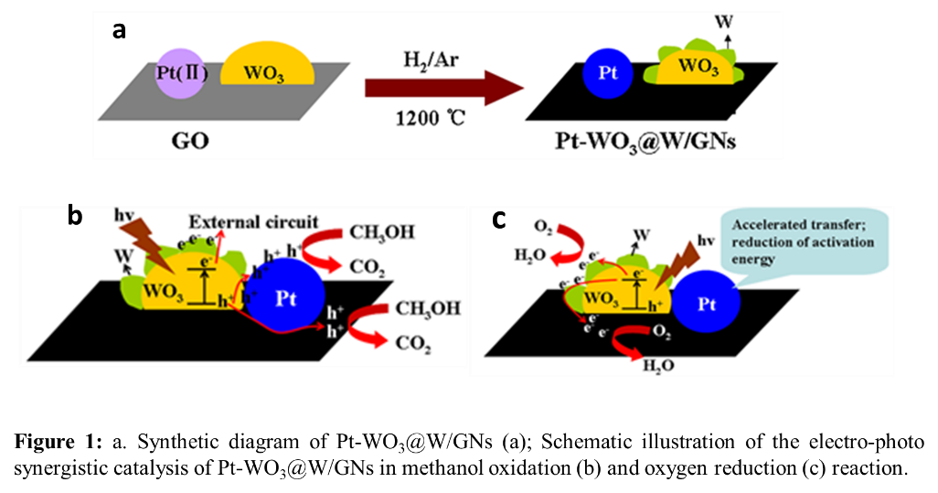

Recent Publications
- Z. Li, S. Xu, Y. Xie, Y. Wang, S. Lin*, Promotional effects of trace Bi on its highly catalytic activity for methanol oxidation of hollow Pt/graphene catalyst, Electrochimica Acta, 264 (2018) 53-60.
- Z. Li, L. Ye, Y. Wang, S. Xu, F. Lei, S. Lin*, Visible light assisted electro-photo synergistic catalysis of heterostructured Pd-Ag NPs/graphene for methanol oxidation, Rsc Advances, 6 (2016) 79533-79541..
- Z. Li, L. Ye, F. Lei, Y. Wang, S. Xu, S. Lin*, Enhanced electro-photo synergistic catalysis of Pt (Pd)/ZnO/graphene composite for methanol oxidation under visible light irradiation, Electrochimica Acta, 188 (2016) 450-460..
- F. Lei, Z. Li, L. Ye, Y. Wang, S. Lin*, One-pot synthesis of Pt/SnO₂/GNs and its electro-photo-synergistic catalysis for methanol oxidation, International Journal of Hydrogen Energy, 41 (2016) 255-264.
5. Z. Li, F. Lei, L. Ye, X. Zhang, S. Lin*, Controlled synthesis of Pt/CS/PW₁₂-GNs composite as an anodic electrocatalyst for direct methanol fuel cells, Journal of Nanoparticle Research, 17 (2015).
6. L. Ye, Z. Li, X. Zhang, F. Lei, S. Lin*, One-step microwave synthesis of Pt (Pd)/Cu₂O/GNs composites and their electro-photosynergistic catalytic properties for methanol oxidation, Journal of Materials Chemistry A, 2 (2014) 21010-21019.
7. L. Ye, Z. Li, L. Zhang, F. Lei, S. Lin*, A green one-pot synthesis of Pt/TiO₂/Graphene composites and its electro-photo-synergistic catalytic properties for methanol oxidation, Journal of Colloid and Interface Science, 433 (2014) 156-162.
8. Z. Li, L. Zhang, X. Huang, L. Ye, S. Lin*, Shape-controlled synthesis of Pt nanoparticles via integration of graphene and beta-cyclodextrin and using as a noval electrocatalyst for methanol oxidation, Electrochimica Acta, 121 (2014) 215-222.
9. Z.-S. Li, S. Lin*, Z.-l. Chen, Y.-D. Shi, X.-M. Huang, In situ electro-deposition of Pt micro-nano clusters on the surface of {PMo₁₂O₄₀³⁻/PAMAM}_{n} multilayer composite films and their electrocatalytic activities regarding methanol oxidation, Journal of Colloid and Interface Science, 368 (2012) 413-419
10. Z. Li, X. Huang, X. Zhang, L. Zhang, S. Lin*, The synergistic effect of graphene and polyoxometalates enhanced electrocatalytic activities of Pt-{PEI-GNs/ PMo₁₂O₄₀³⁻}_{n} composite films regarding methanol oxidation, Journal of Materials Chemistry, 22 (2012) 23602-23607

Biography
Prof. Dr. Shen Lin obtained her B.S. Degree at Xia Men University in China in 1982, and completed her Ph.D. with Prof. Shixiong Liu at Fuzhou University in China in 2002. She works as a professor since 2000 in College of Chemistry and Material Science, Fujian Normal University, China. Her current research focuses on the development of new synthesis strategies of Pt/GNs based and non- noble metal electrocatalysts for their application in cathode and anode reaction of fuel cell, hydrogen evolution reaction and carbon dioxide reduction. Until now, she has published 20+ the related papers with average Impact Factor (corresponding author) over 3 (IF>3)
Email address: shenlin@fjnu.edu.cn

