Thermoelectric properties of ZnO-based ceramics prepared by spark plasma sintering technique
P.M Radingoana¹, S Guillemet-Fritsch¹, P.A Olubambi², C Estournès¹, J.G Noudem³
1. Université de Toulouse, CIRIMAT, CNRS INPT UPS, Université Paul-Sabatier, Toulouse, France
2. University of Johannesburg, School of Mining, Metallurgy and Chemical Engineering, Johannesburg, South Africa
3. CRISMAT-ENSICAEN, CNRS/UMR, Caen, France

Abstract

The scarcity and toxicity of high performance thermoelectric materials (such as Bi, Pb, Sb, Te etc.) has shifted research to focus on metal oxides and organic materials. Recently, inorganic–organic hybrids are of interest due to minimized thermal conductivity and selective scattering of charge carriers that leads to high seebeck coefficient. In this work, Zn_{0.96}Al_{0.04}O prepared through co-precipitation route was sintered using spark plasma sintering. Polyaniline (PANI) concentrations of 5 wt% and 9 wt% were compared. High dense ceramic of 98.5±0.03% was obtained at a low sintering temperature of 250°C using Zn_{0.96}Al_{0.04}O /5wt%PANI. Increasing PANI concentration decreased the relative density. Incorporation of PANI into the inorganic material reduced the thermal conductivity from 27 W/m.K to (0 wt% PANI) to 5.2 W/m.K (5 wt% PANI) and 3.2 W/m.K (9 wt% PANI) at 40°C. Maximum ZT of 2.2x10⁻⁶ is obtained at 200°C with PANI concentration of 9 wt%. These findings are an opening for low temperature applications of ZnO-based ceramics.

Keywords: Thermoelectricity, ZnO, Aluminium, Polyaniline, Spark plasma sintering

Image

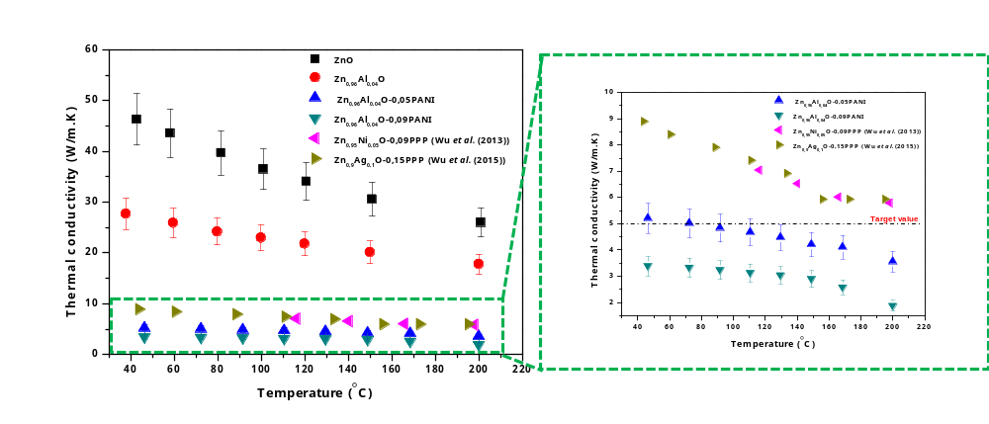

Recent Publications
- Wu, Z.H., Xie, H.Q, X., Wang, Y-Y, Xing, J.J and Ma, J.H., 2015. Nanojunctions Contributing to High Performance Thermoelectric ZnO-Based Inorganic-Organic Hybrids. Chinese Physics Letters, 32(11), p.117303.
- Wu, Z.H., Xie, H.Q. and Zhai, Y.B., 2013. Enhanced thermoelectric figure of merit in nanostructured ZnO by nanojunction effect. Applied Physics Letters, 103(24), p.243901.
- Li, J., Tang, X., Li, H., Yan, Y. and Zhang, Q., 2010. Synthesis and thermoelectric properties of hydrochloric acid-doped polyaniline. Synthetic Metals, 160(11-12), pp.1153-1158.
- Mitra, M., Kargupta, K., Ganguly, S., Goswami, S. and Banerjee, D., 2017. Facile synthesis and thermoelectric properties of aluminum doped zinc oxide/polyaniline (AZO/PANI) hybrid. Synthetic Metals, 228, pp.25-31.
- Zhang, D.B., Zhang, B.P., Shang, P.P., Gao, C. and Zhang, Y.Q., 2014. Effect of ZnAl2O4 phase on thermoelectric properties of Al doped ZnO ceramics fabricated by spark plasma sintering. Materials Research Innovations, 18(sup4), pp.S4-110.
- Beynet, Y., Izoulet, A., Guillemet-Fritsch, S., Chevallier, G., Bley, V., Pérel, T., Malpiece, F., Morel, J. and Estournès, C., 2015. ZnO-based varistors prepared by spark plasma sintering. Journal of the European Ceramic Society, 35(4), pp.1199-1208.
- Wu, Z.H., Xie, H.Q., Yong-Biao Zhai, Y.B., G. and Liu, J., 2015. Enhanced thermoelectric performance of TiO2-based hybrid materials by incorporating conducting polymer. Chinese Physics B, 24(3), p.034402.

Biography (150 word limit)

Radingoana Precious Manti is a PhD student at Université Paul Sabatier/CIRIMAT. She is currently working on spark plasma sintering of ZnO/polymer composites for thermoelectric application. Her research interests are in renewable energies and sustainable development.

Email: radingoana@chimie.ups-tlse.fr

Notes/Comments:

