Tuneable light-emitting carbon-dot/polymer

flexible films prepared through one-pot synthesis
Susanta Kumar Bhunia, Post-doctoral research fellow, Technion - Israel Institute of Technology, Israel

Abstract
Development of efficient, inexpensive, and environmentally-friendly light emitters, particularly devices
that produce white light, have drawn intense interest due to diverse applications in the lighting industry,
photonics, solar energy, and others. We present a simple strategy for the fabrication of flexible transparent
films exhibiting tuneable light emission through one-pot synthesis of polymer matrixes with embedded
carbon dots assembled in situ. Importantly, different luminescence colours were produced simply by preparing
C-dot/polymer films using carbon precursors that yielded C-dots exhibiting distinct fluorescence
emission profiles. Furthermore, mixtures of C-dot precursors could be also employed for fabricating films
exhibiting different colours. In particular, we successfully produced films emitting white light with attractive
properties (i.e. “warm” white light with a high colour rendering index) – a highly sought after goal in
optical technologies.

Image
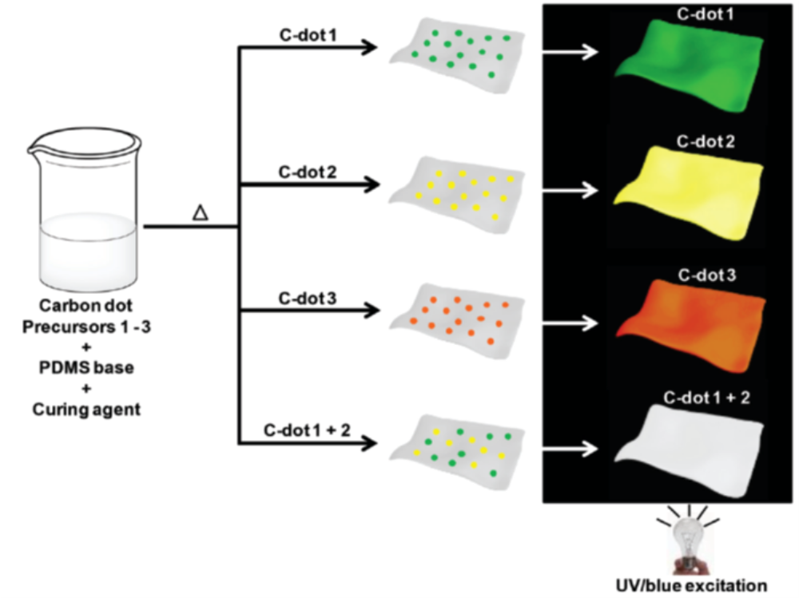

Recent Publications (minimum 5)
- Bhunia, S. K.; Nandi, S.; Manna, J.; Shikler, R.; Jelinek, R. (2016) Nanoscale, 8:3400-3406.
- Efremushkin, L.;# Bhunia, S. K.;# Jelinek, R.; Salomon. A. (2017) J. Phys. Chem. Lett., 8:6080-6085. (# Equal contribution)
- Massad-Ivanir, N.;# Bhunia, S. K.;# Raz, N.; Segal, E.; Jelinek. R. (2018) NPG Asia Mater., 10: e463. (# Equal contribution)
- Bhunia, S. K.; Dolai, S.; Sun, H.; Jelinek, R. (2018) Sens. Actuators, B, 270:223-230.
- Bhunia, S. K.; Zeiri, L.; Manna, J.; Nandi, S.; Jelinek, R. (2016) ACS Appl. Mater. Interfaces, 8:25637-25643.
- Bhunia, S. K.; Maity, A. R.; Nandi, S.; Stepensky, D.; Jelinek, R. (2016) ChemBioChem 17:614-619.
- Dolai, S.; Bhunia, S. K.; Beglaryan, S. S.; Kolusheva, S.; Zeiri, L.; Jelinek, R. (2017) ACS Appl. Mater. Interfaces, 9:2891-2898.


Biography
Dr. Susanta Kumar Bhunia received his Ph.D. in Chemistry in 2015 from Indian Association for the Cultivation of Science, India. He is currently a postdoctoral research associate with Prof. Lilac Amirav in Schulich Faculty of Chemistry at Technion – Israel Institute of Technology, Haifa, Israel. His current research focuses on the development of various smart nanomaterials and carbon-based advanced nanostructures for nano-biotechnology and energy related application. His expertise is in colloidal synthesis and functionalization of tuneable fluorescent carbon dots, graphene for biomedical and environmental application.
Email: susanta.chem@gmail.com

Notes/Comments:

