Energy efficient CuO-ZnO heterojunction nanocomposite: Study of bandgap tuning, energy bend alignment and photo-induced charge transfer mechanisms
Gautam SK, Malik M, Jyotsna S and Poddar P
Physical & Materials Chemistry Division, CSIR-National Chemical laboratory, Pune 411008, India

Abstract
Oxide-semiconductor based heterojunction nanocomposites (HNCs) have garnered enormous research interest worldwide and exhibited progressively advanced features such as- effective separation of photo-generated electron–hole pairs for their auspicious adoption in photovoltaic, photocatalytic and optoelectronic applications [1-3]. Great emphasis has been paid to fulfill the objectives of HNCs by synthesizing nanocrystalline narrow bandgap p-type copper oxide with wide bandgap n-type zinc oxide using sol-gel technique. The structural, optical and electronic properties of developed HNCs were studied using X-ray diffraction, micro-Raman spectroscopy, high resolution transmission electron microscopy (HRTEM), Photo-luminescence spectroscopy and X-ray photoelectron spectroscopy (XPS) and ultraviolet photoelectron spectroscopy (UPS) techniques. Results revealed that Cu doping concentration up to 5 at.% remains within the solubility limit of ZnO however, the higher Cu-doping concentration leads to formation of ZnO-CuO HNCs. Cu-doping decreases ZnO bandgap by introducing impurity energy levels and exhibits absorption in visible region of electromagnetic radiation [4]. The crucial information of local electronic structures has been understood in term of the hybridized electronic states and variation of valence band maxima with respect to Fermi level with increasing the Cu-doping in ZnO-CuO HNCs [5]. The enhanced photocatalytic activities and efficient charge transfer mechanism in ZnO/CuO HNCs are rationalized and studied in terms of bandgap tuning, energy band alignment and charge migration at ZnO/CuO heterojunction interfaces [6]. Detailed results will be presented.

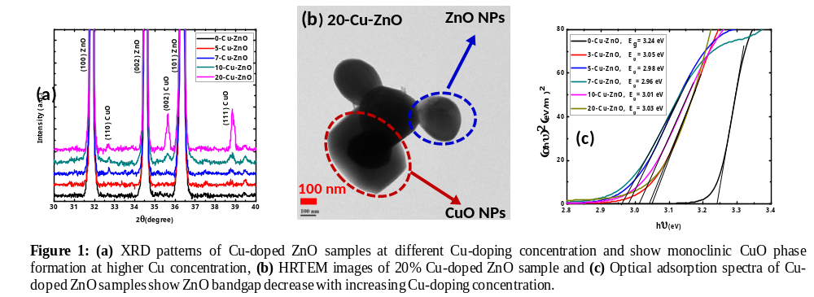

Recent Publications
- Gautam SK, Das A, Singh RG, Kumar VVS, Singh F (2006) Carrier transport mechanism of highly-sensitive niobium doped titanium dioxide/p-Si heterojunction photodiode under illuminations by solar simulated light. J. Applied Physics 120: 214502.
- Djurisic AB, Leung YH, Chang Ng AM (2014) Strategies for improving the efficiency of semiconductor metal oxide photocatalysis. Mater. Horiz. 1: 400-410
- Joshi K, Rawat M, Gautam SK, Singh RG, Ramola, RC, Singh F (2016) Band gap widening and narrowing in Cu-doped ZnO thin films. J. Alloys and Compounds. 680:252-258
- Gautam SK, Das A, Ojha S, Shukla DK, Phase D, Singh F (2006) Electronic structure modification and Fermi level shifting in Niobium doped anatase Titanium dioxide thin films: A comparative study of NEXAFS, Work function and stiffening of phonons. Phys. Chem. Chem. Phys. 18: 3618-3627.
- Meier R, Word RC, Nadarajah A, Könenkamp A (2008) Unipolar transport and interface charge transfer in nanostructured CdTe/polymer hybrid film. Phys. Rev. B - Condens. Matter Mater. Phys. 77: 195314

 Biography
Dr. Subodh Kumar Gautam is currently working as a National Post-doctoral Fellow at CSIR-National Chemical Laboratory, Pune, India. He has studied Physics and completed his Ph.D. degree from Inter-University Accelerator Centre, New Delhi India affiliated to Jawaharlal Nehru University, New Delhi, India. His expertise in growth of oxides semiconductors thin films and nanocomposites and their modifications by energetic ions for optoelectronic applications. He has studied the structural phase transformation, phonon confinement effect, electronic properties modification (p-d hybridization), Fermi level shifting, development of ultra-sensitive heterojunction photodiode and their radiation stability. Currently working on heterojunction semiconductors nanocomposite for light harvesting and effective charge carriers transfer studies for efficient phtocatalytic applications. He has published more than 25 research papers in peer reviewed international journals.

Email: subodhkgtm@gmail.com

Notes/Comments:

